Transmission Timings Report – Week 04
18/01/2021 - 24/01/2021
SBR2 External Vendor Testing Environment (EVTE3)
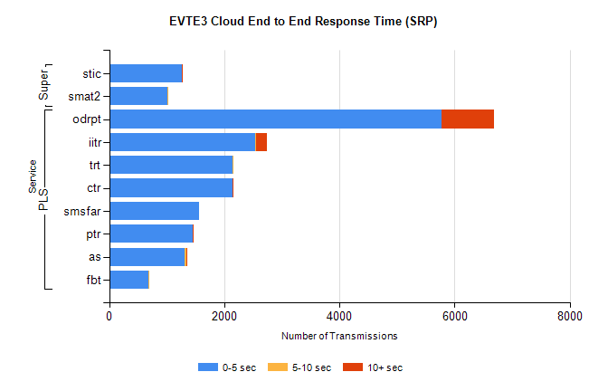
Stream | Service | 0-5 sec | 5-10 sec | >10 sec | Total | % within 5 sec timing target
PLS | odrpt | 5770 | 7 | 900 | 6677 | 86.4%
PLS | iitr | 2536 | 16 | 189 | 2741 | 92.5%
PLS | trt | 2150 | 2 |  | 2152 | 99.9%
PLS | ctr | 2143 | 3 | 2 | 2148 | 99.8%
PLS | smsfar | 1563 |  |  | 1563 | 100.0%
PLS | ptr | 1452 | 4 | 1 | 1457 | 99.7%
PLS | as | 1312 | 36 | 5 | 1353 | 97.0%
PLS | fbt | 676 | 3 |  | 679 | 99.6%
Super | stic | 1265 | 4 | 3 | 1272 | 99.4%
Super | smat2 | 1012 | 8 |  | 1020 | 99.2%

SBR2 External Vendor Testing Environment (EVTE3)
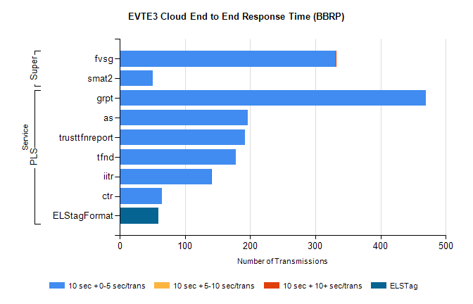
Stream | Service | 10 sec + 0-5 sec /trans | 10 sec + 5-10 sec /trans | 10 sec + >10 sec /trans | Processing Incomplete | ELStag | Total
PLS | grpt | 469 |  |  |  |  | 469
PLS | as | 196 |  |  | 4 |  | 200
PLS | trusttfnreport | 192 |  |  |  |  | 192
PLS | tfnd | 178 |  |  |  |  | 178
PLS | iitr | 140 |  | 2 |  |  | 142
PLS | ctr | 65 |  |  |  |  | 65
PLS | ELStagFormat |  |  |  |  | 60 | 60
Super | fvsg | 331 |  | 2 | 6 |  | 339
Super | smat2 | 51 |  |  |  |  | 51

