Transmission Timings Report – Week 04
18/01/2021 - 24/01/2021
Production2 Cloud - Single Requests (SRP)
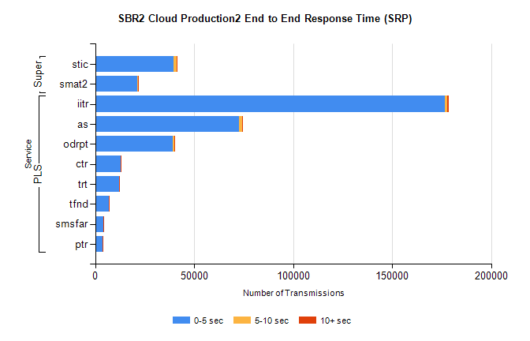
Stream | Service | 0-5 sec | 5-10 sec | >10 sec | Total | % within 5 sec timing target
PLS | iitr | 176558 | 1364 | 856 | 178865 | 98.7%
PLS | as | 72805 | 1479 | 360 | 74688 | 97.5%
PLS | odrpt | 39032 | 875 | 392 | 40308 | 96.8%
PLS | ctr | 12967 | 91 | 76 | 13135 | 98.7%
PLS | trt | 12009 | 120 | 84 | 12222 | 98.3%
PLS | tfnd | 6915 | 42 | 19 | 6980 | 99.1%
PLS | smsfar | 4158 | 33 | 27 | 4220 | 98.5%
PLS | ptr | 3912 | 35 | 22 | 3972 | 98.5%
Super | stic | 39601 | 1586 | 471 | 41677 | 95.0%
Super | smat2 | 21257 | 474 | 212 | 21950 | 96.8%

Production2 Cloud - Bulk or Batch Requests (BBRP)
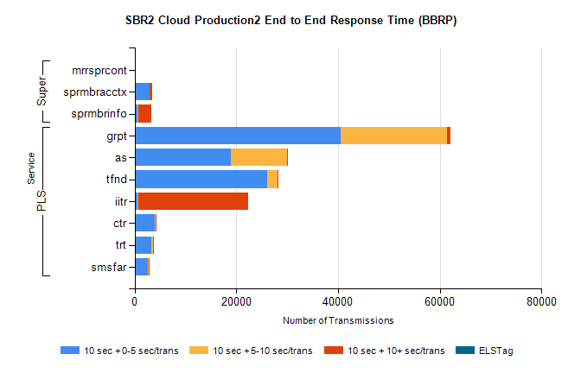
Stream | Service | 10 sec + 0-5 sec /trans | 10 sec + 5-10 sec /trans | 10 sec + >10 sec /trans | Processing Incomplete | ELStag | Total
PLS | grpt | 40449 | 21044 | 632 | 60 | 0 | 62947
PLS | as | 18955 | 11073 | 149 | 94 | 0 | 30608
PLS | tfnd | 26115 | 2064 | 105 | 416 | 0 | 28762
PLS | iitr | 579 | 58 | 21711 | 76 | 0 | 22466
PLS | ctr | 3867 | 261 | 33 | 18 | 0 | 4186
PLS | trt | 3321 | 210 | 18 | 24 | 0 | 3579
PLS | smsfar | 2557 | 216 | 14 | 8 | 0 | 2802
Super | mrrsprcont | 0 | 0 | 0 | 0 | 0 | 5363
Super | sprmbracctx | 2903 | 87 | 429 | 3 | 0 | 3462
Super | sprmbrinfo | 503 | 174 | 2559 | 4 | 0 | 3446

SBR1 Production Transactions
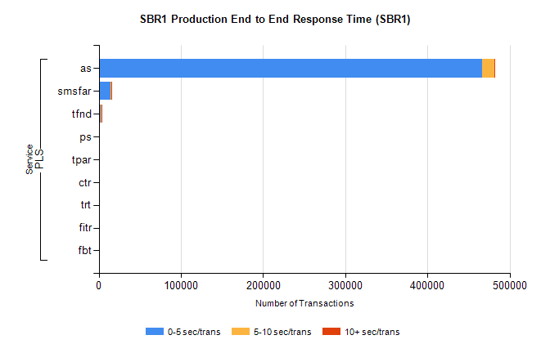
Stream | Service | 0-5 sec/trans | 5-10 sec/trans | 10+ sec/trans | Total | % within 5 sec timing target
PLS | as | 466743 | 14298 | 712 | 481753 | 96.9%
PLS | smsfar | 14708 | 511 | 35 | 15254 | 96.4%
PLS | tfnd | 2332 | 1279 | 15 | 3626 | 64.3%
PLS | ps | 38 | 73 | 246 | 357 | 10.6%
PLS | tpar | 21 | 26 | 152 | 199 | 10.6%
PLS | ctr | 39 | 3 | 5 | 47 | 83.0%
PLS | trt | 6 |  | 4 | 10 | 60.0%
PLS | fitr | 8 |  |  | 8 | 100.0%
PLS | fbt |  |  | 2 | 2 | 0.0%

