Transmission Timings Report – Week 07
8/02/2021 - 14/02/2021
Production2 Cloud - Single Requests (SRP)
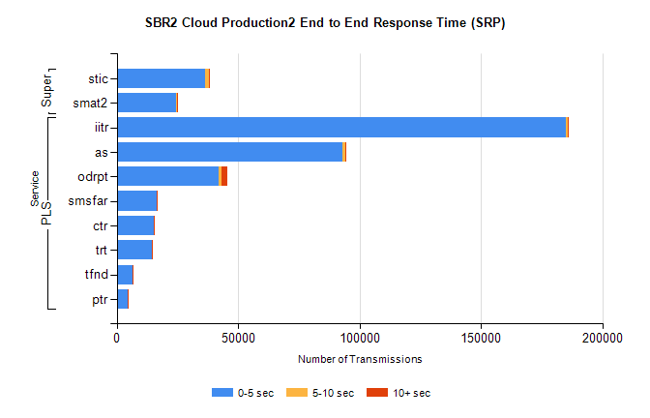
Stream | Service | 0-5 sec | 5-10 sec | >10 sec | Total | % within 5 sec timing target
PLS | iitr | 185058 | 753 | 209 | 186205 | 99.4%
PLS | as | 92967 | 1365 | 104 | 94502 | 98.4%
PLS | odrpt | 42031 | 1137 | 2348 | 45836 | 91.7%
PLS | smsfar | 16429 | 76 | 47 | 16577 | 99.1%
PLS | ctr | 15394 | 70 | 25 | 15506 | 99.3%
PLS | trt | 14419 | 76 | 19 | 14525 | 99.3%
PLS | tfnd | 6651 | 22 | 3 | 6683 | 99.5%
PLS | ptr | 4608 | 37 | 6 | 4654 | 99.0%
Super | stic | 36484 | 1431 | 250 | 38345 | 95.1%
Super | smat2 | 24486 | 531 | 191 | 25265 | 96.9%

Production2 Cloud - Bulk or Batch Requests (BBRP)
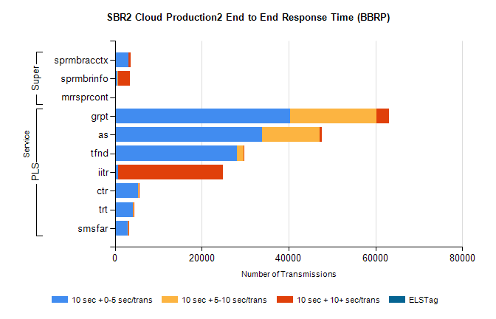
Stream | Service | 10 sec + 0-5 sec /trans | 10 sec + 5-10 sec /trans | 10 sec + >10 sec /trans | Processing Incomplete | ELStag | Total
PLS | grpt | 40266 | 19981 | 2905 | 354 | 0 | 64785
PLS | as | 33931 | 13200 | 573 | 168 | 0 | 48413
PLS | tfnd | 28144 | 1430 | 240 | 497 | 0 | 30517
PLS | iitr | 662 | 42 | 24144 | 109 | 0 | 25023
PLS | ctr | 5240 | 229 | 21 | 66 | 0 | 5576
PLS | trt | 4093 | 179 | 16 | 37 | 0 | 4353
PLS | smsfar | 2999 | 129 | 22 | 7 | 0 | 3172
Super | sprmbracctx | 3114 | 52 | 442 | 19 | 0 | 3675
Super | sprmbrinfo | 493 | 164 | 2720 | 28 | 0 | 3606
Super | mrrsprcont | 0 | 0 | 0 | 0 | 0 | 2463

SBR1 Production Transactions
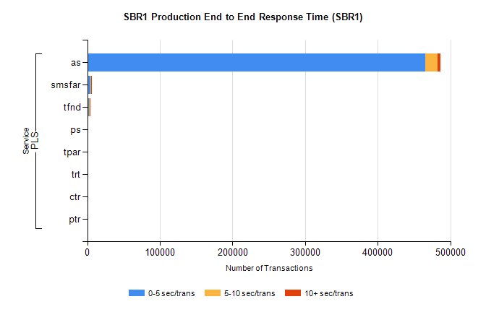
Stream | Service | 0-5 sec/trans | 5-10 sec/trans | 10+ sec/trans | Total | % within 5 sec timing target
PLS | as | 465844 | 16741 | 3898 | 486483 | 95.8%
PLS | smsfar | 4144 | 1002 | 95 | 5241 | 79.1%
PLS | tfnd | 2092 | 1392 | 84 | 3568 | 58.6%
PLS | ps | 72 | 70 | 318 | 460 | 15.7%
PLS | tpar | 78 | 63 | 317 | 458 | 17.0%
PLS | trt | 58 | 25 | 2 | 85 | 68.2%
PLS | ctr | 42 | 10 | 5 | 57 | 73.7%
PLS | ptr |  | 1 |  | 1 | 0.0%

