Transmission Timings Report – Week 10
1/03/2021 - 7/03/2021
Production2 Cloud - Single Requests (SRP)
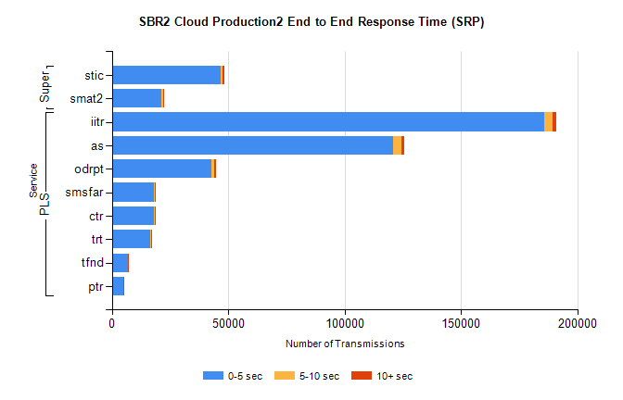
Stream | Service | 0-5 sec | 5-10 sec | >10 sec | Total | % within 5 sec timing target
PLS | iitr | 185747 | 3693 | 1691 | 191256 | 97.1%
PLS | as | 120699 | 3820 | 937 | 125515 | 96.2%
PLS | odrpt | 42598 | 1496 | 775 | 44919 | 94.8%
PLS | smsfar | 18149 | 258 | 126 | 18546 | 97.9%
PLS | ctr | 18132 | 187 | 118 | 18452 | 98.3%
PLS | trt | 16624 | 186 | 70 | 16888 | 98.4%
PLS | tfnd | 6746 | 38 | 21 | 6810 | 99.1%
PLS | ptr | 4776 | 67 | 26 | 4872 | 98.0%
Super | stic | 46885 | 620 | 836 | 48365 | 96.9%
Super | smat2 | 21428 | 647 | 381 | 22471 | 95.4%

Production2 Cloud - Bulk or Batch Requests (BBRP)
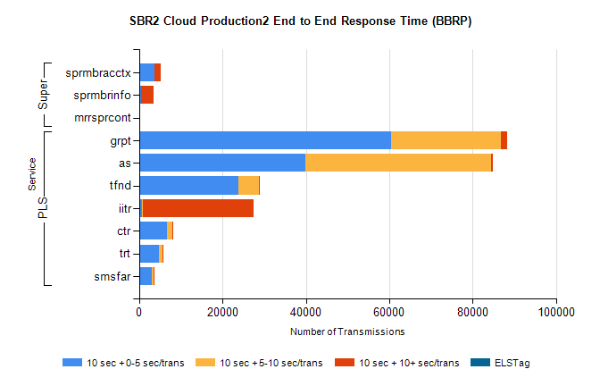
Stream | Service | 10 sec + 0-5 sec /trans | 10 sec + 5-10 sec /trans | 10 sec + >10 sec /trans | Processing Incomplete | ELStag | Total
PLS | grpt | 60522 | 26270 | 1487 | 94 | 0 | 90564
PLS | as | 39787 | 44599 | 514 | 395 | 0 | 87639
PLS | tfnd | 23812 | 5011 | 201 | 452 | 0 | 29679
PLS | iitr | 707 | 137 | 26516 | 136 | 0 | 27665
PLS | ctr | 6716 | 1176 | 31 | 24 | 0 | 8015
PLS | trt | 4685 | 838 | 10 | 37 | 0 | 5630
PLS | smsfar | 2960 | 550 | 7 | 4 | 0 | 3546
Super | sprmbracctx | 3658 | 116 | 1308 | 3 | 0 | 5140
Super | sprmbrinfo | 370 | 128 | 3011 | 67 | 0 | 3770
Super | mrrsprcont | 0 | 0 | 0 | 0 | 0 | 2585

SBR1 Production Transactions
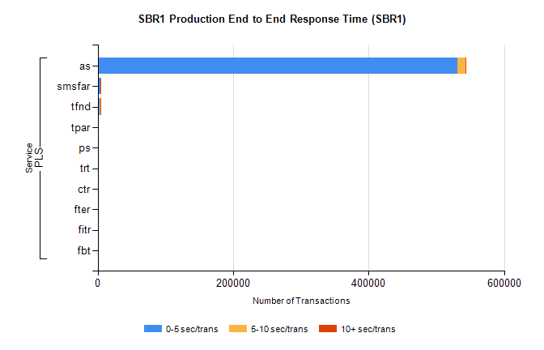
Stream | Service | 0-5 sec/trans | 5-10 sec/trans | 10+ sec/trans | Total | % within 5 sec timing target
PLS | as | 530715 | 11899 | 1464 | 544078 | 97.5%
PLS | smsfar | 3714 | 616 | 22 | 4352 | 85.3%
PLS | tfnd | 2975 | 1286 | 27 | 4288 | 69.4%
PLS | tpar | 110 | 73 | 331 | 514 | 21.4%
PLS | ps | 53 | 77 | 293 | 423 | 12.5%
PLS | trt | 40 | 9 | 1 | 50 | 80.0%
PLS | ctr | 27 | 7 | 3 | 37 | 73.0%
PLS | fter |  | 2 | 1 | 3 | 0.0%
PLS | fitr | 2 |  |  | 2 | 100.0%
PLS | fbt |  | 1 |  | 1 | 0.0%

