Transmission Timings Report – Week 18
26/04/2021 - 2/05/2021
SBR2 External Vendor Testing Environment (EVTE3)
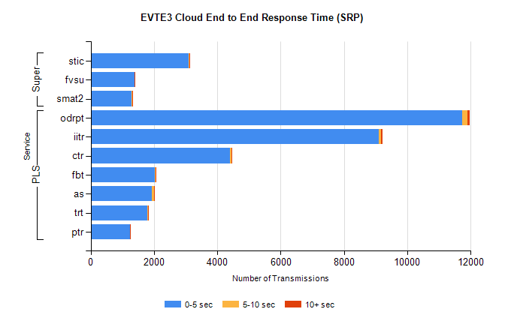
Stream | Service | 0-5 sec | 5-10 sec | >10 sec | Total | % within 5 sec timing target
PLS | odrpt | 11736 | 154 | 73 | 11963 | 98.1%
PLS | iitr | 9096 | 86 | 35 | 9251 | 98.3%
PLS | ctr | 4412 | 34 | 21 | 4488 | 98.3%
PLS | fbt | 2026 | 21 | 5 | 2052 | 98.7%
PLS | as | 1938 | 64 | 8 | 2010 | 96.4%
PLS | trt | 1795 | 9 | 4 | 1808 | 99.3%
PLS | ptr | 1248 | 4 | 1 | 1253 | 99.6%
Super | stic | 3090 | 30 | 10 | 3130 | 98.7%
Super | fvsu | 1385 | 8 | 9 | 1402 | 98.8%
Super | smat2 | 1302 | 24 | 6 | 1332 | 97.7%

SBR2 External Vendor Testing Environment (EVTE3)
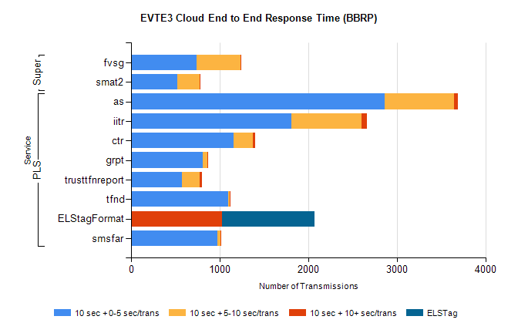
Stream | Service | 10 sec + 0-5 sec /trans | 10 sec + 5-10 sec /trans | 10 sec + >10 sec /trans | Processing Incomplete | ELStag | Total
PLS | as | 2864 | 782 | 39 | 7 | 0 | 4045
PLS | iitr | 1807 | 793 | 66 | 0 | 0 | 3110
PLS | ctr | 1160 | 217 | 22 | 1 | 0 | 2044
PLS | grpt | 810 | 53 | 10 | 0 | 0 | 1545
PLS | trusttfnreport | 571 | 207 | 26 | 0 | 0 | 1246
PLS | tfnd | 1097 | 18 | 6 | 0 | 0 | 1159
PLS | ELStagFormat | 0 | 0 | 1030 | 0 | 1042 | 1042
PLS | smsfar | 979 | 28 | 6 | 0 | 0 | 1038
Super | fvsg | 740 | 493 | 13 | 47 | 0 | 1323
Super | smat2 | 527 | 248 | 9 | 0 | 0 | 1051

