Transmission Timings Report – Week 25
14/06/2021 - 20/06/2021
Production2 Cloud - Single Requests (SRP)
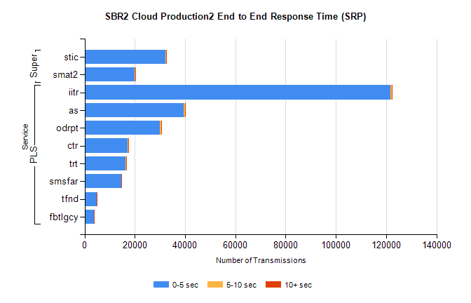
Stream | Service | 0-5 sec | 5-10 sec | >10 sec | Total | % within 5 sec timing target
PLS | iitr | 121796 | 497 | 221 | 154328 | 78.9%
PLS | as | 39435 | 605 | 45 | 51929 | 75.9%
PLS | odrpt | 29901 | 517 | 145 | 35606 | 84.0%
PLS | ctr | 17220 | 59 | 34 | 20973 | 82.1%
PLS | trt | 16426 | 89 | 37 | 20216 | 81.3%
PLS | smsfar | 14684 | 68 | 27 | 18249 | 80.5%
PLS | tfnd | 4862 | 11 | 3 | 5930 | 82.0%
PLS | fbtlgcy | 3790 | 37 | 4 | 4973 | 76.2%
Super | stic | 32241 | 90 | 57 | 45964 | 70.1%
Super | smat2 | 20027 | 75 | 52 | 26418 | 75.8%

Production2 Cloud - Bulk or Batch Requests (BBRP)
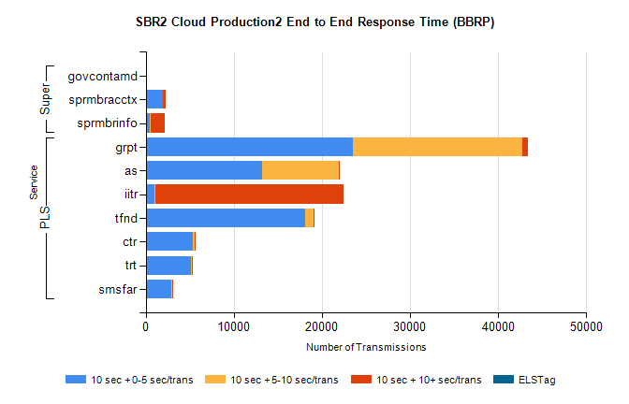
Stream | Service | 10 sec + 0-5 sec /trans | 10 sec + 5-10 sec /trans | 10 sec + >10 sec /trans | Processing Incomplete | ELStag | Total
PLS | grpt | 23558 | 19156 | 623 | 6906 | 0 | 50786
PLS | as | 13177 | 8765 | 62 | 5938 | 0 | 28162
PLS | iitr | 1023 | 76 | 21388 | 5357 | 0 | 28089
PLS | tfnd | 18133 | 947 | 77 | 5290 | 0 | 24507
PLS | ctr | 5331 | 249 | 11 | 1201 | 0 | 6805
PLS | trt | 5075 | 189 | 9 | 1168 | 0 | 6458
PLS | smsfar | 2912 | 107 | 8 | 786 | 0 | 3819
Super | govcontamd | 0 | 0 | 0 | 0 | 0 | 5535
Super | sprmbracctx | 1915 | 38 | 281 | 875 | 0 | 3139
Super | sprmbrinfo | 461 | 105 | 1549 | 765 | 0 | 3006

SBR1 Production Transactions
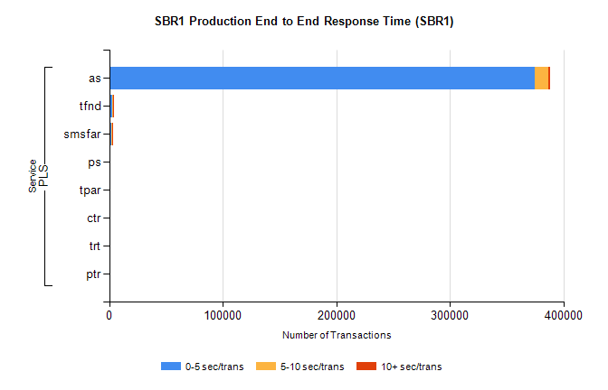
Stream | Service | 0-5 sec/trans | 5-10 sec/trans | 10+ sec/trans | Total | % within 5 sec timing target
PLS | as | 374600 | 12484 | 1594 | 388678 | 96.4%
PLS | tfnd | 2465 | 1370 | 28 | 3863 | 63.8%
PLS | smsfar | 2167 | 458 | 24 | 2649 | 81.8%
PLS | ps | 46 | 69 | 308 | 423 | 10.9%
PLS | tpar | 26 | 40 | 202 | 268 | 9.7%
PLS | ctr | 52 | 25 | 3 | 80 | 65.0%
PLS | trt | 50 | 18 | 3 | 71 | 70.4%
PLS | ptr | 6 | 3 |  | 9 | 66.7%

