Transmission Timings Report – Week 28
5/07/2021 - 11/07/2021

Production2 Cloud - Single Requests (SRP)

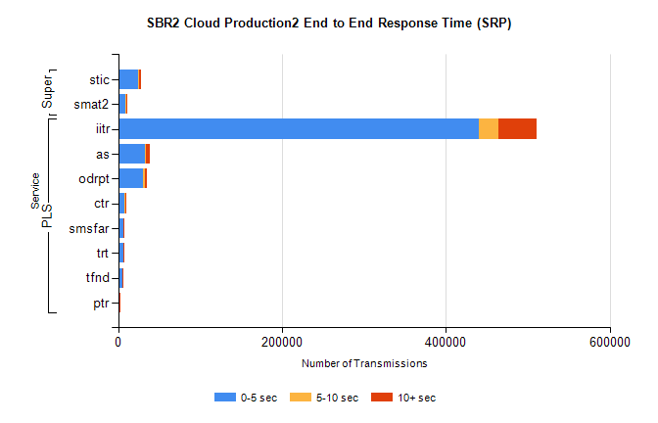
Stream | Service | 0-5 sec | 5-10 sec | >10 sec | Total | % within 5 sec timing target
PLS | iitr | 440032 | 24085 | 46850 | 821151 | 53.6%
PLS | as | 32203 | 2257 | 3725 | 60896 | 52.9%
PLS | odrpt | 29967 | 2343 | 3124 | 47289 | 63.4%
PLS | ctr | 7898 | 418 | 845 | 14734 | 53.6%
PLS | smsfar | 6260 | 384 | 703 | 11590 | 54.0%
PLS | trt | 6086 | 306 | 675 | 11381 | 53.5%
PLS | tfnd | 4841 | 271 | 483 | 8200 | 59.0%
PLS | ptr | 1606 | 92 | 149 | 3008 | 53.4%
Super | stic | 23982 | 1478 | 2866 | 46661 | 51.4%
Super | smat2 | 9448 | 546 | 1133 | 17011 | 55.5%

Production2 Cloud - Bulk or Batch Requests (BBRP)
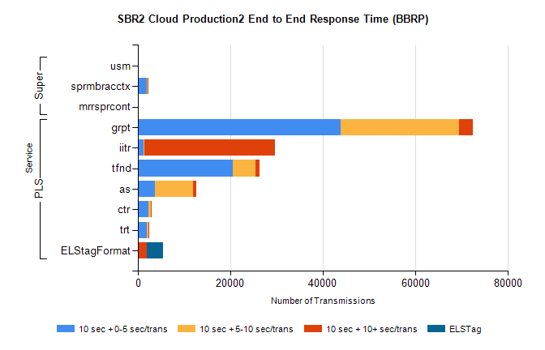
Service | 10 sec + 0-5 sec /trans | 10 sec + 5-10 sec /trans | 10 sec + >10 sec /trans | Processing Incomplete | ELStag | Total
grpt | 43791 | 25640 | 3011 | 29590 | 0 | 107935
iitr | 1168 | 224 | 28343 | 21330 | 0 | 51202
tfnd | 20543 | 4889 | 908 | 13781 | 0 | 41992
as | 3641 | 8316 | 606 | 8088 | 0 | 21961
ctr | 2314 | 529 | 139 | 1739 | 0 | 4935
trt | 1972 | 406 | 89 | 1499 | 0 | 4128
ELStagFormat | 0 | 0 | 1907 | 0 | 3499 | 3499
usm | 0 | 0 | 0 | 0 | 0 | 6378
sprmbracctx | 1971 | 92 | 282 | 2027 | 0 | 4429
mrrsprcont | 0 | 0 | 0 | 0 | 0 | 3903

SBR1 Production Transactions
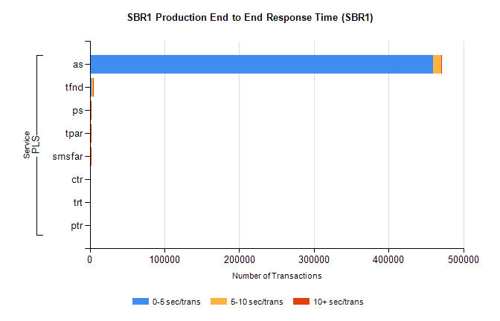
Stream | Service | 0-5 sec/trans | 5-10 sec/trans | 10+ sec/trans | Total | % within 5 sec timing target
PLS | as | 459322 | 11098 | 199 | 470619 | 97.6%
PLS | tfnd | 2901 | 1352 | 6 | 4259 | 68.1%
PLS | ps | 1128 | 451 | 893 | 2472 | 45.6%
PLS | tpar | 957 | 144 | 848 | 1949 | 49.1%
PLS | smsfar | 923 | 558 | 8 | 1489 | 62.0%
PLS | ctr | 23 | 27 | 3 | 53 | 43.4%
PLS | trt | 27 | 12 | 3 | 42 | 64.3%
PLS | ptr | 23 | 10 |  | 33 | 69.7%

