Transmission Timings Report Week - 35
23/08/2021 - 29/08/2021

SBR2 External Vendor Testing Environment (EVTE3)

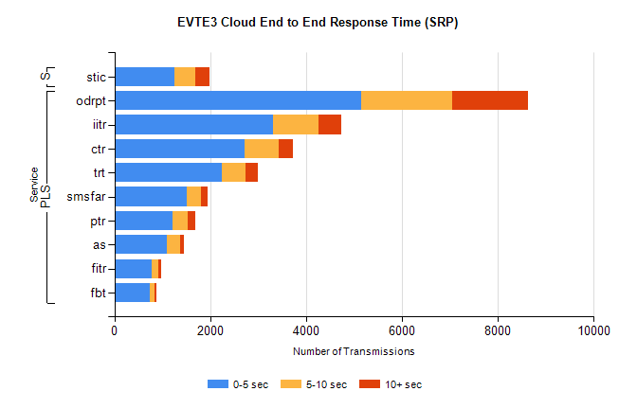
Stream | Service | 0-5 sec | 5-10 sec | >10 sec | Total | % within 5 sec timing target
PLS | odrpt | 5157 | 1887 | 1587 | 8639 | 59.7%
PLS | iitr | 3314 | 952 | 461 | 4733 | 70.0%
PLS | ctr | 2719 | 718 | 285 | 3753 | 72.4%
PLS | trt | 2235 | 507 | 262 | 3007 | 74.3%
PLS | smsfar | 1504 | 300 | 150 | 1954 | 77.0%
PLS | ptr | 1207 | 327 | 161 | 1699 | 71.0%
PLS | as | 1091 | 284 | 80 | 1464 | 74.5%
PLS | fitr | 780 | 147 | 53 | 982 | 79.4%
PLS | fbt | 738 | 108 | 26 | 876 | 84.2%
Super | stic | 1251 | 431 | 302 | 1984 | 63.1%

SBR2 External Vendor Testing Environment (EVTE3)
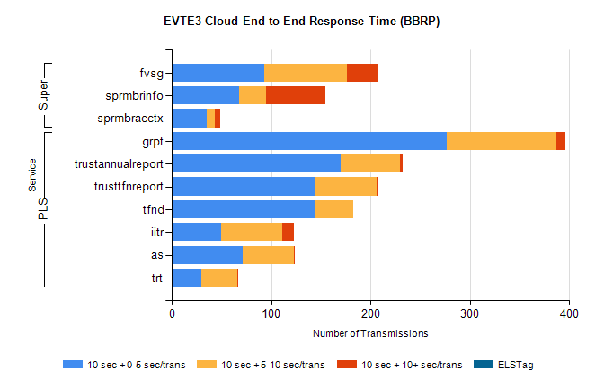
Stream | Service | 10 sec + 0-5 sec /trans | 10 sec + 5-10 sec /trans | 10 sec + >10 sec /trans | Processing Incomplete | ELStag | Total
PLS | grpt | 277 | 110 | 9 | 4 | 0 | 434
PLS | trustannualreport | 170 | 60 | 2 | 0 | 0 | 261
PLS | trusttfnreport | 145 | 61 | 1 | 0 | 0 | 230
PLS | tfnd | 144 | 39 | 0 | 0 | 0 | 189
PLS | iitr | 50 | 61 | 12 | 8 | 0 | 162
PLS | as | 71 | 52 | 1 | 8 | 0 | 155
PLS | trt | 30 | 36 | 1 | 1 | 0 | 88
Super | fvsg | 93 | 83 | 31 | 99 | 0 | 454
Super | sprmbrinfo | 68 | 27 | 60 | 0 | 0 | 182
Super | sprmbracctx | 35 | 8 | 6 | 0 | 0 | 51

