Transmission Timings Report Week - 39
20/09/2021 - 26/09/2021

SBR2 External Vendor Testing Environment (EVTE3)

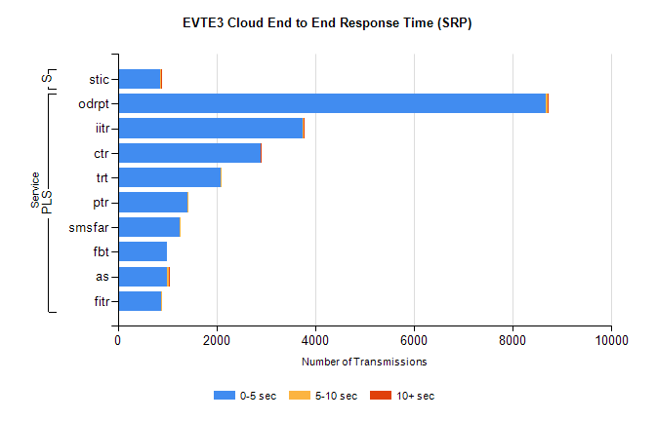
Stream | Service | 0-5 sec | 5-10 sec | >10 sec | Total | % within 5 sec timing target
PLS | odrpt | 8663 | 43 | 2 | 8733 | 99.2%
PLS | iitr | 3755 | 15 | 4 | 3839 | 97.8%
PLS | ctr | 2892 | 2 | 1 | 2969 | 97.4%
PLS | trt | 2079 | 9 | 0 | 2117 | 98.2%
PLS | ptr | 1407 | 3 | 0 | 1442 | 97.6%
PLS | smsfar | 1259 | 3 | 0 | 1280 | 98.4%
PLS | fbt | 1006 | 0 | 0 | 1070 | 94.0%
PLS | as | 992 | 44 | 3 | 1057 | 93.9%
PLS | fitr | 884 | 1 | 0 | 921 | 96.0%
Super | stic | 866 | 3 | 4 | 880 | 98.4%

SBR2 External Vendor Testing Environment (EVTE3)
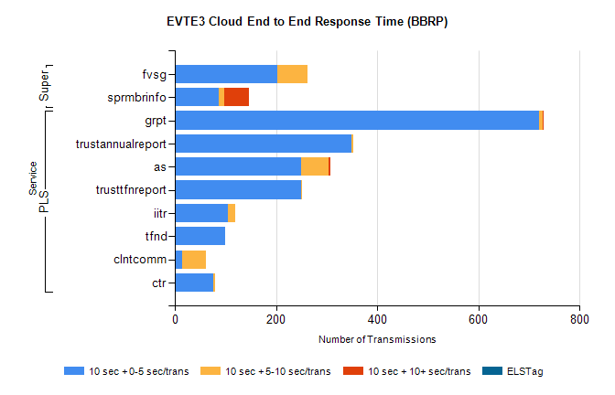
Stream | Service | 10 sec + 0-5 sec /trans | 10 sec + 5-10 sec /trans | 10 sec + >10 sec /trans | Processing Incomplete | ELStag | Total
PLS | grpt | 720 | 8 | 1 | 16 | 0 | 747
PLS | trustannualreport | 349 | 4 | 0 | 25 | 0 | 378
PLS | as | 250 | 54 | 4 | 1 | 0 | 319
PLS | trusttfnreport | 250 | 1 | 0 | 0 | 0 | 251
PLS | iitr | 105 | 14 | 0 | 7 | 0 | 127
PLS | tfnd | 100 | 0 | 0 | 2 | 0 | 102
PLS | clntcomm | 15 | 47 | 0 | 0 | 0 | 86
PLS | ctr | 76 | 3 | 0 | 0 | 0 | 79
Super | fvsg | 203 | 59 | 0 | 84 | 0 | 347
Super | sprmbrinfo | 86 | 11 | 49 | 0 | 0 | 249

