Transmission Timings Report Week - 48
22/11/2021 - 28/11/2021

SBR2 Cloud Production2 - Single Requests (SRP)

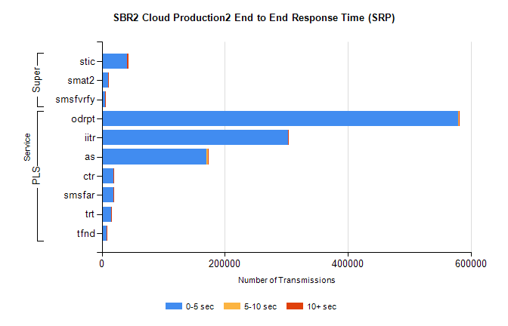

Stream | Service | 0-5 sec | 5-10 sec | >10 sec | Total | % within 5 sec timing target
PLS | odrpt | 579179 | 1171 | 794 | 581185 | 99.7%
PLS | iitr | 302627 | 839 | 387 | 303869 | 99.6%
PLS | as | 169794 | 3162 | 332 | 173308 | 98.0%
PLS | ctr | 19167 | 59 | 30 | 19259 | 99.5%
PLS | smsfar | 18701 | 45 | 38 | 18787 | 99.5%
PLS | trt | 15340 | 71 | 34 | 15445 | 99.3%
PLS | tfnd | 7971 | 6 | 10 | 7987 | 99.8%
Super | stic | 40878 | 236 | 1860 | 42975 | 95.1%
Super | smat2 | 9943 | 139 | 472 | 10555 | 94.2%
Super | smsfvrfy | 5625 | 118 | 69 | 5812 | 96.8%

SBR2 Cloud Production2 - Bulk or Batch Requests (BBRP)

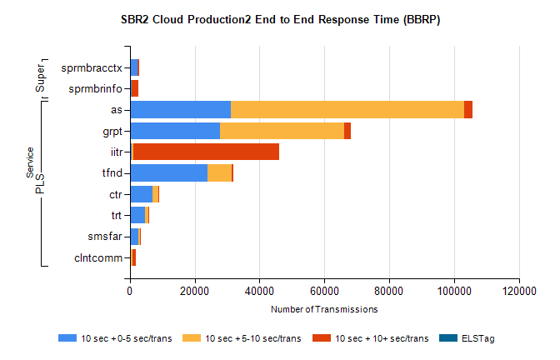

Stream | Service | 10 sec + 0-5 sec /trans | 10 sec + 5-10 sec /trans | 10 sec + >10 sec /trans | Processing Incomplete | ELStag | Total
PLS | as | 31246 | 71863 | 2597 | 3070 | 0 | 116296
PLS | grpt | 27901 | 38215 | 1921 | 70 | 0 | 73415
PLS | iitr | 660 | 318 | 45172 | 174 | 0 | 47101
PLS | tfnd | 23879 | 7497 | 565 | 472 | 0 | 33224
PLS | ctr | 7008 | 1674 | 101 | 29 | 0 | 9009
PLS | trt | 4583 | 1134 | 92 | 27 | 0 | 5994
PLS | smsfar | 2549 | 626 | 53 | 4 | 0 | 3307
PLS | clntcomm | 79 | 688 | 1183 | 36 | 0 | 2379
Super | sprmbracctx | 2331 | 98 | 381 | 23 | 0 | 2886
Super | sprmbrinfo | 453 | 165 | 1918 | 2 | 0 | 2722
SBR2 Cloud Production2 - ...

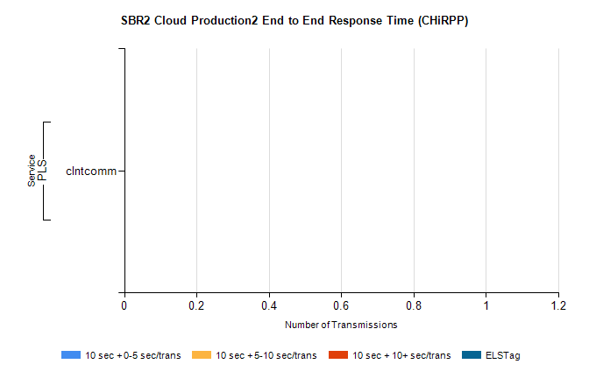

Stream | Service | 10 sec + 0-5 sec /trans | 10 sec + 5-10 sec /trans | 10 sec + >10 sec /trans | Total | % within 5 sec timing target
PLS | clntcomm | 0 | 0 | 0 | 600 | 0.0%
SBR1 Production Transactions

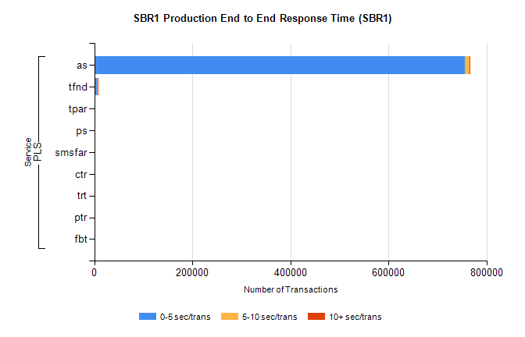
Stream | Service | 0-5 sec/trans | 5-10 sec/trans | 10+ sec/trans | Total | % within 5 sec timing target
PLS | as | 755622 | 10477 | 513 | 766612 | 98.6%
PLS | tfnd | 6193 | 945 | 13 | 7151 | 86.6%
PLS | tpar | 212 | 65 | 411 | 688 | 30.8%
PLS | ps | 111 | 98 | 340 | 549 | 20.2%
PLS | smsfar | 373 | 130 | 3 | 506 | 73.7%
PLS | ctr | 24 | 22 |  | 46 | 52.2%
PLS | trt | 19 | 12 | 1 | 32 | 59.4%
PLS | ptr | 19 | 6 |  | 25 | 76.0%
PLS | fbt | 2 | 12 | 1 | 15 | 13.3%

