Transmission Timings Report Week - 01
27/12/2021 - 2/01/2022

SBR2 Cloud Production2 - Single Requests (SRP)

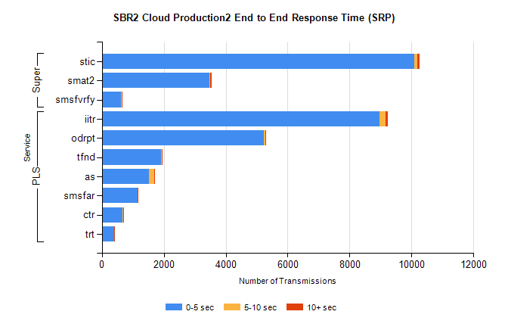

Stream | Service | 0-5 sec | 5-10 sec | >10 sec | Total | % within 5 sec timing target
PLS | iitr | 8976 | 191 | 76 | 9247 | 97.1%
PLS | odrpt | 5238 | 42 | 21 | 5304 | 98.8%
PLS | tfnd | 1914 | 12 | 11 | 1937 | 98.8%
PLS | as | 1522 | 177 | 17 | 1717 | 88.6%
PLS | smsfar | 1158 | 4 | 8 | 1170 | 99.0%
PLS | ctr | 673 | 25 | 4 | 703 | 95.7%
PLS | trt | 390 | 8 | 4 | 402 | 97.0%
Super | stic | 10101 | 86 | 64 | 10253 | 98.5%
Super | smat2 | 3465 | 43 | 37 | 3548 | 97.7%
Super | smsfvrfy | 619 | 30 | 10 | 659 | 93.9%

SBR2 Cloud Production2 - Bulk or Batch Requests (BBRP)

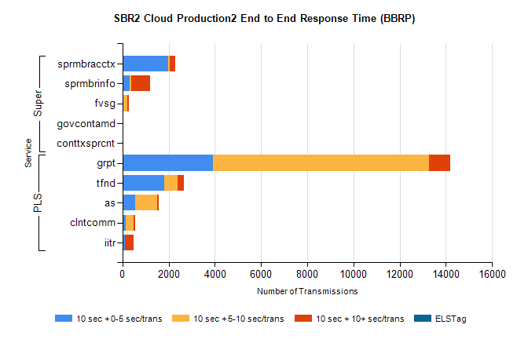

Stream | Service | 10 sec + 0-5 sec /trans | 10 sec + 5-10 sec /trans | 10 sec + >10 sec /trans | Processing Incomplete | ELStag | Total
PLS | grpt | 3903 | 9373 | 917 | 22 | 0 | 14824
PLS | tfnd | 1817 | 570 | 257 | 21 | 0 | 2704
PLS | as | 557 | 960 | 61 | 14 | 0 | 1714
PLS | clntcomm | 150 | 336 | 62 | 1 | 0 | 654
PLS | iitr | 99 | 5 | 395 | 3 | 0 | 505
Super | sprmbracctx | 1994 | 46 | 252 | 0 | 0 | 2319
Super | sprmbrinfo | 320 | 66 | 810 | 0 | 0 | 1270
Super | fvsg | 24 | 177 | 95 | 4 | 0 | 319
Super | govcontamd | 0 | 0 | 0 | 156 | 0 | 156
Super | conttxsprcnt | 0 | 0 | 0 | 98 | 0 | 98
SBR2 Cloud Production2 - ...

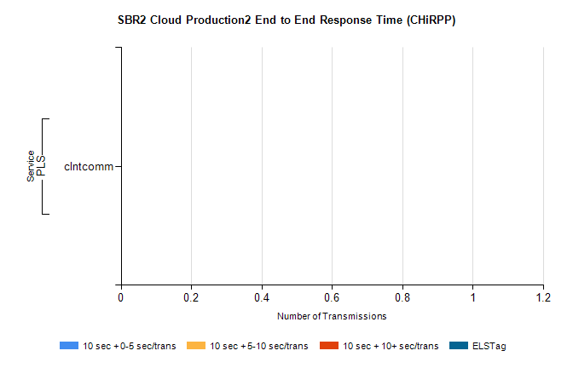

Stream | Service | 10 sec + 0-5 sec /trans | 10 sec + 5-10 sec /trans | 10 sec + >10 sec /trans | Total | % within 5 sec timing target
PLS | clntcomm | 0 | 0 | 0 | 17 | 0.0%
SBR1 Production Transactions

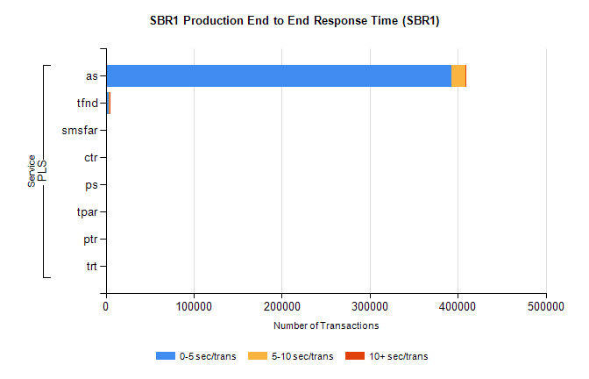
Stream | Service | 0-5 sec/trans | 5-10 sec/trans | 10+ sec/trans | Total | % within 5 sec timing target
PLS | as | 392404 | 16460 | 100 | 408964 | 96.0%
PLS | tfnd | 3895 | 656 | 12 | 4563 | 85.4%
PLS | smsfar | 18 | 13 | 1 | 32 | 56.3%
PLS | ctr | 5 | 5 |  | 10 | 50.0%
PLS | ps |  | 2 | 7 | 9 | 0.0%
PLS | tpar |  |  | 4 | 4 | 0.0%
PLS | ptr |  | 3 |  | 3 | 0.0%
PLS | trt | 1 |  |  | 1 | 100.0%

