Transmission Timings Report Week - 45
1/11/2021 - 7/11/2021

SBR2 External Vendor Testing Environment (EVTE3)

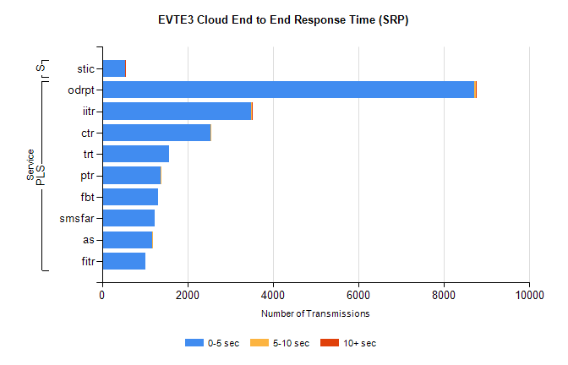
Stream | Service | 0-5 sec | 5-10 sec | >10 sec | Total | % within 5 sec timing target
PLS | odrpt | 8705 | 53 | 6 | 8766 | 99.3%
PLS | iitr | 3496 | 15 | 8 | 3579 | 97.7%
PLS | ctr | 2541 | 4 | 0 | 2600 | 97.7%
PLS | trt | 1579 | 0 | 0 | 1629 | 96.9%
PLS | ptr | 1370 | 1 | 0 | 1414 | 96.9%
PLS | fbt | 1305 | 0 | 0 | 1348 | 96.8%
PLS | smsfar | 1225 | 0 | 0 | 1248 | 98.2%
PLS | as | 1183 | 19 | 0 | 1216 | 97.3%
PLS | fitr | 1013 | 0 | 0 | 1054 | 96.1%
Super | stic | 545 | 1 | 2 | 557 | 97.8%

SBR2 External Vendor Testing Environment (EVTE3)
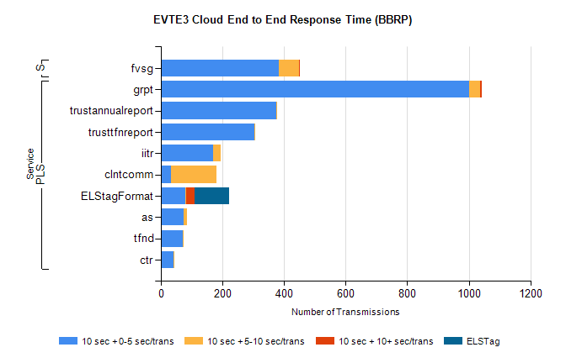
Stream | Service | 10 sec + 0-5 sec /trans | 10 sec + 5-10 sec /trans | 10 sec + >10 sec /trans | Processing Incomplete | ELStag | Total
PLS | grpt | 1002 | 34 | 6 | 0 | 0 | 1045
PLS | trustannualreport | 374 | 4 | 0 | 0 | 0 | 378
PLS | trusttfnreport | 304 | 3 | 0 | 0 | 0 | 307
PLS | iitr | 169 | 24 | 0 | 74 | 0 | 273
PLS | clntcomm | 34 | 146 | 0 | 0 | 0 | 183
PLS | ELStagFormat | 80 | 1 | 29 | 0 | 111 | 111
PLS | as | 75 | 9 | 0 | 0 | 0 | 84
PLS | tfnd | 71 | 2 | 0 | 0 | 0 | 73
PLS | ctr | 42 | 2 | 0 | 16 | 0 | 60
Super | fvsg | 384 | 64 | 1 | 78 | 0 | 531

