Transmission Timings Report Week - 21
16/05/2022 - 22/05/2022

SBR2 External Vendor Testing Environment (EVTE3)

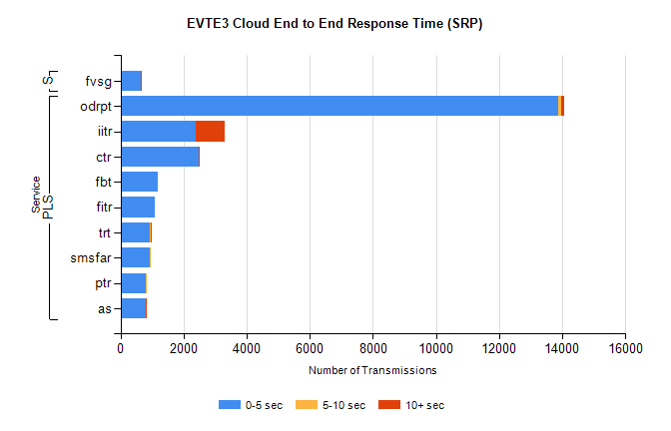

Stream | Service | 0-5 sec | 5-10 sec | >10 sec | Total | % within 5 sec timing target
PLS | odrpt | 13870 | 107 | 85 | 14069 | 98.6%
PLS | iitr | 2378 | 21 | 896 | 3407 | 69.8%
PLS | ctr | 2466 | 1 | 2 | 2730 | 90.3%
PLS | fbt | 1174 | 0 | 0 | 1452 | 80.9%
PLS | fitr | 1101 | 0 | 0 | 1351 | 81.5%
PLS | trt | 946 | 15 | 1 | 1108 | 85.4%
PLS | smsfar | 929 | 10 | 0 | 983 | 94.5%
PLS | ptr | 811 | 2 | 0 | 927 | 87.5%
PLS | as | 800 | 3 | 5 | 865 | 92.5%
Super | fvsg | 638 | 0 | 3 | 641 | 99.5%

SBR2 External Vendor Testing Environment (EVTE3)

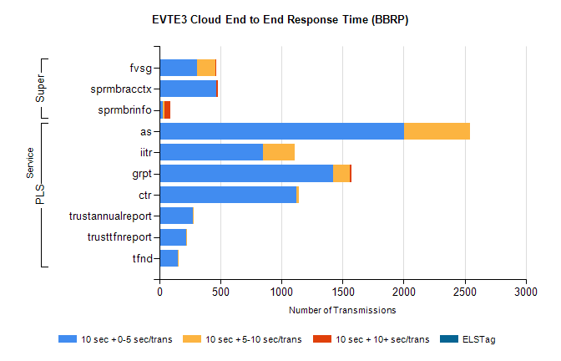

Stream | Service | 10 sec + 0-5 sec /trans | 10 sec + 5-10 sec /trans | 10 sec + >10 sec /trans | Processing Incomplete | ELStag | Total
PLS | as | 2005 | 540 | 0 | 1 | 0 | 2546
PLS | iitr | 847 | 262 | 0 | 1197 | 0 | 2306
PLS | grpt | 1424 | 132 | 20 | 7 | 0 | 1592
PLS | ctr | 1120 | 22 | 0 | 10 | 0 | 1152
PLS | trustannualreport | 271 | 11 | 0 | 0 | 0 | 282
PLS | trusttfnreport | 221 | 2 | 0 | 0 | 0 | 223
PLS | tfnd | 152 | 1 | 0 | 16 | 0 | 169
Super | fvsg | 309 | 146 | 6 | 107 | 0 | 575
Super | sprmbracctx | 462 | 2 | 12 | 1 | 0 | 478
Super | sprmbrinfo | 30 | 12 | 45 | 8 | 0 | 109

