Transmission Timings Report Week - 38
18/09/2023 - 24/09/2023

SBR2 Cloud Production2 - Single Requests (SRP)

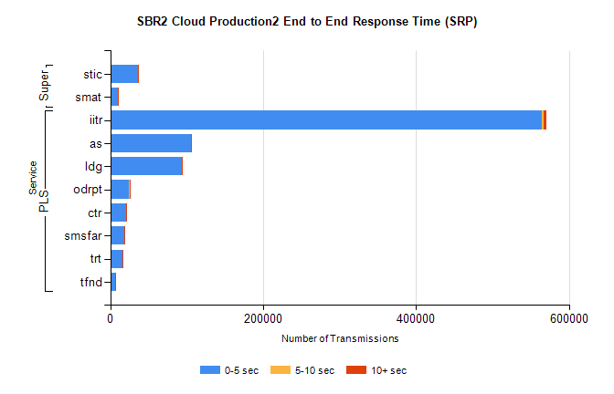
Stream | Service | 0-5 sec | 5-10 sec | >10 sec | Total | % within 5 sec timing target
PLS | iitr | 564617 | 2400 | 3388 | 570434 | 99.0%
PLS | as | 105714 | 243 | 431 | 106412 | 99.3%
PLS | ldg | 93806 | 94 | 85 | 94046 | 99.7%
PLS | odrpt | 24470 | 794 | 146 | 25427 | 96.2%
PLS | ctr | 20900 | 102 | 112 | 21116 | 99.0%
PLS | smsfar | 17890 | 80 | 94 | 18064 | 99.0%
PLS | trt | 15629 | 82 | 73 | 15784 | 99.0%
PLS | tfnd | 6947 | 22 | 47 | 7017 | 99.0%
Super | stic | 35809 | 206 | 185 | 36205 | 98.9%
Super | smat | 9857 | 120 | 89 | 10067 | 97.9%

SBR2 Cloud Production2 - Bulk or Batch Requests (BBRP)

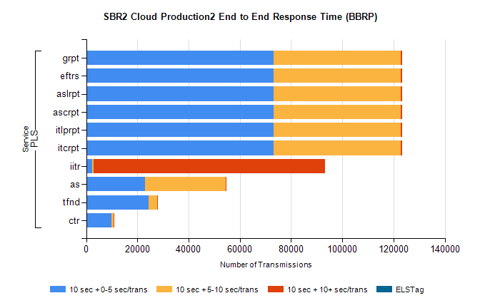
Stream | Service | 10 sec + 0-5 sec /trans | 10 sec + 5-10 sec /trans | 10 sec + >10 sec /trans | Processing Incomplete | ELStag | Total
PLS | itcrpt | 73175 | 49563 | 698 | 17 | 0 | 125706
PLS | itlprpt | 73175 | 49563 | 698 | 17 | 0 | 125706
PLS | ascrpt | 73175 | 49563 | 698 | 17 | 0 | 125706
PLS | aslrpt | 73175 | 49563 | 698 | 17 | 0 | 125706
PLS | eftrs | 73175 | 49563 | 698 | 17 | 0 | 125706
PLS | grpt | 73175 | 49563 | 698 | 17 | 0 | 125706
PLS | iitr | 2232 | 559 | 90450 | 301 | 0 | 97186
PLS | as | 22990 | 31480 | 144 | 147 | 0 | 55258
PLS | tfnd | 24389 | 3312 | 61 | 2243 | 0 | 30240
PLS | ctr | 9850 | 799 | 20 | 23 | 0 | 10793

SBR2 Cloud Production2 - ...

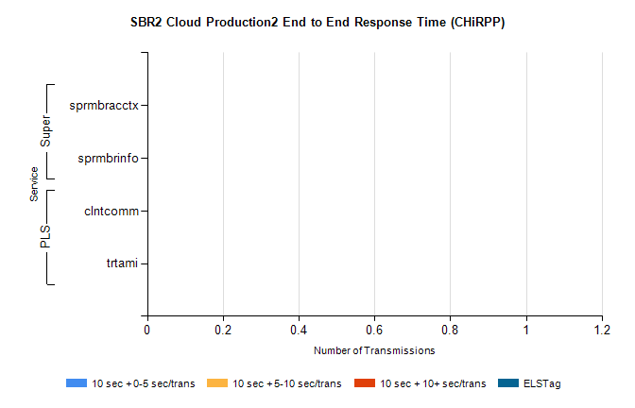
Stream | Service | 10 sec + 0-5 sec /trans | 10 sec + 5-10 sec /trans | 10 sec + >10 sec /trans | Total | % within 5 sec timing target
PLS | clntcomm | 0 | 0 | 0 | 8701 | 0.0%
PLS | trtami | 0 | 0 | 0 | 47 | 0.0%
Super | sprmbracctx | 0 | 0 | 0 | 3080 | 0.0%
Super | sprmbrinfo | 0 | 0 | 0 | 2583 | 0.0%

SBR1 Production Transactions

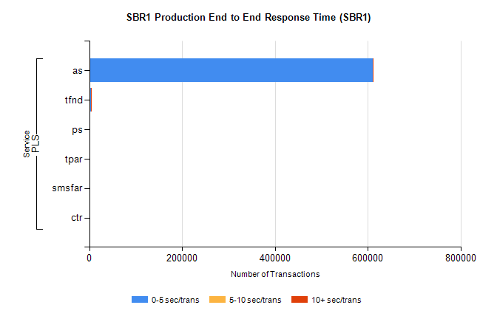
Stream | Service | 0-5 sec/trans | 5-10 sec/trans | 10+ sec/trans | Total | % within 5 sec timing target
PLS | as | 610709 | 204 | 419 | 611332 | 99.9%
PLS | tfnd | 3543 | 937 | 104 | 4584 | 77.3%
PLS | ps | 88 | 119 | 192 | 399 | 22.1%
PLS | tpar | 152 |  |  | 152 | 100.0%
PLS | smsfar | 24 | 31 |  | 55 | 43.6%
PLS | ctr |  |  | 1 | 1 | 0.0%

