Transmission Timings Report Week - 39
25/09/2023 - 1/10/2023

SBR2 External Vendor Testing Environment (EVTE3)

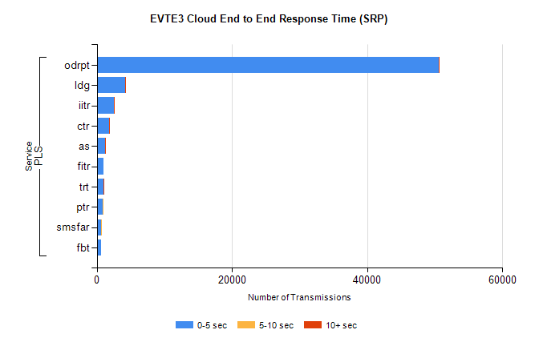
Stream | Service | 0-5 sec | 5-10 sec | >10 sec | Total | % within 5 sec timing target
PLS | odrpt | 50545 | 36 | 18 | 50612 | 99.9%
PLS | ldg | 4167 | 7 | 7 | 4182 | 99.6%
PLS | iitr | 2524 | 23 | 14 | 2565 | 98.4%
PLS | ctr | 1865 | 12 | 2 | 1933 | 96.5%
PLS | as | 1190 | 7 | 5 | 1220 | 97.5%
PLS | fitr | 1023 | 0 | 0 | 1023 | 100.0%
PLS | trt | 954 | 4 | 1 | 961 | 99.3%
PLS | ptr | 848 | 2 | 0 | 850 | 99.8%
PLS | smsfar | 683 | 2 | 0 | 685 | 99.7%
PLS | fbt | 628 | 0 | 0 | 630 | 99.7%

SBR2 External Vendor Testing Environment (EVTE3)

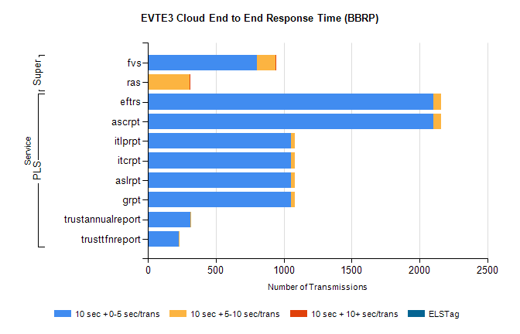
Stream | Service | 10 sec + 0-5 sec /trans | 10 sec + 5-10 sec /trans | 10 sec + >10 sec /trans | Processing Incomplete | ELStag | Total
PLS | ascrpt | 2104 | 58 | 0 | 26 | 0 | 2190
PLS | eftrs | 2104 | 58 | 0 | 26 | 0 | 2190
PLS | grpt | 1052 | 29 | 0 | 13 | 0 | 1095
PLS | aslrpt | 1052 | 29 | 0 | 13 | 0 | 1095
PLS | itcrpt | 1052 | 29 | 0 | 13 | 0 | 1095
PLS | itlprpt | 1052 | 29 | 0 | 13 | 0 | 1095
PLS | trustannualreport | 313 | 5 | 0 | 0 | 0 | 318
PLS | trusttfnreport | 227 | 4 | 0 | 0 | 0 | 231
Super | fvs | 802 | 139 | 2 | 499 | 0 | 1444
Super | ras | 0 | 305 | 3 | 0 | 0 | 489

