Transmission Timings Report Week - 39
25/09/2023 - 1/10/2023

SBR2 Cloud Production2 - Single Requests (SRP)

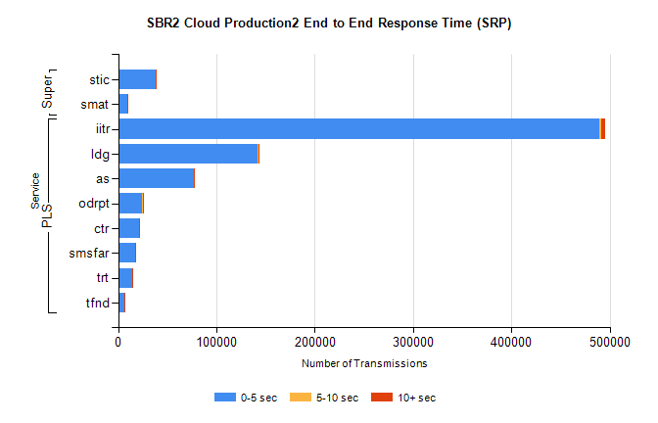
Stream | Service | 0-5 sec | 5-10 sec | >10 sec | Total | % within 5 sec timing target
PLS | iitr | 489521 | 2166 | 3588 | 495357 | 98.8%
PLS | ldg | 142183 | 191 | 278 | 142740 | 99.6%
PLS | as | 76754 | 266 | 526 | 77559 | 99.0%
PLS | odrpt | 24468 | 663 | 392 | 25527 | 95.9%
PLS | ctr | 21104 | 90 | 126 | 21323 | 99.0%
PLS | smsfar | 16979 | 94 | 136 | 17215 | 98.6%
PLS | trt | 14754 | 78 | 107 | 14939 | 98.8%
PLS | tfnd | 6567 | 36 | 48 | 6651 | 98.7%
Super | stic | 38324 | 188 | 280 | 38794 | 98.8%
Super | smat | 9003 | 122 | 114 | 9240 | 97.4%

SBR2 Cloud Production2 - Bulk or Batch Requests (BBRP)

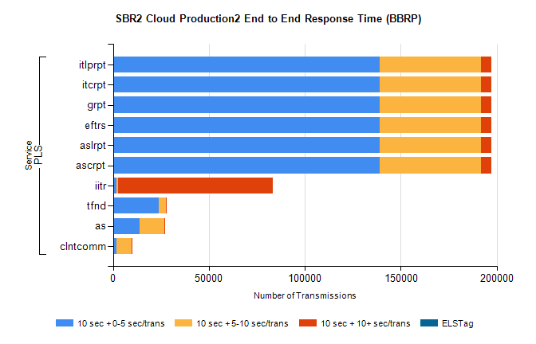
Stream | Service | 10 sec + 0-5 sec /trans | 10 sec + 5-10 sec /trans | 10 sec + >10 sec /trans | Processing Incomplete | ELStag | Total
PLS | ascrpt | 139064 | 52919 | 5321 | 50 | 0 | 203570
PLS | aslrpt | 139064 | 52919 | 5321 | 50 | 0 | 203570
PLS | eftrs | 139064 | 52919 | 5321 | 50 | 0 | 203570
PLS | grpt | 139064 | 52919 | 5321 | 50 | 0 | 203570
PLS | itcrpt | 139064 | 52919 | 5321 | 50 | 0 | 203570
PLS | itlprpt | 139064 | 52919 | 5321 | 50 | 0 | 203570
PLS | iitr | 1907 | 600 | 80964 | 282 | 0 | 87163
PLS | tfnd | 23871 | 3679 | 103 | 2247 | 0 | 30181
PLS | as | 13788 | 13008 | 143 | 130 | 0 | 27315
PLS | clntcomm | 1730 | 7850 | 157 | 2 | 0 | 10004

SBR2 Cloud Production2 - ...

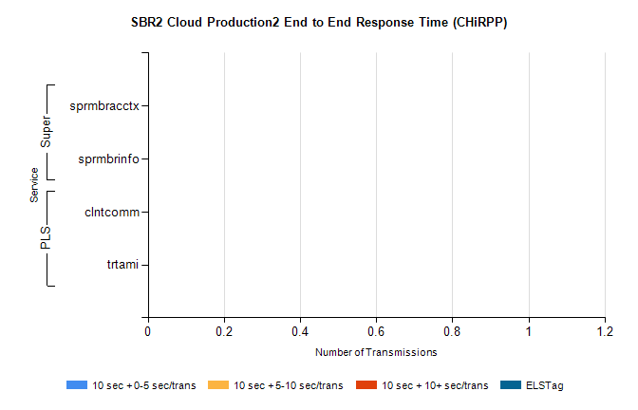
Stream | Service | 10 sec + 0-5 sec /trans | 10 sec + 5-10 sec /trans | 10 sec + >10 sec /trans | Total | % within 5 sec timing target
PLS | clntcomm | 0 | 0 | 0 | 7469 | 0.0%
PLS | trtami | 0 | 0 | 0 | 59 | 0.0%
Super | sprmbracctx | 0 | 0 | 0 | 3717 | 0.0%
Super | sprmbrinfo | 0 | 0 | 0 | 2533 | 0.0%

SBR1 Production Transactions

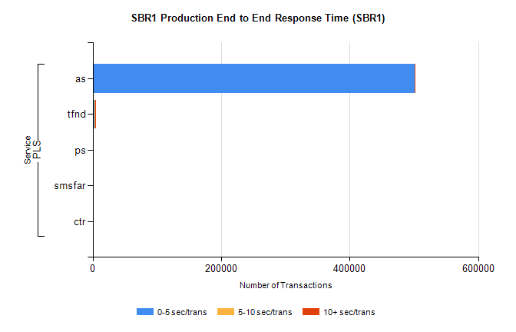
Stream | Service | 0-5 sec/trans | 5-10 sec/trans | 10+ sec/trans | Total | % within 5 sec timing target
PLS | as | 501575 | 175 | 662 | 502412 | 99.8%
PLS | tfnd | 3108 | 890 | 96 | 4094 | 75.9%
PLS | ps | 54 | 111 | 175 | 340 | 15.9%
PLS | smsfar | 8 | 19 |  | 27 | 29.6%
PLS | ctr |  |  | 2 | 2 | 0.0%

