Transmission Timings Report Week - 40
2/10/2023 - 8/10/2023

SBR2 External Vendor Testing Environment (EVTE3)

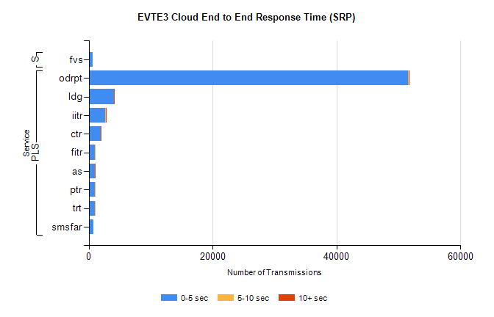
Stream | Service | 0-5 sec | 5-10 sec | >10 sec | Total | % within 5 sec timing target
PLS | odrpt | 51580 | 36 | 16 | 51639 | 99.9%
PLS | ldg | 4111 | 7 | 6 | 4124 | 99.7%
PLS | iitr | 2698 | 27 | 18 | 2761 | 97.7%
PLS | ctr | 1936 | 15 | 2 | 2002 | 96.7%
PLS | fitr | 1050 | 5 | 0 | 1056 | 99.4%
PLS | as | 1007 | 5 | 6 | 1032 | 97.6%
PLS | ptr | 995 | 2 | 0 | 998 | 99.7%
PLS | trt | 966 | 2 | 0 | 969 | 99.7%
PLS | smsfar | 815 | 0 | 0 | 815 | 100.0%
Super | fvs | 682 | 0 | 0 | 682 | 100.0%

SBR2 External Vendor Testing Environment (EVTE3)

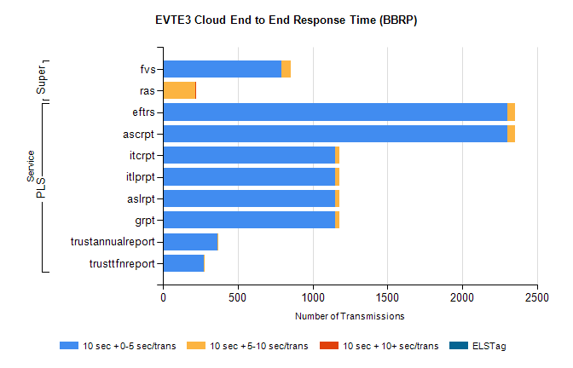
Stream | Service | 10 sec + 0-5 sec /trans | 10 sec + 5-10 sec /trans | 10 sec + >10 sec /trans | Processing Incomplete | ELStag | Total
PLS | ascrpt | 2300 | 56 | 0 | 0 | 0 | 2358
PLS | eftrs | 2300 | 56 | 0 | 0 | 0 | 2358
PLS | grpt | 1150 | 28 | 0 | 0 | 0 | 1179
PLS | aslrpt | 1150 | 28 | 0 | 0 | 0 | 1179
PLS | itlprpt | 1150 | 28 | 0 | 0 | 0 | 1179
PLS | itcrpt | 1150 | 28 | 0 | 0 | 0 | 1179
PLS | trustannualreport | 364 | 1 | 0 | 0 | 0 | 365
PLS | trusttfnreport | 274 | 4 | 0 | 0 | 0 | 278
Super | fvs | 791 | 61 | 0 | 428 | 0 | 1281
Super | ras | 0 | 219 | 1 | 0 | 0 | 407

