Transmission Timings Report Week - 40
2/10/2023 - 8/10/2023

SBR2 Cloud Production2 - Single Requests (SRP)

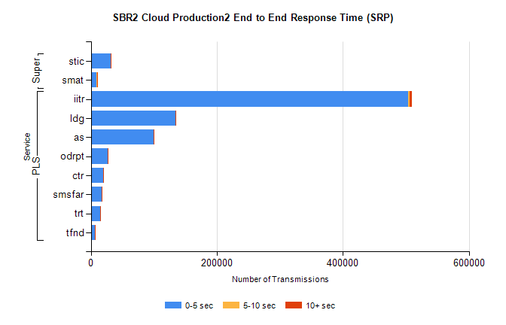
Stream | Service | 0-5 sec | 5-10 sec | >10 sec | Total | % within 5 sec timing target
PLS | iitr | 503378 | 2181 | 4129 | 509811 | 98.7%
PLS | ldg | 133796 | 178 | 292 | 134292 | 99.6%
PLS | as | 99795 | 292 | 483 | 100591 | 99.2%
PLS | odrpt | 26281 | 878 | 262 | 27421 | 95.8%
PLS | ctr | 19180 | 90 | 145 | 19419 | 98.8%
PLS | smsfar | 16837 | 82 | 119 | 17041 | 98.8%
PLS | trt | 15201 | 70 | 94 | 15366 | 98.9%
PLS | tfnd | 5909 | 30 | 64 | 6006 | 98.4%
Super | stic | 31508 | 179 | 270 | 31960 | 98.6%
Super | smat | 9408 | 117 | 102 | 9629 | 97.7%

SBR2 Cloud Production2 - Bulk or Batch Requests (BBRP)

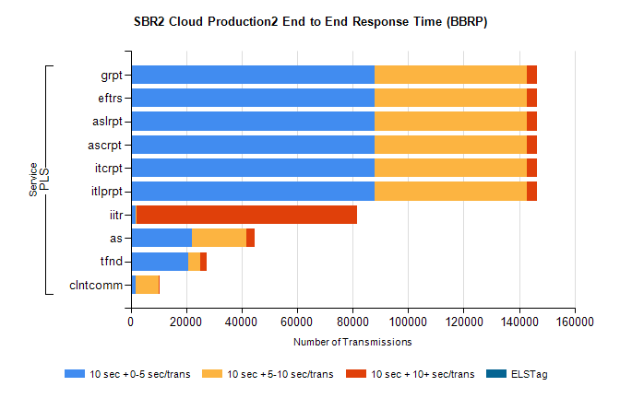
Stream | Service | 10 sec + 0-5 sec /trans | 10 sec + 5-10 sec /trans | 10 sec + >10 sec /trans | Processing Incomplete | ELStag | Total
PLS | itlprpt | 87813 | 54847 | 3690 | 21 | 0 | 149524
PLS | itcrpt | 87813 | 54847 | 3690 | 21 | 0 | 149524
PLS | ascrpt | 87813 | 54847 | 3690 | 21 | 0 | 149524
PLS | aslrpt | 87813 | 54847 | 3690 | 21 | 0 | 149524
PLS | eftrs | 87813 | 54847 | 3690 | 21 | 0 | 149524
PLS | grpt | 87813 | 54847 | 3690 | 21 | 0 | 149524
PLS | iitr | 1650 | 360 | 79543 | 429 | 0 | 83666
PLS | as | 21931 | 19849 | 2790 | 80 | 0 | 45067
PLS | tfnd | 20612 | 4366 | 2368 | 2173 | 0 | 29838
PLS | clntcomm | 1708 | 8312 | 31 | 0 | 0 | 10226

SBR2 Cloud Production2 - ...

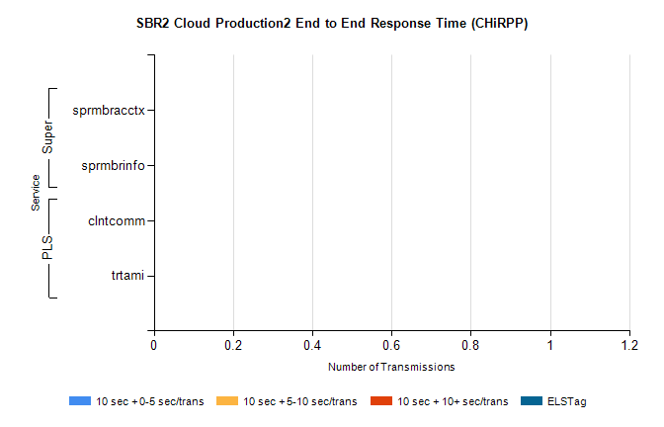
Stream | Service | 10 sec + 0-5 sec /trans | 10 sec + 5-10 sec /trans | 10 sec + >10 sec /trans | Total | % within 5 sec timing target
PLS | clntcomm | 0 | 0 | 0 | 9736 | 0.0%
PLS | trtami | 0 | 0 | 0 | 89 | 0.0%
Super | sprmbracctx | 0 | 0 | 0 | 4005 | 0.0%
Super | sprmbrinfo | 0 | 0 | 0 | 2782 | 0.0%

SBR1 Production Transactions

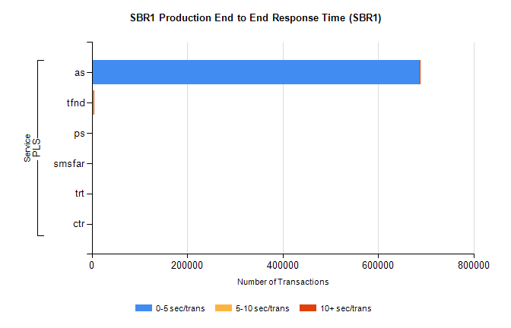
Stream | Service | 0-5 sec/trans | 5-10 sec/trans | 10+ sec/trans | Total | % within 5 sec timing target
PLS | as | 687832 | 176 | 678 | 688686 | 99.9%
PLS | tfnd | 2888 | 926 | 34 | 3848 | 75.1%
PLS | ps | 83 | 102 | 155 | 340 | 24.4%
PLS | smsfar | 80 | 45 | 8 | 133 | 60.2%
PLS | trt | 11 |  | 11 | 22 | 50.0%
PLS | ctr | 7 |  | 6 | 13 | 53.8%

