Transmission Timings Report Week - 41
9/10/2023 - 15/10/2023

SBR2 External Vendor Testing Environment (EVTE3)

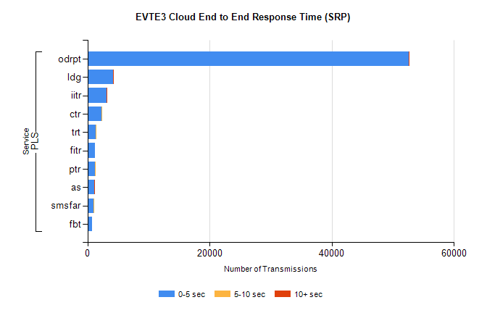
Stream | Service | 0-5 sec | 5-10 sec | >10 sec | Total | % within 5 sec timing target
PLS | odrpt | 52626 | 25 | 20 | 52678 | 99.9%
PLS | ldg | 4199 | 6 | 5 | 4224 | 99.4%
PLS | iitr | 3100 | 26 | 12 | 3144 | 98.6%
PLS | ctr | 2283 | 6 | 0 | 2349 | 97.2%
PLS | trt | 1406 | 10 | 0 | 1421 | 98.9%
PLS | fitr | 1263 | 0 | 0 | 1265 | 99.8%
PLS | ptr | 1235 | 2 | 0 | 1242 | 99.4%
PLS | as | 1060 | 4 | 4 | 1103 | 96.1%
PLS | smsfar | 1047 | 3 | 0 | 1050 | 99.7%
PLS | fbt | 789 | 0 | 0 | 789 | 100.0%

SBR2 External Vendor Testing Environment (EVTE3)

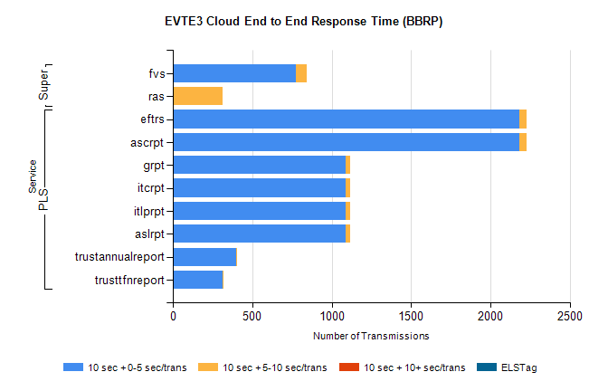
Stream | Service | 10 sec + 0-5 sec /trans | 10 sec + 5-10 sec /trans | 10 sec + >10 sec /trans | Processing Incomplete | ELStag | Total
PLS | ascrpt | 2180 | 50 | 0 | 0 | 0 | 2234
PLS | eftrs | 2180 | 50 | 0 | 0 | 0 | 2234
PLS | aslrpt | 1090 | 25 | 0 | 0 | 0 | 1117
PLS | itlprpt | 1090 | 25 | 0 | 0 | 0 | 1117
PLS | itcrpt | 1090 | 25 | 0 | 0 | 0 | 1117
PLS | grpt | 1090 | 25 | 0 | 0 | 0 | 1117
PLS | trustannualreport | 400 | 7 | 0 | 0 | 0 | 407
PLS | trusttfnreport | 314 | 5 | 0 | 0 | 0 | 319
Super | fvs | 773 | 72 | 0 | 423 | 0 | 1268
Super | ras | 1 | 312 | 0 | 0 | 0 | 549

