Transmission Timings Report Week - 41
9/10/2023 - 15/10/2023

SBR2 Cloud Production2 - Single Requests (SRP)

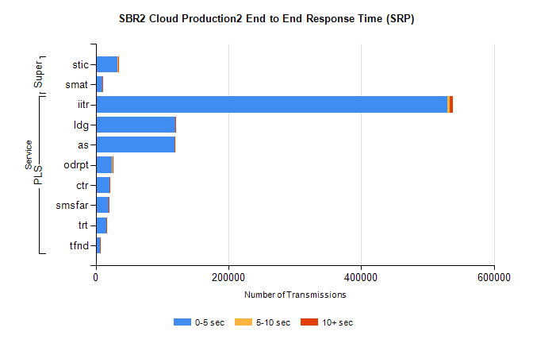
Stream | Service | 0-5 sec | 5-10 sec | >10 sec | Total | % within 5 sec timing target
PLS | iitr | 530329 | 2556 | 4864 | 537815 | 98.6%
PLS | ldg | 119416 | 204 | 182 | 119874 | 99.6%
PLS | as | 118672 | 371 | 662 | 119719 | 99.1%
PLS | odrpt | 24528 | 872 | 480 | 25880 | 94.8%
PLS | ctr | 20361 | 99 | 141 | 20604 | 98.8%
PLS | smsfar | 19377 | 94 | 184 | 19656 | 98.6%
PLS | trt | 16165 | 69 | 122 | 16366 | 98.8%
PLS | tfnd | 7028 | 30 | 58 | 7116 | 98.8%
Super | stic | 33337 | 255 | 556 | 34151 | 97.6%
Super | smat | 9828 | 131 | 99 | 10059 | 97.7%

SBR2 Cloud Production2 - Bulk or Batch Requests (BBRP)

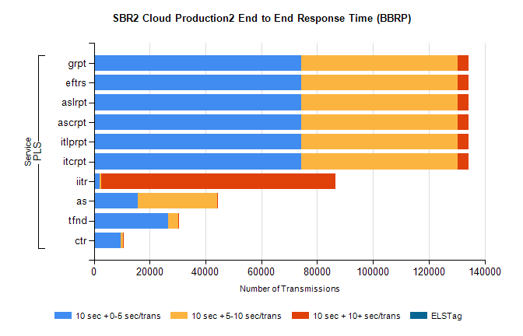
Stream | Service | 10 sec + 0-5 sec /trans | 10 sec + 5-10 sec /trans | 10 sec + >10 sec /trans | Processing Incomplete | ELStag | Total
PLS | itcrpt | 74354 | 55962 | 4017 | 31 | 0 | 137022
PLS | itlprpt | 74354 | 55962 | 4017 | 31 | 0 | 137022
PLS | ascrpt | 74354 | 55962 | 4017 | 31 | 0 | 137022
PLS | aslrpt | 74354 | 55962 | 4017 | 31 | 0 | 137022
PLS | eftrs | 74354 | 55962 | 4017 | 31 | 0 | 137022
PLS | grpt | 74354 | 55962 | 4017 | 31 | 0 | 137022
PLS | iitr | 2039 | 602 | 83917 | 285 | 0 | 90238
PLS | as | 15866 | 28332 | 238 | 129 | 0 | 45009
PLS | tfnd | 26508 | 3708 | 161 | 2299 | 0 | 33097
PLS | ctr | 9616 | 807 | 58 | 21 | 0 | 10564

SBR2 Cloud Production2 - ...

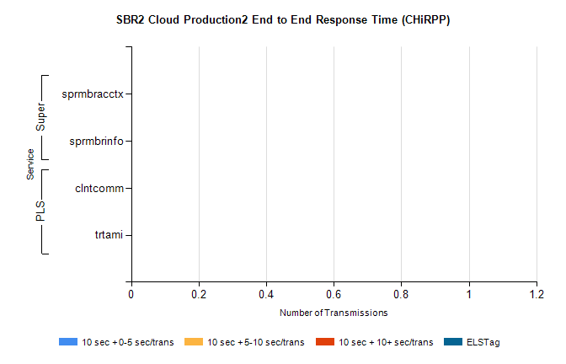
Stream | Service | 10 sec + 0-5 sec /trans | 10 sec + 5-10 sec /trans | 10 sec + >10 sec /trans | Total | % within 5 sec timing target
PLS | clntcomm | 0 | 0 | 0 | 8098 | 0.0%
PLS | trtami | 0 | 0 | 0 | 21 | 0.0%
Super | sprmbracctx | 0 | 0 | 0 | 3906 | 0.0%
Super | sprmbrinfo | 0 | 0 | 0 | 2709 | 0.0%

SBR1 Production Transactions

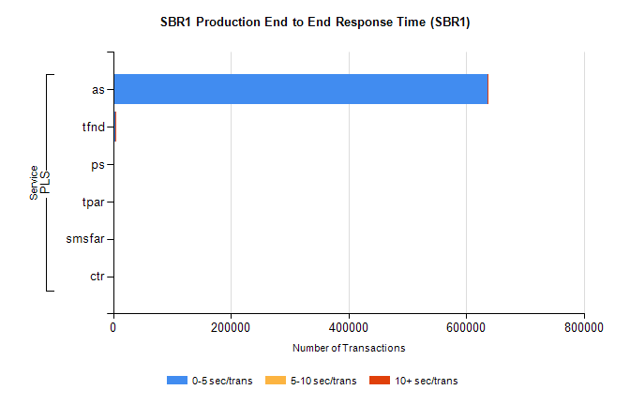
Stream | Service | 0-5 sec/trans | 5-10 sec/trans | 10+ sec/trans | Total | % within 5 sec timing target
PLS | as | 636256 | 290 | 255 | 636801 | 99.9%
PLS | tfnd | 3288 | 942 | 9 | 4239 | 77.6%
PLS | ps | 91 | 121 | 147 | 359 | 25.3%
PLS | tpar | 305 |  |  | 305 | 100.0%
PLS | smsfar | 7 | 18 | 2 | 27 | 25.9%
PLS | ctr |  | 1 | 5 | 6 | 0.0%

