Transmission Timings Report Week - 42
16/10/2023 - 22/10/2023

SBR2 External Vendor Testing Environment (EVTE3)

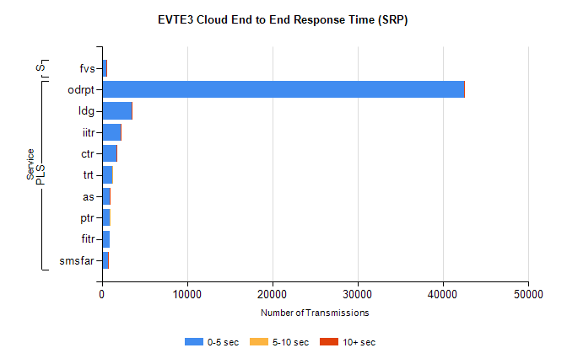
Stream | Service | 0-5 sec | 5-10 sec | >10 sec | Total | % within 5 sec timing target
PLS | odrpt | 42421 | 31 | 4 | 49647 | 85.4%
PLS | ldg | 3525 | 5 | 5 | 4034 | 87.4%
PLS | iitr | 2177 | 21 | 6 | 2232 | 97.5%
PLS | ctr | 1764 | 5 | 1 | 1804 | 97.8%
PLS | trt | 1203 | 6 | 0 | 1236 | 97.3%
PLS | as | 971 | 6 | 3 | 1004 | 96.7%
PLS | ptr | 949 | 3 | 0 | 968 | 98.0%
PLS | fitr | 898 | 0 | 0 | 900 | 99.8%
PLS | smsfar | 701 | 1 | 1 | 705 | 99.4%
Super | fvs | 564 | 1 | 3 | 574 | 98.3%

SBR2 External Vendor Testing Environment (EVTE3)

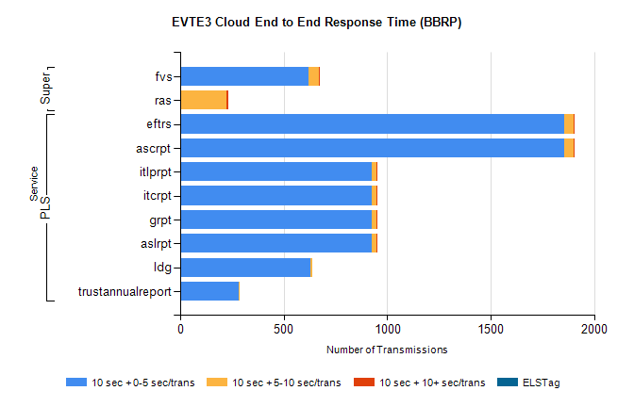
Stream | Service | 10 sec + 0-5 sec /trans | 10 sec + 5-10 sec /trans | 10 sec + >10 sec /trans | Processing Incomplete | ELStag | Total
PLS | ascrpt | 1854 | 46 | 2 | 244 | 0 | 2146
PLS | eftrs | 1854 | 46 | 2 | 244 | 0 | 2146
PLS | aslrpt | 927 | 23 | 1 | 122 | 0 | 1073
PLS | grpt | 927 | 23 | 1 | 122 | 0 | 1073
PLS | itcrpt | 927 | 23 | 1 | 122 | 0 | 1073
PLS | itlprpt | 927 | 23 | 1 | 122 | 0 | 1073
PLS | ldg | 630 | 6 | 0 | 29 | 0 | 665
PLS | trustannualreport | 283 | 4 | 0 | 2 | 0 | 289
Super | fvs | 620 | 52 | 1 | 448 | 0 | 1121
Super | ras | 0 | 224 | 9 | 0 | 0 | 445

