Transmission Timings Report Week - 42
16/10/2023 - 22/10/2023

SBR2 Cloud Production2 - Single Requests (SRP)

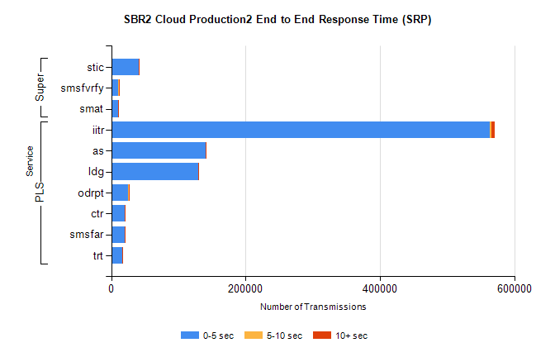
Stream | Service | 0-5 sec | 5-10 sec | >10 sec | Total | % within 5 sec timing target
PLS | iitr | 563696 | 2769 | 4989 | 571467 | 98.6%
PLS | as | 139962 | 673 | 1036 | 141685 | 98.8%
PLS | ldg | 128945 | 211 | 171 | 129338 | 99.7%
PLS | odrpt | 24442 | 1252 | 265 | 25959 | 94.2%
PLS | ctr | 20482 | 83 | 161 | 20726 | 98.8%
PLS | smsfar | 19675 | 113 | 199 | 19987 | 98.4%
PLS | trt | 16135 | 74 | 118 | 16327 | 98.8%
Super | stic | 40947 | 271 | 438 | 41656 | 98.3%
Super | smsfvrfy | 10778 | 121 | 348 | 11249 | 95.8%
Super | smat | 10168 | 143 | 124 | 10435 | 97.4%

SBR2 Cloud Production2 - Bulk or Batch Requests (BBRP)

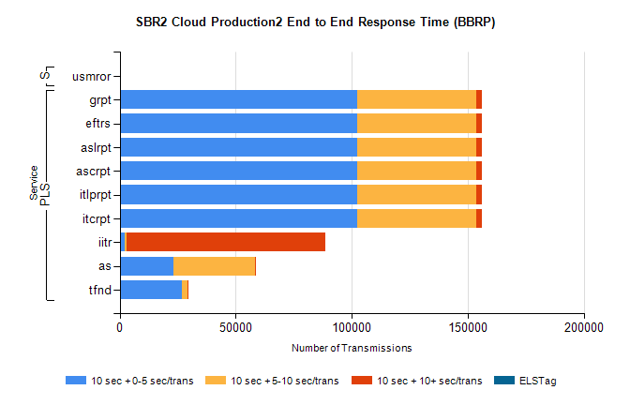
Stream | Service | 10 sec + 0-5 sec /trans | 10 sec + 5-10 sec /trans | 10 sec + >10 sec /trans | Processing Incomplete | ELStag | Total
PLS | itcrpt | 102492 | 51119 | 2428 | 25 | 0 | 158722
PLS | itlprpt | 102492 | 51119 | 2428 | 25 | 0 | 158722
PLS | ascrpt | 102492 | 51119 | 2428 | 25 | 0 | 158722
PLS | aslrpt | 102492 | 51119 | 2428 | 25 | 0 | 158722
PLS | eftrs | 102492 | 51119 | 2428 | 25 | 0 | 158722
PLS | grpt | 102492 | 51119 | 2428 | 25 | 0 | 158722
PLS | iitr | 2099 | 779 | 85751 | 343 | 0 | 92346
PLS | as | 23260 | 35239 | 407 | 99 | 0 | 59618
PLS | tfnd | 26833 | 2411 | 130 | 2282 | 0 | 31907
Super | usmror | 0 | 0 | 0 | 15416 | 0 | 15416

SBR2 Cloud Production2 - ...

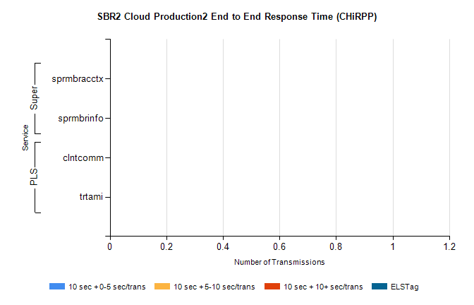
Stream | Service | 10 sec + 0-5 sec /trans | 10 sec + 5-10 sec /trans | 10 sec + >10 sec /trans | Total | % within 5 sec timing target
PLS | clntcomm | 0 | 0 | 0 | 8350 | 0.0%
PLS | trtami | 0 | 0 | 0 | 50 | 0.0%
Super | sprmbracctx | 0 | 0 | 0 | 4535 | 0.0%
Super | sprmbrinfo | 0 | 0 | 0 | 2870 | 0.0%

SBR1 Production Transactions

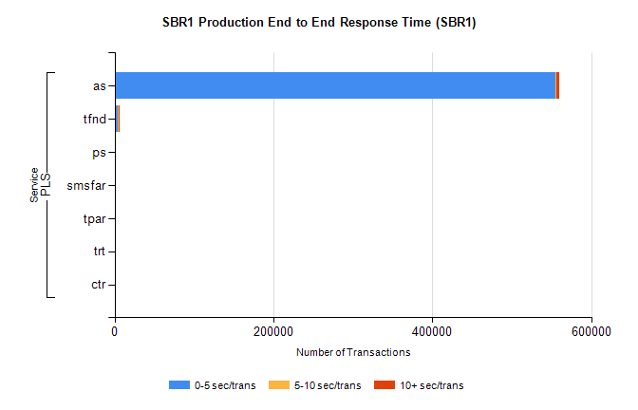
Stream | Service | 0-5 sec/trans | 5-10 sec/trans | 10+ sec/trans | Total | % within 5 sec timing target
PLS | as | 555436 | 315 | 3522 | 559273 | 99.3%
PLS | tfnd | 4228 | 889 | 36 | 5153 | 82.0%
PLS | ps | 52 | 91 | 178 | 321 | 16.2%
PLS | smsfar | 22 | 40 | 5 | 67 | 32.8%
PLS | tpar | 55 |  |  | 55 | 100.0%
PLS | trt |  | 1 | 1 | 2 | 0.0%
PLS | ctr |  |  | 1 | 1 | 0.0%

