Transmission Timings Report Week - 44
30/10/2023 - 5/11/2023

SBR2 External Vendor Testing Environment (EVTE3)

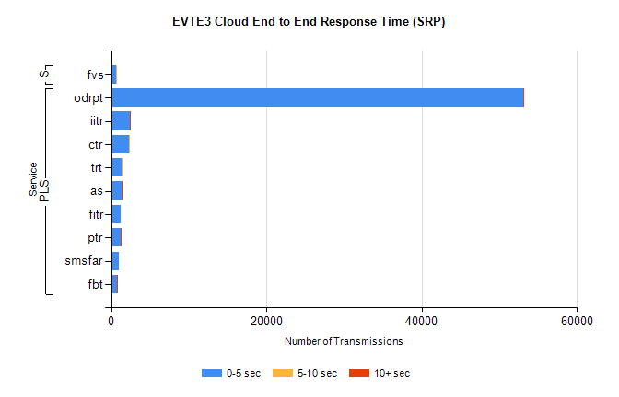
Stream | Service | 0-5 sec | 5-10 sec | >10 sec | Total | % within 5 sec timing target
PLS | odrpt | 53040 | 79 | 13 | 53158 | 99.8%
PLS | iitr | 2435 | 23 | 17 | 2478 | 98.3%
PLS | ctr | 2291 | 16 | 0 | 2319 | 98.8%
PLS | trt | 1379 | 9 | 0 | 1407 | 98.0%
PLS | as | 1301 | 9 | 13 | 1361 | 95.6%
PLS | fitr | 1205 | 0 | 0 | 1205 | 100.0%
PLS | ptr | 1179 | 3 | 2 | 1186 | 99.4%
PLS | smsfar | 976 | 0 | 0 | 976 | 100.0%
PLS | fbt | 763 | 2 | 1 | 775 | 98.5%
Super | fvs | 675 | 3 | 0 | 678 | 99.6%

SBR2 External Vendor Testing Environment (EVTE3)

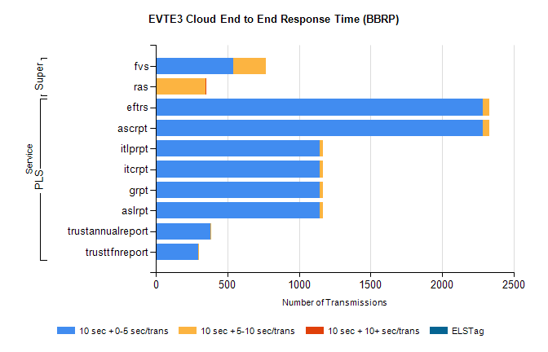
Stream | Service | 10 sec + 0-5 sec /trans | 10 sec + 5-10 sec /trans | 10 sec + >10 sec /trans | Processing Incomplete | ELStag | Total
PLS | ascrpt | 2286 | 46 | 0 | 0 | 0 | 2332
PLS | eftrs | 2286 | 46 | 0 | 0 | 0 | 2332
PLS | aslrpt | 1143 | 23 | 0 | 0 | 0 | 1166
PLS | grpt | 1143 | 23 | 0 | 0 | 0 | 1166
PLS | itcrpt | 1143 | 23 | 0 | 0 | 0 | 1166
PLS | itlprpt | 1143 | 23 | 0 | 0 | 0 | 1166
PLS | trustannualreport | 383 | 4 | 0 | 0 | 0 | 387
PLS | trusttfnreport | 296 | 6 | 0 | 0 | 0 | 303
Super | fvs | 544 | 224 | 0 | 337 | 0 | 1110
Super | ras | 0 | 350 | 2 | 0 | 0 | 462

