Transmission Timings Report Week - 44
30/10/2023 - 5/11/2023

SBR2 Cloud Production2 - Single Requests (SRP)

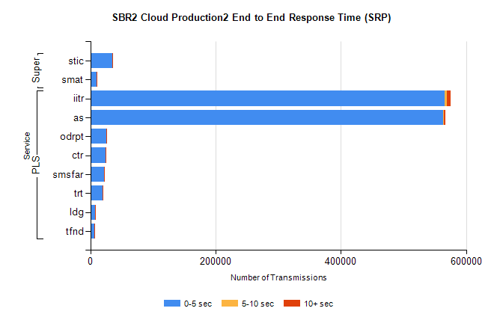
Stream | Service | 0-5 sec | 5-10 sec | >10 sec | Total | % within 5 sec timing target
PLS | iitr | 565826 | 3722 | 5261 | 574852 | 98.4%
PLS | as | 563279 | 1397 | 2277 | 567004 | 99.3%
PLS | odrpt | 25111 | 858 | 377 | 26347 | 95.3%
PLS | ctr | 24080 | 103 | 203 | 24388 | 98.7%
PLS | smsfar | 22122 | 137 | 188 | 22447 | 98.6%
PLS | trt | 19870 | 94 | 148 | 20117 | 98.8%
PLS | ldg | 7359 | 19 | 28 | 7406 | 99.4%
PLS | tfnd | 7059 | 25 | 62 | 7146 | 98.8%
Super | stic | 35350 | 182 | 416 | 35948 | 98.3%
Super | smat | 9723 | 139 | 139 | 10001 | 97.2%

SBR2 Cloud Production2 - Bulk or Batch Requests (BBRP)

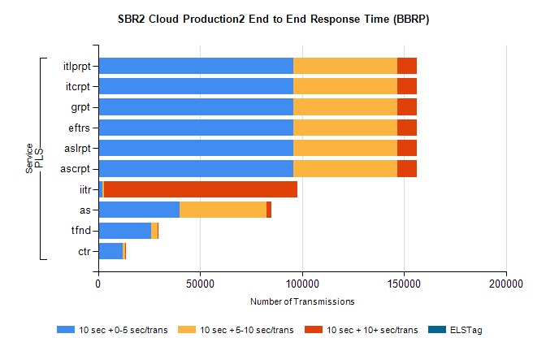
Stream | Service | 10 sec + 0-5 sec /trans | 10 sec + 5-10 sec /trans | 10 sec + >10 sec /trans | Processing Incomplete | ELStag | Total
PLS | ascrpt | 95612 | 51305 | 9300 | 25 | 0 | 162329
PLS | aslrpt | 95612 | 51305 | 9300 | 25 | 0 | 162329
PLS | eftrs | 95612 | 51305 | 9300 | 25 | 0 | 162329
PLS | grpt | 95612 | 51305 | 9300 | 25 | 0 | 162329
PLS | itcrpt | 95612 | 51305 | 9300 | 25 | 0 | 162329
PLS | itlprpt | 95612 | 51305 | 9300 | 25 | 0 | 162329
PLS | iitr | 2221 | 673 | 94787 | 509 | 0 | 102092
PLS | as | 40042 | 42713 | 2089 | 227 | 0 | 86347
PLS | tfnd | 25976 | 3223 | 543 | 2249 | 0 | 32348
PLS | ctr | 11931 | 1192 | 301 | 67 | 0 | 13646

SBR2 Cloud Production2 - ...

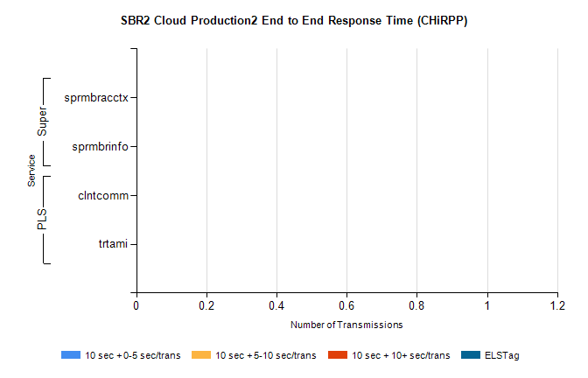
Stream | Service | 10 sec + 0-5 sec /trans | 10 sec + 5-10 sec /trans | 10 sec + >10 sec /trans | Total | % within 5 sec timing target
PLS | clntcomm | 0 | 0 | 0 | 8538 | 0.0%
PLS | trtami | 0 | 0 | 0 | 24 | 0.0%
Super | sprmbracctx | 0 | 0 | 0 | 4594 | 0.0%
Super | sprmbrinfo | 0 | 0 | 0 | 2525 | 0.0%

SBR1 Production Transactions

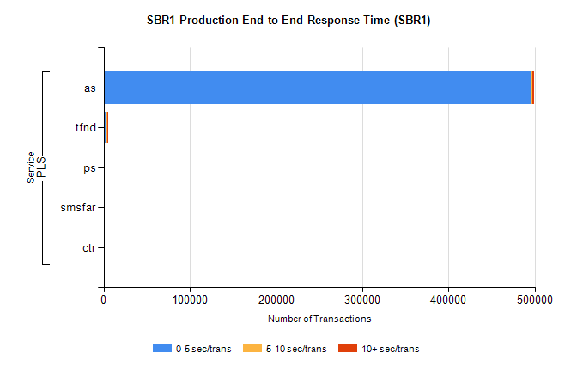
Stream | Service | 0-5 sec/trans | 5-10 sec/trans | 10+ sec/trans | Total | % within 5 sec timing target
PLS | as | 495813 | 1664 | 2180 | 499657 | 99.2%
PLS | tfnd | 3158 | 878 | 142 | 4178 | 75.6%
PLS | ps | 65 | 75 | 186 | 326 | 19.9%
PLS | smsfar | 16 | 27 | 4 | 47 | 34.0%
PLS | ctr | 2 |  | 3 | 5 | 40.0%

