Transmission Timings Report Week - 47
20/11/2023 - 26/11/2023

SBR2 External Vendor Testing Environment (EVTE3)

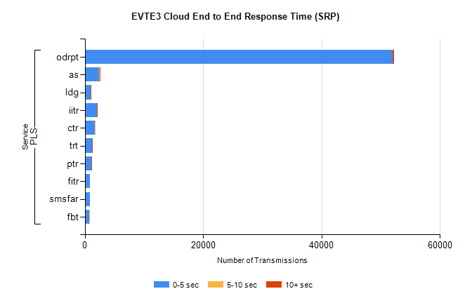
Stream | Service | 0-5 sec | 5-10 sec | >10 sec | Total | % within 5 sec timing target
PLS | odrpt | 51997 | 73 | 161 | 52271 | 99.5%
PLS | as | 2481 | 5 | 10 | 2536 | 97.8%
PLS | ldg | 942 | 9 | 6 | 2353 | 40.0%
PLS | iitr | 2090 | 15 | 15 | 2121 | 98.5%
PLS | ctr | 1726 | 7 | 0 | 1763 | 97.9%
PLS | trt | 1194 | 5 | 1 | 1208 | 98.8%
PLS | ptr | 1066 | 4 | 1 | 1075 | 99.2%
PLS | fitr | 916 | 0 | 0 | 936 | 97.9%
PLS | smsfar | 829 | 0 | 0 | 829 | 100.0%
PLS | fbt | 707 | 4 | 0 | 738 | 95.8%

SBR2 External Vendor Testing Environment (EVTE3)

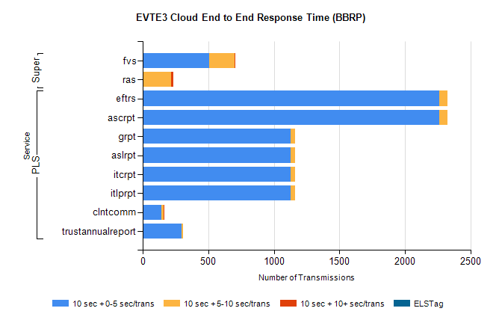
Stream | Service | 10 sec + 0-5 sec /trans | 10 sec + 5-10 sec /trans | 10 sec + >10 sec /trans | Processing Incomplete | ELStag | Total
PLS | ascrpt | 2260 | 66 | 0 | 24 | 0 | 2352
PLS | eftrs | 2260 | 66 | 0 | 24 | 0 | 2352
PLS | itlprpt | 1130 | 33 | 0 | 12 | 0 | 1176
PLS | itcrpt | 1130 | 33 | 0 | 12 | 0 | 1176
PLS | aslrpt | 1130 | 33 | 0 | 12 | 0 | 1176
PLS | grpt | 1130 | 33 | 0 | 12 | 0 | 1176
PLS | clntcomm | 141 | 21 | 1 | 140 | 0 | 313
PLS | trustannualreport | 299 | 10 | 0 | 0 | 0 | 309
Super | fvs | 505 | 197 | 1 | 289 | 0 | 997
Super | ras | 0 | 217 | 16 | 0 | 0 | 372

