Transmission Timings Report Week - 47
20/11/2023 - 26/11/2023

SBR2 Cloud Production2 - Single Requests (SRP)

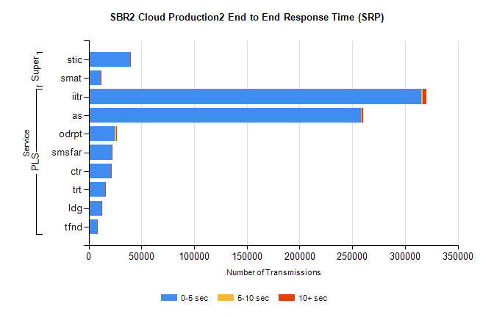
Stream | Service | 0-5 sec | 5-10 sec | >10 sec | Total | % within 5 sec timing target
PLS | iitr | 315174 | 1741 | 3430 | 320352 | 98.4%
PLS | as | 258030 | 792 | 1731 | 260588 | 99.0%
PLS | odrpt | 24734 | 1092 | 469 | 26295 | 94.1%
PLS | smsfar | 21950 | 144 | 220 | 22314 | 98.4%
PLS | ctr | 21058 | 107 | 183 | 21348 | 98.6%
PLS | trt | 15774 | 81 | 103 | 15958 | 98.8%
PLS | ldg | 11940 | 44 | 32 | 12016 | 99.4%
PLS | tfnd | 8189 | 34 | 72 | 8295 | 98.7%
Super | stic | 39423 | 200 | 351 | 39974 | 98.6%
Super | smat | 11594 | 141 | 182 | 11917 | 97.3%

SBR2 Cloud Production2 - Bulk or Batch Requests (BBRP)

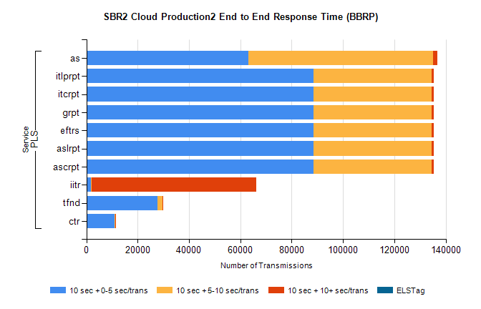
Stream | Service | 10 sec + 0-5 sec /trans | 10 sec + 5-10 sec /trans | 10 sec + >10 sec /trans | Processing Incomplete | ELStag | Total
PLS | as | 63099 | 71929 | 1618 | 270 | 0 | 138478
PLS | ascrpt | 88642 | 45773 | 1043 | 24 | 0 | 137276
PLS | aslrpt | 88642 | 45773 | 1043 | 24 | 0 | 137276
PLS | eftrs | 88642 | 45773 | 1043 | 24 | 0 | 137276
PLS | grpt | 88642 | 45773 | 1043 | 24 | 0 | 137276
PLS | itcrpt | 88642 | 45773 | 1043 | 24 | 0 | 137276
PLS | itlprpt | 88642 | 45773 | 1043 | 24 | 0 | 137276
PLS | iitr | 1660 | 307 | 64286 | 240 | 0 | 68371
PLS | tfnd | 27747 | 1857 | 254 | 2497 | 0 | 32631
PLS | ctr | 10962 | 427 | 113 | 11 | 0 | 11623

SBR2 Cloud Production2 - ...

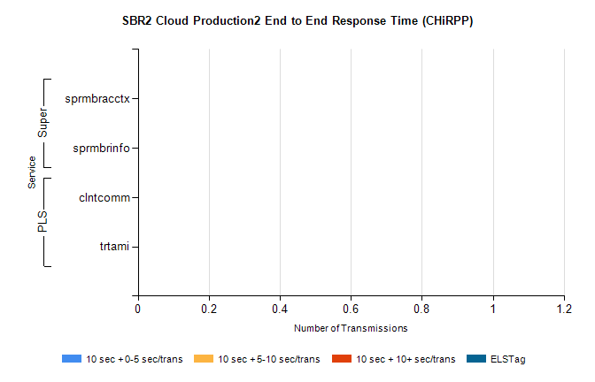
Stream | Service | 10 sec + 0-5 sec /trans | 10 sec + 5-10 sec /trans | 10 sec + >10 sec /trans | Total | % within 5 sec timing target
PLS | clntcomm | 0 | 0 | 0 | 8626 | 0.0%
PLS | trtami | 0 | 0 | 0 | 22 | 0.0%
Super | sprmbracctx | 0 | 0 | 0 | 2997 | 0.0%
Super | sprmbrinfo | 0 | 0 | 0 | 2826 | 0.0%

SBR1 Production Transactions

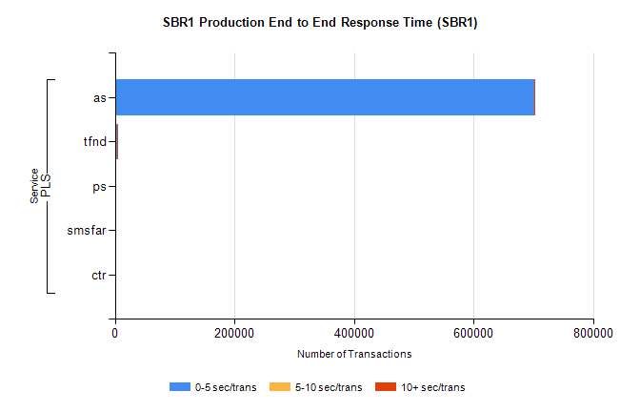
Stream | Service | 0-5 sec/trans | 5-10 sec/trans | 10+ sec/trans | Total | % within 5 sec timing target
PLS | as | 701143 | 505 | 2166 | 703814 | 99.6%
PLS | tfnd | 3325 | 1014 | 33 | 4372 | 76.1%
PLS | ps | 39 | 50 | 155 | 244 | 16.0%
PLS | smsfar | 17 | 67 | 10 | 94 | 18.1%
PLS | ctr |  |  | 1 | 1 | 0.0%

