Transmission Timings Report Week - 43
23/10/2023 - 29/10/2023

SBR2 External Vendor Testing Environment (EVTE3)

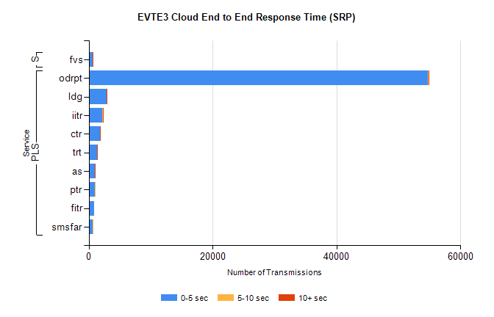
Stream | Service | 0-5 sec | 5-10 sec | >10 sec | Total | % within 5 sec timing target
PLS | odrpt | 54730 | 124 | 28 | 54891 | 99.7%
PLS | ldg | 2929 | 7 | 6 | 2943 | 99.5%
PLS | iitr | 2228 | 22 | 7 | 2259 | 98.6%
PLS | ctr | 1843 | 6 | 1 | 1872 | 98.5%
PLS | trt | 1334 | 4 | 2 | 1359 | 98.2%
PLS | as | 990 | 4 | 5 | 1037 | 95.5%
PLS | ptr | 997 | 1 | 0 | 1003 | 99.4%
PLS | fitr | 887 | 0 | 0 | 890 | 99.7%
PLS | smsfar | 681 | 1 | 0 | 682 | 99.9%
Super | fvs | 600 | 1 | 1 | 602 | 99.7%

SBR2 External Vendor Testing Environment (EVTE3)

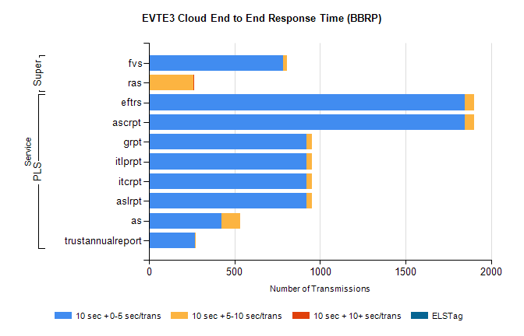
Stream | Service | 10 sec + 0-5 sec /trans | 10 sec + 5-10 sec /trans | 10 sec + >10 sec /trans | Processing Incomplete | ELStag | Total
PLS | ascrpt | 1846 | 56 | 0 | 0 | 0 | 1902
PLS | eftrs | 1846 | 56 | 0 | 0 | 0 | 1902
PLS | aslrpt | 923 | 28 | 0 | 0 | 0 | 951
PLS | itcrpt | 923 | 28 | 0 | 0 | 0 | 951
PLS | itlprpt | 923 | 28 | 0 | 0 | 0 | 951
PLS | grpt | 923 | 28 | 0 | 0 | 0 | 951
PLS | as | 425 | 107 | 0 | 24 | 0 | 564
PLS | trustannualreport | 267 | 7 | 0 | 0 | 0 | 274
Super | fvs | 783 | 24 | 0 | 352 | 0 | 1160
Super | ras | 0 | 262 | 2 | 0 | 0 | 377

