Transmission Timings Report Week - 43
23/10/2023 - 29/10/2023

SBR2 Cloud Production2 - Single Requests (SRP)

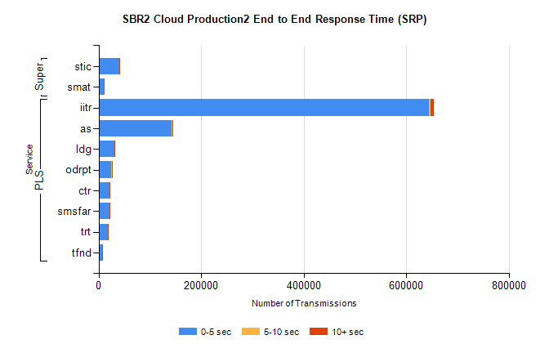
Stream | Service | 0-5 sec | 5-10 sec | >10 sec | Total | % within 5 sec timing target
PLS | iitr | 643609 | 3434 | 6643 | 653723 | 98.5%
PLS | as | 143025 | 1000 | 1919 | 145974 | 98.0%
PLS | ldg | 31520 | 54 | 80 | 31656 | 99.6%
PLS | odrpt | 24656 | 1156 | 227 | 26065 | 94.6%
PLS | ctr | 21147 | 98 | 190 | 21437 | 98.6%
PLS | smsfar | 20607 | 106 | 195 | 20908 | 98.6%
PLS | trt | 17557 | 72 | 158 | 17789 | 98.7%
PLS | tfnd | 7421 | 33 | 82 | 7538 | 98.4%
Super | stic | 40954 | 196 | 348 | 41500 | 98.7%
Super | smat | 10624 | 156 | 161 | 11014 | 96.5%

SBR2 Cloud Production2 - Bulk or Batch Requests (BBRP)

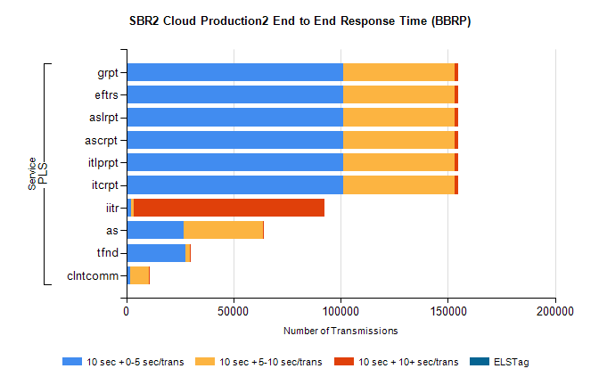
Stream | Service | 10 sec + 0-5 sec /trans | 10 sec + 5-10 sec /trans | 10 sec + >10 sec /trans | Processing Incomplete | ELStag | Total
PLS | itcrpt | 101348 | 51804 | 1538 | 19 | 0 | 157624
PLS | itlprpt | 101348 | 51804 | 1538 | 19 | 0 | 157624
PLS | ascrpt | 101348 | 51804 | 1538 | 19 | 0 | 157624
PLS | aslrpt | 101348 | 51804 | 1538 | 19 | 0 | 157624
PLS | eftrs | 101348 | 51804 | 1538 | 19 | 0 | 157624
PLS | grpt | 101348 | 51804 | 1538 | 19 | 0 | 157624
PLS | iitr | 2282 | 1318 | 88937 | 334 | 0 | 96686
PLS | as | 26687 | 36865 | 716 | 195 | 0 | 65268
PLS | tfnd | 27754 | 1982 | 248 | 2351 | 0 | 32630
PLS | clntcomm | 1878 | 8735 | 49 | 1 | 0 | 10940

SBR2 Cloud Production2 - ...

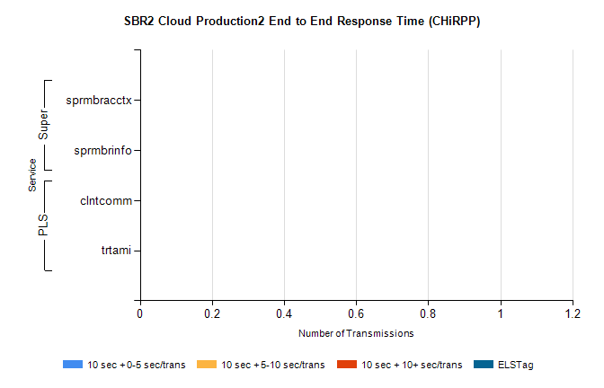
Stream | Service | 10 sec + 0-5 sec /trans | 10 sec + 5-10 sec /trans | 10 sec + >10 sec /trans | Total | % within 5 sec timing target
PLS | clntcomm | 0 | 0 | 0 | 8446 | 0.0%
PLS | trtami | 0 | 0 | 0 | 87 | 0.0%
Super | sprmbracctx | 0 | 0 | 0 | 4042 | 0.0%
Super | sprmbrinfo | 0 | 0 | 0 | 2699 | 0.0%

SBR1 Production Transactions

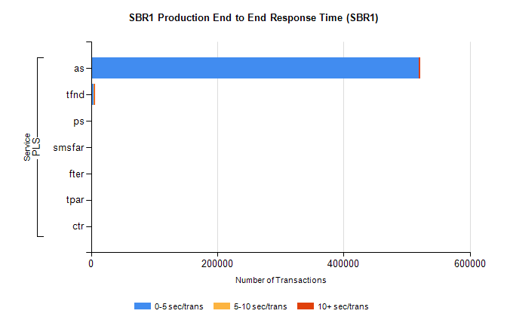
Stream | Service | 0-5 sec/trans | 5-10 sec/trans | 10+ sec/trans | Total | % within 5 sec timing target
PLS | as | 518695 | 343 | 2542 | 521580 | 99.4%
PLS | tfnd | 4196 | 926 | 64 | 5186 | 80.9%
PLS | ps | 52 | 75 | 157 | 284 | 18.3%
PLS | smsfar | 11 | 14 | 3 | 28 | 39.3%
PLS | fter | 2 |  | 4 | 6 | 33.3%
PLS | tpar | 2 |  |  | 2 | 100.0%
PLS | ctr |  |  | 1 | 1 | 0.0%

