Transmission Timings Report Week – 45
6/11/2023 – 12/11/2023

SBR2 External Vendor Testing Environment (EVTE3)

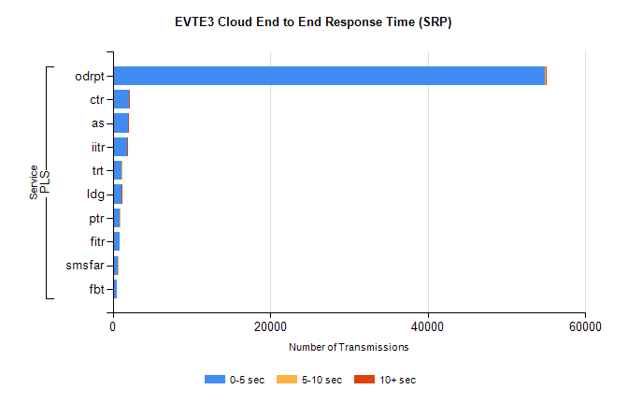
Stream | Service | 0-5 sec | 5-10 sec | >10 sec | Total | % within 5 sec timing target
PLS | odrpt | 54921 | 80 | 5 | 55016 | 99.8%
PLS | ctr | 2035 | 8 | 1 | 2082 | 97.7%
PLS | as | 1906 | 9 | 7 | 1961 | 97.2%
PLS | iitr | 1817 | 22 | 15 | 1875 | 96.9%
PLS | trt | 1119 | 4 | 0 | 1124 | 99.6%
PLS | ldg | 1091 | 5 | 6 | 1114 | 97.9%
PLS | ptr | 927 | 3 | 0 | 930 | 99.7%
PLS | fitr | 855 | 0 | 0 | 857 | 99.8%
PLS | smsfar | 670 | 2 | 0 | 673 | 99.6%
PLS | fbt | 526 | 0 | 0 | 536 | 98.1%

SBR2 External Vendor Testing Environment (EVTE3)

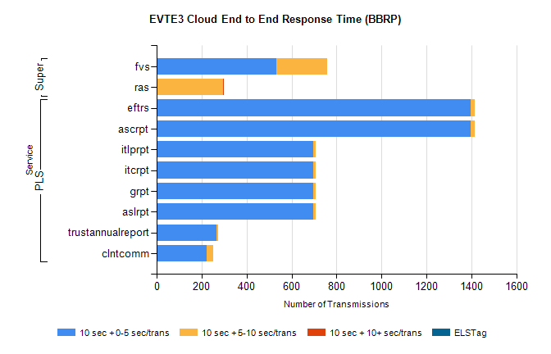
Stream | Service | 10 sec + 0-5 sec /trans | 10 sec + 5-10 sec /trans | 10 sec + >10 sec /trans | Processing Incomplete | ELStag | Total
PLS | ascrpt | 1396 | 18 | 0 | 0 | 0 | 1414
PLS | eftrs | 1396 | 18 | 0 | 0 | 0 | 1414
PLS | aslrpt | 698 | 9 | 0 | 0 | 0 | 707
PLS | grpt | 698 | 9 | 0 | 0 | 0 | 707
PLS | itcrpt | 698 | 9 | 0 | 0 | 0 | 707
PLS | itlprpt | 698 | 9 | 0 | 0 | 0 | 707
PLS | trustannualreport | 267 | 5 | 0 | 0 | 0 | 272
PLS | clntcomm | 222 | 28 | 0 | 0 | 0 | 261
Super | fvs | 531 | 226 | 0 | 322 | 0 | 1084
Super | ras | 0 | 294 | 3 | 0 | 0 | 443

