Transmission Timings Report Week – 45
6/11/2023 – 12/11/2023

SBR2 Cloud Production2 - Single Requests (SRP)

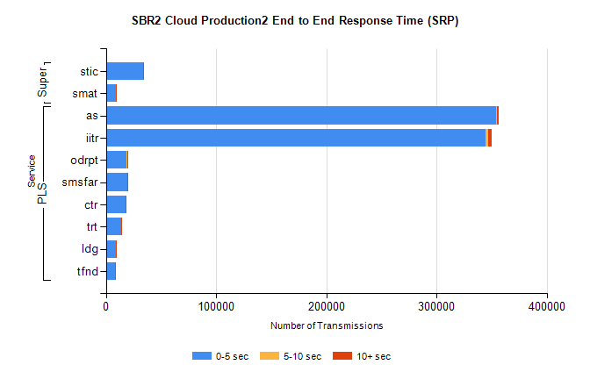
Stream | Service | 0-5 sec | 5-10 sec | >10 sec | Total | % within 5 sec timing target
PLS | as | 353669 | 892 | 1847 | 356910 | 99.1%
PLS | iitr | 344706 | 2086 | 3447 | 351032 | 98.2%
PLS | odrpt | 18561 | 797 | 441 | 19803 | 93.7%
PLS | smsfar | 19159 | 100 | 198 | 19585 | 97.8%
PLS | ctr | 18091 | 68 | 148 | 18327 | 98.7%
PLS | trt | 13943 | 85 | 114 | 14163 | 98.4%
PLS | ldg | 8891 | 29 | 34 | 8981 | 99.0%
PLS | tfnd | 8236 | 25 | 67 | 8352 | 98.6%
Super | stic | 33949 | 168 | 292 | 34587 | 98.2%
Super | smat | 9159 | 153 | 101 | 9539 | 96.0%

SBR2 Cloud Production2 - Bulk or Batch Requests (BBRP)

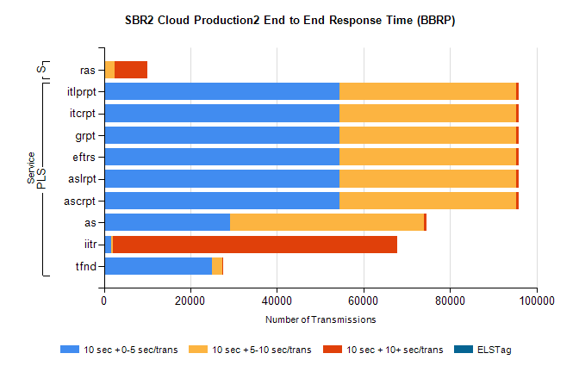
Stream | Service | 10 sec + 0-5 sec /trans | 10 sec + 5-10 sec /trans | 10 sec + >10 sec /trans | Processing Incomplete | ELStag | Total
PLS | ascrpt | 54550 | 40694 | 734 | 237 | 0 | 97893
PLS | aslrpt | 54550 | 40694 | 734 | 237 | 0 | 97893
PLS | eftrs | 54550 | 40694 | 734 | 237 | 0 | 97893
PLS | grpt | 54550 | 40694 | 734 | 237 | 0 | 97893
PLS | itcrpt | 54550 | 40694 | 734 | 237 | 0 | 97893
PLS | itlprpt | 54550 | 40694 | 734 | 237 | 0 | 97893
PLS | as | 29220 | 44791 | 623 | 1054 | 0 | 76569
PLS | iitr | 1661 | 402 | 65762 | 354 | 0 | 70272
PLS | tfnd | 24913 | 2491 | 196 | 2238 | 0 | 30116
Super | ras | 93 | 2375 | 7644 | 1 | 0 | 12221

SBR2 Cloud Production2 - ...

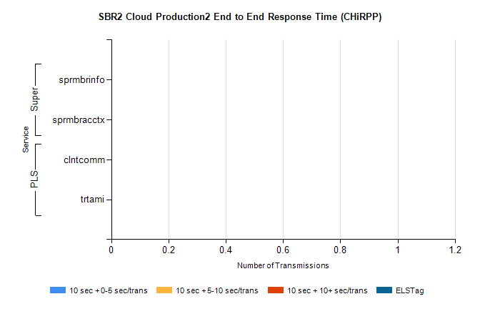
Stream | Service | 10 sec + 0-5 sec /trans | 10 sec + 5-10 sec /trans | 10 sec + >10 sec /trans | Total | % within 5 sec timing target
PLS | clntcomm | 0 | 0 | 0 | 8240 | 0.0%
PLS | trtami | 0 | 0 | 0 | 18 | 0.0%
Super | sprmbrinfo | 0 | 0 | 0 | 2770 | 0.0%
Super | sprmbracctx | 0 | 0 | 0 | 2592 | 0.0%

SBR1 Production Transactions

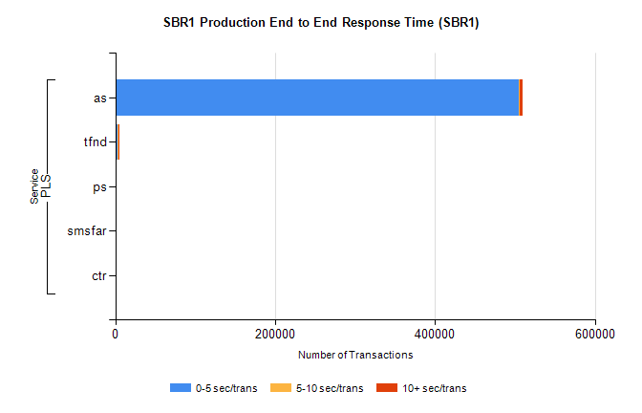
Stream | Service | 0-5 sec/trans | 5-10 sec/trans | 10+ sec/trans | Total | % within 5 sec timing target
PLS | as | 505346 | 299 | 3433 | 509078 | 99.3%
PLS | tfnd | 3434 | 907 | 303 | 4644 | 73.9%
PLS | ps | 17 | 37 | 142 | 196 | 8.7%
PLS | smsfar | 13 | 26 | 1 | 40 | 32.5%
PLS | ctr |  |  | 2 | 2 | 0.0%

