Transmission Timings Report Week – 46
13/11/2023 – 19/11/2023

SBR2 Cloud Production2 - Single Requests (SRP)

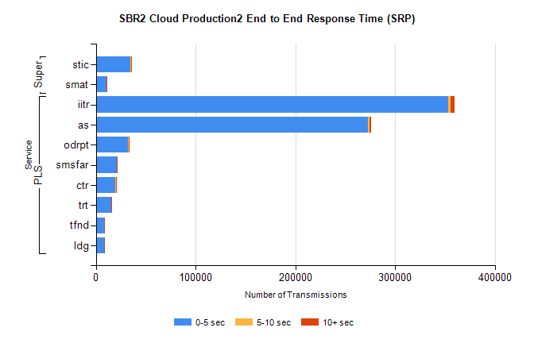
Stream | Service | 0-5 sec | 5-10 sec | >10 sec | Total | % within 5 sec timing target
PLS | iitr | 353582 | 2180 | 3893 | 359687 | 98.3%
PLS | as | 273176 | 850 | 1937 | 276021 | 99.0%
PLS | odrpt | 31899 | 847 | 357 | 33104 | 96.4%
PLS | smsfar | 20765 | 128 | 223 | 21116 | 98.3%
PLS | ctr | 19817 | 88 | 193 | 20098 | 98.6%
PLS | trt | 15578 | 85 | 171 | 15837 | 98.4%
PLS | tfnd | 8386 | 66 | 91 | 8543 | 98.2%
PLS | ldg | 8247 | 30 | 29 | 8306 | 99.3%
Super | stic | 34817 | 239 | 367 | 35426 | 98.3%
Super | smat | 10558 | 156 | 143 | 10858 | 97.2%

SBR2 Cloud Production2 - Bulk or Batch Requests (BBRP)

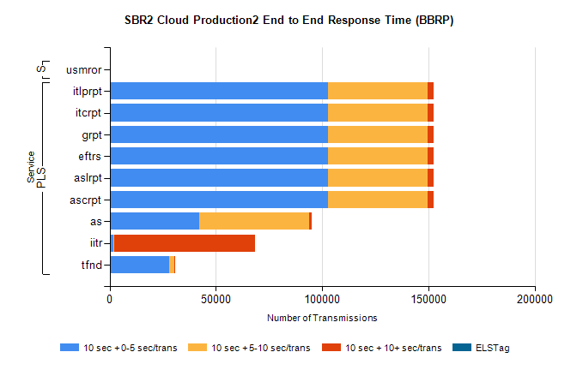
Stream | Service | 10 sec + 0-5 sec /trans | 10 sec + 5-10 sec /trans | 10 sec + >10 sec /trans | Processing Incomplete | ELStag | Total
PLS | ascrpt | 102945 | 46859 | 2842 | 54 | 0 | 157234
PLS | aslrpt | 102945 | 46859 | 2842 | 54 | 0 | 157234
PLS | eftrs | 102945 | 46859 | 2842 | 54 | 0 | 157234
PLS | grpt | 102945 | 46859 | 2842 | 54 | 0 | 157234
PLS | itcrpt | 102945 | 46859 | 2842 | 54 | 0 | 157234
PLS | itlprpt | 102945 | 46859 | 2842 | 54 | 0 | 157234
PLS | as | 42328 | 51456 | 1276 | 166 | 0 | 96698
PLS | iitr | 1636 | 357 | 66608 | 180 | 0 | 70929
PLS | tfnd | 28013 | 2307 | 332 | 2537 | 0 | 33589
Super | usmror | 0 | 0 | 0 | 22844 | 0 | 22844

SBR2 Cloud Production2 - ...

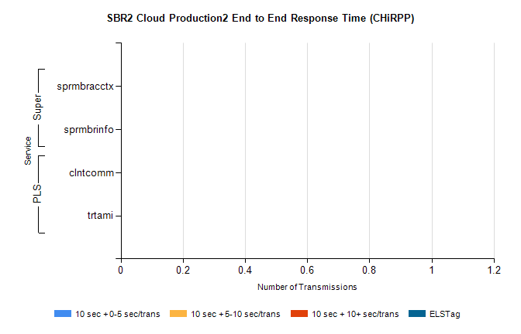
Stream | Service | 10 sec + 0-5 sec /trans | 10 sec + 5-10 sec /trans | 10 sec + >10 sec /trans | Total | % within 5 sec timing target
PLS | clntcomm | 0 | 0 | 0 | 8914 | 0.0%
PLS | trtami | 0 | 0 | 0 | 26 | 0.0%
Super | sprmbracctx | 0 | 0 | 0 | 3163 | 0.0%
Super | sprmbrinfo | 0 | 0 | 0 | 2782 | 0.0%

SBR1 Production Transactions

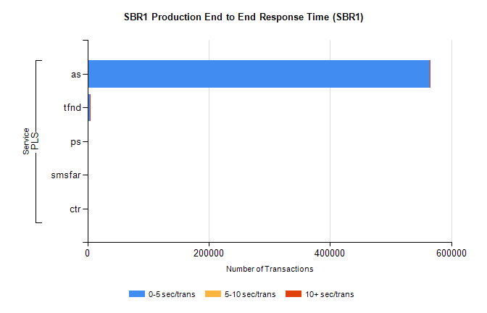
Stream | Service | 0-5 sec/trans | 5-10 sec/trans | 10+ sec/trans | Total | % within 5 sec timing target
PLS | as | 564048 | 388 | 667 | 565103 | 99.8%
PLS | tfnd | 3717 | 937 | 6 | 4660 | 79.8%
PLS | ps | 65 | 60 | 158 | 283 | 23.0%
PLS | smsfar | 30 | 88 | 4 | 122 | 24.6%
PLS | ctr |  |  | 2 | 2 | 0.0%

