Transmission Timings Report Week - 48
27/11/2023 - 3/12/2023

SBR2 External Vendor Testing Environment (EVTE3)

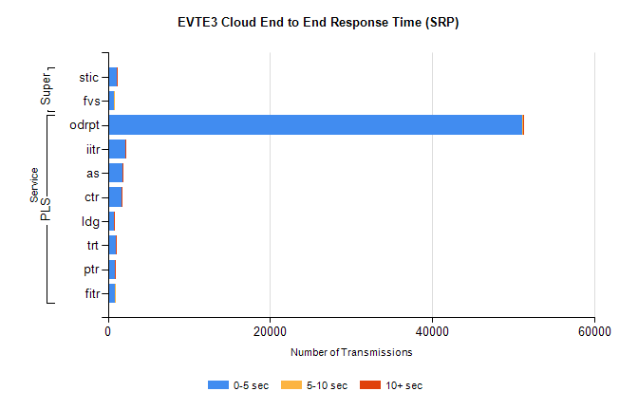
Stream | Service | 0-5 sec | 5-10 sec | >10 sec | Total | % within 5 sec timing target
PLS | odrpt | 51081 | 117 | 34 | 51243 | 99.7%
PLS | iitr | 2136 | 12 | 16 | 2164 | 98.7%
PLS | as | 1855 | 5 | 5 | 1918 | 96.7%
PLS | ctr | 1646 | 17 | 2 | 1693 | 97.2%
PLS | ldg | 798 | 6 | 2 | 1222 | 65.3%
PLS | trt | 1020 | 3 | 2 | 1031 | 98.9%
PLS | ptr | 902 | 1 | 1 | 909 | 99.2%
PLS | fitr | 866 | 4 | 0 | 877 | 98.7%
Super | stic | 1130 | 2 | 1 | 1133 | 99.7%
Super | fvs | 762 | 3 | 0 | 765 | 99.6%

SBR2 External Vendor Testing Environment (EVTE3)

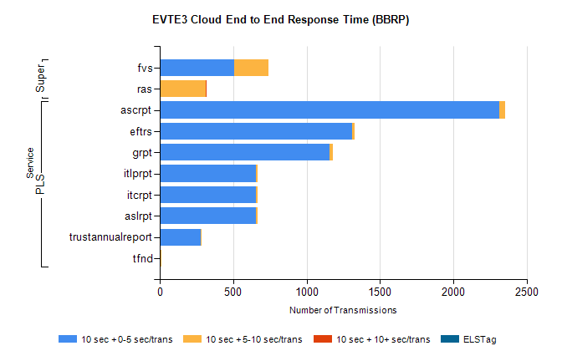
Stream | Service | 10 sec + 0-5 sec /trans | 10 sec + 5-10 sec /trans | 10 sec + >10 sec /trans | Processing Incomplete | ELStag | Total
PLS | ascrpt | 2314 | 42 | 0 | 4 | 0 | 2366
PLS | eftrs | 1312 | 18 | 0 | 2 | 0 | 1334
PLS | grpt | 1157 | 21 | 0 | 2 | 0 | 1183
PLS | aslrpt | 656 | 9 | 0 | 1 | 0 | 667
PLS | itcrpt | 656 | 9 | 0 | 1 | 0 | 667
PLS | itlprpt | 656 | 9 | 0 | 1 | 0 | 667
PLS | trustannualreport | 277 | 8 | 0 | 0 | 0 | 285
PLS | tfnd | 5 | 1 | 0 | 262 | 0 | 268
Super | fvs | 507 | 233 | 0 | 297 | 0 | 1043
Super | ras | 0 | 313 | 1 | 0 | 0 | 540

