Transmission Timings Report Week - 48
27/11/2023 - 3/12/2023

SBR2 Cloud Production2 - Single Requests (SRP)

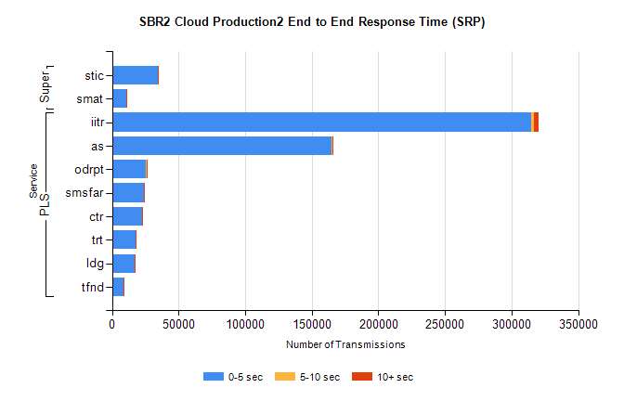
Stream | Service | 0-5 sec | 5-10 sec | >10 sec | Total | % within 5 sec timing target
PLS | iitr | 314922 | 1958 | 3274 | 320273 | 98.3%
PLS | as | 164609 | 551 | 1005 | 166217 | 99.0%
PLS | odrpt | 25140 | 1027 | 323 | 26490 | 94.9%
PLS | smsfar | 24147 | 136 | 205 | 24497 | 98.6%
PLS | ctr | 22719 | 85 | 198 | 23012 | 98.7%
PLS | trt | 17602 | 90 | 161 | 17862 | 98.5%
PLS | ldg | 16937 | 38 | 38 | 17014 | 99.5%
PLS | tfnd | 8520 | 35 | 84 | 8646 | 98.5%
Super | stic | 34342 | 215 | 359 | 34957 | 98.2%
Super | smat | 10699 | 144 | 154 | 11000 | 97.3%

SBR2 Cloud Production2 - Bulk or Batch Requests (BBRP)

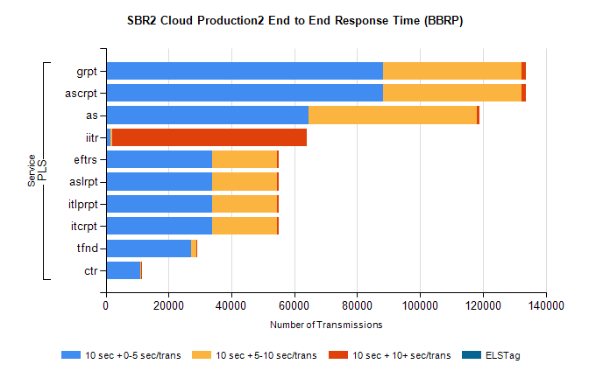
Stream | Service | 10 sec + 0-5 sec /trans | 10 sec + 5-10 sec /trans | 10 sec + >10 sec /trans | Processing Incomplete | ELStag | Total
PLS | ascrpt | 88362 | 43932 | 1509 | 48 | 0 | 135615
PLS | grpt | 88362 | 43932 | 1509 | 48 | 0 | 135615
PLS | as | 64417 | 53602 | 875 | 336 | 0 | 120421
PLS | iitr | 1622 | 320 | 61921 | 189 | 0 | 65792
PLS | itcrpt | 33801 | 20686 | 699 | 36 | 0 | 56006
PLS | itlprpt | 33801 | 20686 | 699 | 36 | 0 | 56006
PLS | aslrpt | 33801 | 20686 | 699 | 36 | 0 | 56006
PLS | eftrs | 33801 | 20686 | 699 | 36 | 0 | 56006
PLS | tfnd | 27257 | 1531 | 174 | 2382 | 0 | 31594
PLS | ctr | 10865 | 440 | 83 | 7 | 0 | 11487

SBR2 Cloud Production2 - ...

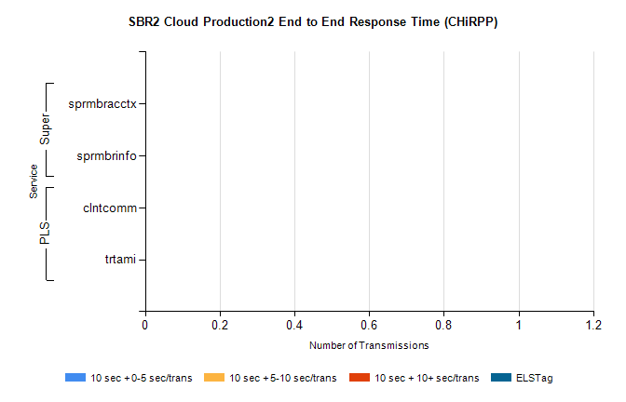
Stream | Service | 10 sec + 0-5 sec /trans | 10 sec + 5-10 sec /trans | 10 sec + >10 sec /trans | Total | % within 5 sec timing target
PLS | clntcomm | 0 | 0 | 0 | 9101 | 0.0%
PLS | trtami | 0 | 0 | 0 | 39 | 0.0%
Super | sprmbracctx | 0 | 0 | 0 | 3675 | 0.0%
Super | sprmbrinfo | 0 | 0 | 0 | 2702 | 0.0%

SBR1 Production Transactions

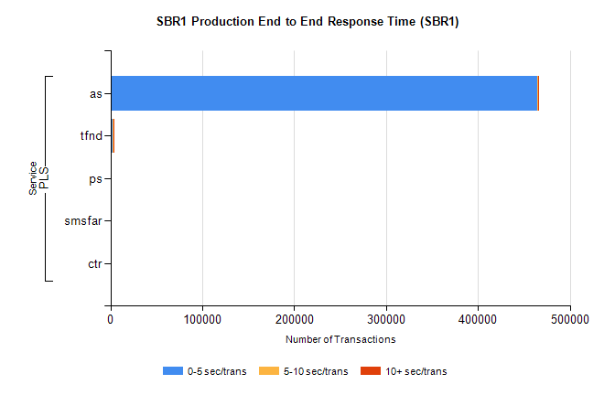
Stream | Service | 0-5 sec/trans | 5-10 sec/trans | 10+ sec/trans | Total | % within 5 sec timing target
PLS | as | 464827 | 194 | 1287 | 466308 | 99.7%
PLS | tfnd | 2502 | 796 | 139 | 3437 | 72.8%
PLS | ps | 43 | 48 | 137 | 228 | 18.9%
PLS | smsfar | 14 | 45 |  | 59 | 23.7%
PLS | ctr |  |  | 3 | 3 | 0.0%

