Transmission Timings Report Week - 49
4/12/2023 - 10/12/2023

SBR2 External Vendor Testing Environment (EVTE3)

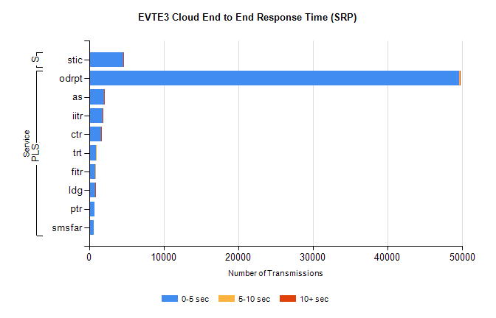
Stream | Service | 0-5 sec | 5-10 sec | >10 sec | Total | % within 5 sec timing target
PLS | odrpt | 49572 | 63 | 28 | 49669 | 99.8%
PLS | as | 2033 | 11 | 16 | 2075 | 98.0%
PLS | iitr | 1846 | 23 | 13 | 1885 | 97.9%
PLS | ctr | 1597 | 15 | 1 | 1615 | 98.9%
PLS | trt | 907 | 5 | 0 | 912 | 99.5%
PLS | fitr | 865 | 3 | 0 | 868 | 99.7%
PLS | ldg | 788 | 6 | 7 | 814 | 96.8%
PLS | ptr | 781 | 0 | 0 | 781 | 100.0%
PLS | smsfar | 677 | 0 | 0 | 677 | 100.0%
Super | stic | 4565 | 3 | 1 | 4569 | 99.9%

SBR2 External Vendor Testing Environment (EVTE3)

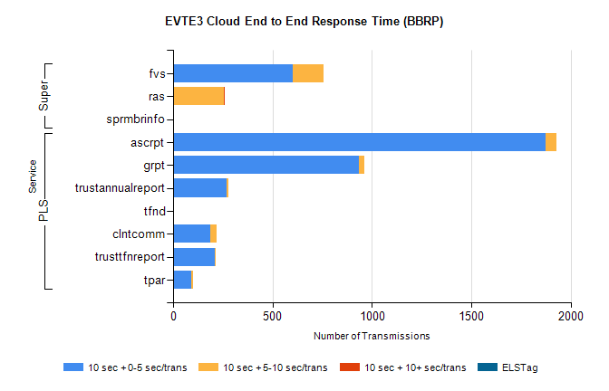
Stream | Service | 10 sec + 0-5 sec /trans | 10 sec + 5-10 sec /trans | 10 sec + >10 sec /trans | Processing Incomplete | ELStag | Total
PLS | ascrpt | 1872 | 56 | 0 | 0 | 0 | 1932
PLS | grpt | 936 | 28 | 0 | 0 | 0 | 966
PLS | trustannualreport | 268 | 8 | 0 | 0 | 0 | 277
PLS | tfnd | 3 | 0 | 0 | 229 | 0 | 232
PLS | clntcomm | 188 | 32 | 0 | 0 | 0 | 226
PLS | trusttfnreport | 209 | 3 | 0 | 0 | 0 | 212
PLS | tpar | 93 | 9 | 0 | 0 | 0 | 105
Super | fvs | 603 | 153 | 0 | 331 | 0 | 1093
Super | ras | 0 | 256 | 2 | 0 | 0 | 326
Super | sprmbrinfo | 0 | 0 | 0 | 0 | 0 | 141

