Transmission Timings Report Week - 49
4/12/2023 - 10/12/2023

SBR2 Cloud Production2 - Single Requests (SRP)

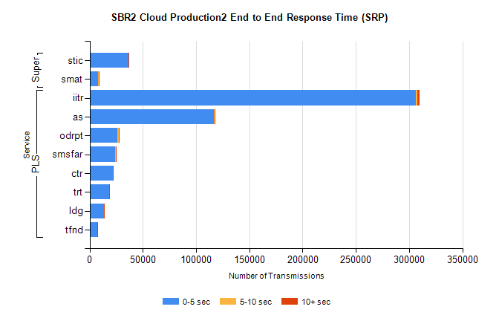
Stream | Service | 0-5 sec | 5-10 sec | >10 sec | Total | % within 5 sec timing target
PLS | iitr | 306334 | 1583 | 1538 | 309491 | 99.0%
PLS | as | 116878 | 315 | 317 | 117520 | 99.5%
PLS | odrpt | 26320 | 1104 | 121 | 27545 | 95.6%
PLS | smsfar | 24264 | 106 | 105 | 24476 | 99.1%
PLS | ctr | 22093 | 86 | 91 | 22273 | 99.2%
PLS | trt | 18273 | 85 | 70 | 18429 | 99.2%
PLS | ldg | 13648 | 42 | 20 | 13715 | 99.5%
PLS | tfnd | 7391 | 32 | 45 | 7468 | 99.0%
Super | stic | 36636 | 189 | 270 | 37095 | 98.8%
Super | smat | 8296 | 113 | 51 | 8461 | 98.0%

SBR2 Cloud Production2 - Bulk or Batch Requests (BBRP)

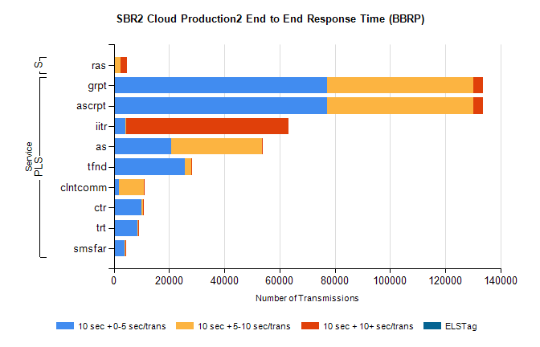
Stream | Service | 10 sec + 0-5 sec /trans | 10 sec + 5-10 sec /trans | 10 sec + >10 sec /trans | Processing Incomplete | ELStag | Total
PLS | ascrpt | 77110 | 53200 | 3320 | 15 | 0 | 137193
PLS | grpt | 77110 | 53200 | 3320 | 15 | 0 | 137193
PLS | iitr | 4101 | 438 | 58852 | 378 | 0 | 65635
PLS | as | 20726 | 33021 | 254 | 148 | 0 | 54533
PLS | tfnd | 25577 | 2527 | 117 | 2336 | 0 | 30711
PLS | clntcomm | 1871 | 8924 | 7 | 4 | 0 | 10962
PLS | ctr | 9850 | 620 | 29 | 6 | 0 | 10551
PLS | trt | 8516 | 395 | 32 | 0 | 0 | 8982
PLS | smsfar | 3901 | 229 | 5 | 7 | 0 | 4167
Super | ras | 97 | 2285 | 2324 | 1 | 0 | 6417

SBR2 Cloud Production2 - ...

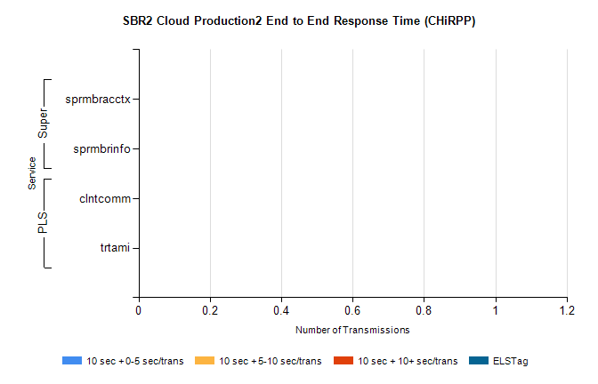
Stream | Service | 10 sec + 0-5 sec /trans | 10 sec + 5-10 sec /trans | 10 sec + >10 sec /trans | Total | % within 5 sec timing target
PLS | clntcomm | 0 | 0 | 0 | 8654 | 0.0%
PLS | trtami | 0 | 0 | 0 | 48 | 0.0%
Super | sprmbracctx | 0 | 0 | 0 | 2796 | 0.0%
Super | sprmbrinfo | 0 | 0 | 0 | 2587 | 0.0%

SBR1 Production Transactions

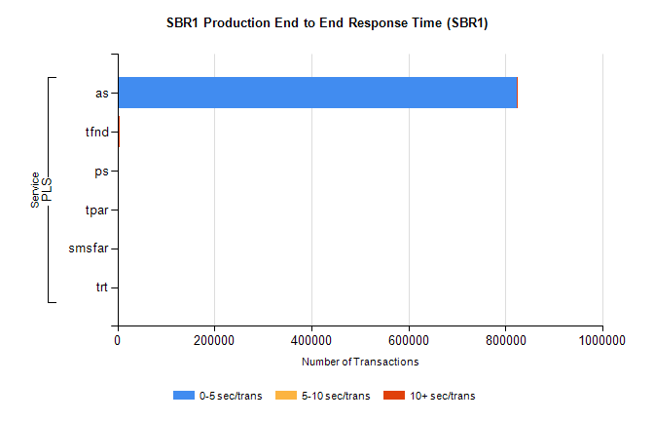
Stream | Service | 0-5 sec/trans | 5-10 sec/trans | 10+ sec/trans | Total | % within 5 sec timing target
PLS | as | 823074 | 228 | 641 | 823943 | 99.9%
PLS | tfnd | 2756 | 1043 | 29 | 3828 | 72.0%
PLS | ps | 72 | 68 | 152 | 292 | 24.7%
PLS | tpar | 57 |  |  | 57 | 100.0%
PLS | smsfar | 20 | 25 |  | 45 | 44.4%
PLS | trt | 2 |  | 12 | 14 | 14.3%

