Transmission Timings Report Week - 1
1/01/2024 - 7/01/2024

SBR2 External Vendor Testing Environment (EVTE3)

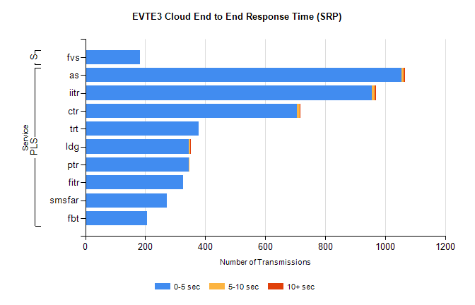
Stream | Service | 0-5 sec | 5-10 sec | >10 sec | Total | % within 5 sec timing target
PLS | as | 1054 | 8 | 4 | 1084 | 97.2%
PLS | iitr | 955 | 9 | 5 | 998 | 95.7%
PLS | ctr | 705 | 9 | 2 | 730 | 96.6%
PLS | trt | 379 | 0 | 0 | 379 | 100.0%
PLS | ldg | 346 | 4 | 3 | 353 | 98.0%
PLS | ptr | 344 | 1 | 0 | 345 | 99.7%
PLS | fitr | 326 | 0 | 0 | 326 | 100.0%
PLS | smsfar | 272 | 0 | 0 | 272 | 100.0%
PLS | fbt | 205 | 0 | 0 | 210 | 97.6%
Super | fvs | 183 | 0 | 0 | 183 | 100.0%

SBR2 External Vendor Testing Environment (EVTE3)

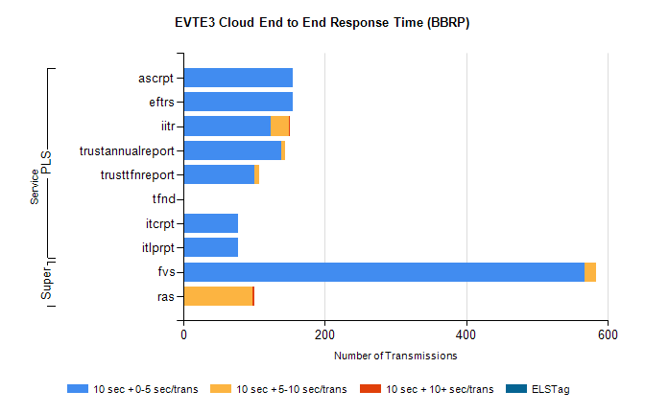
Stream | Service | 10 sec + 0-5 sec /trans | 10 sec + 5-10 sec /trans | 10 sec + >10 sec /trans | Processing Incomplete | ELStag | Total
PLS | eftrs | 154 | 0 | 0 | 10 | 0 | 164
PLS | ascrpt | 154 | 0 | 0 | 10 | 0 | 164
PLS | iitr | 123 | 26 | 1 | 0 | 0 | 153
PLS | trustannualreport | 139 | 5 | 0 | 0 | 0 | 144
PLS | trusttfnreport | 100 | 7 | 0 | 0 | 0 | 107
PLS | tfnd | 0 | 0 | 0 | 97 | 0 | 97
PLS | itlprpt | 77 | 0 | 0 | 5 | 0 | 82
PLS | itcrpt | 77 | 0 | 0 | 5 | 0 | 82
Super | fvs | 567 | 16 | 0 | 230 | 0 | 813
Super | ras | 0 | 97 | 3 | 0 | 0 | 175

