Transmission Timings Report Week - 1
1/01/2024 - 7/01/2024

SBR2 Cloud Production2 - Single Requests (SRP)

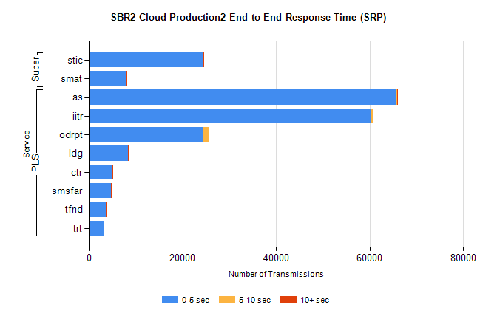
Stream | Service | 0-5 sec | 5-10 sec | >10 sec | Total | % within 5 sec timing target
PLS | as | 65740 | 153 | 16 | 65916 | 99.7%
PLS | iitr | 60175 | 448 | 69 | 60693 | 99.1%
PLS | odrpt | 24429 | 1129 | 79 | 25637 | 95.3%
PLS | ldg | 8278 | 19 | 7 | 8304 | 99.7%
PLS | ctr | 4876 | 34 | 4 | 4914 | 99.2%
PLS | smsfar | 4707 | 26 | 3 | 4736 | 99.4%
PLS | tfnd | 3687 | 14 | 1 | 3702 | 99.6%
PLS | trt | 3072 | 17 | 0 | 3089 | 99.4%
Super | stic | 24271 | 200 | 27 | 24498 | 99.1%
Super | smat | 7816 | 96 | 22 | 7934 | 98.5%

SBR2 Cloud Production2 - Bulk or Batch Requests (BBRP)

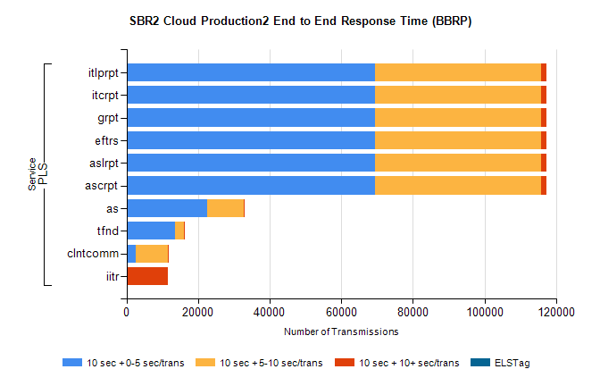
Stream | Service | 10 sec + 0-5 sec /trans | 10 sec + 5-10 sec /trans | 10 sec + >10 sec /trans | Processing Incomplete | ELStag | Total
PLS | ascrpt | 69496 | 46217 | 1540 | 1 | 0 | 118635
PLS | aslrpt | 69496 | 46217 | 1540 | 1 | 0 | 118635
PLS | eftrs | 69496 | 46217 | 1540 | 1 | 0 | 118635
PLS | grpt | 69496 | 46217 | 1540 | 1 | 0 | 118635
PLS | itcrpt | 69496 | 46217 | 1540 | 1 | 0 | 118635
PLS | itlprpt | 69496 | 46217 | 1540 | 1 | 0 | 118635
PLS | as | 22626 | 10166 | 56 | 20 | 0 | 32969
PLS | tfnd | 13664 | 2307 | 28 | 1356 | 0 | 17396
PLS | clntcomm | 2683 | 8962 | 10 | 0 | 0 | 11794
PLS | iitr | 397 | 35 | 11008 | 37 | 0 | 11531

SBR2 Cloud Production2 - ...

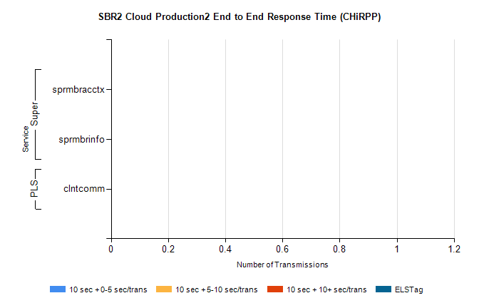
Stream | Service | 10 sec + 0-5 sec /trans | 10 sec + 5-10 sec /trans | 10 sec + >10 sec /trans | Total | % within 5 sec timing target
PLS | clntcomm | 0 | 0 | 0 | 5431 | 0.0%
Super | sprmbracctx | 0 | 0 | 0 | 3039 | 0.0%
Super | sprmbrinfo | 0 | 0 | 0 | 2253 | 0.0%

SBR1 Production Transactions

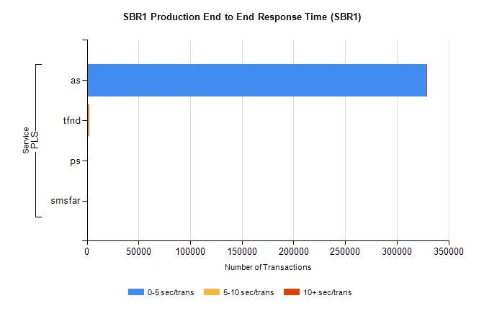
Stream | Service | 0-5 sec/trans | 5-10 sec/trans | 10+ sec/trans | Total | % within 5 sec timing target
PLS | as | 328333 | 286 | 89 | 328708 | 99.9%
PLS | tfnd | 794 | 781 | 6 | 1581 | 50.2%
PLS | ps | 3 | 5 | 35 | 43 | 7.0%
PLS | smsfar | 1 | 2 | 3 | 6 | 16.7%

