Transmission Timings Report Week - 2
8/01/2024 - 14/01/2024

SBR2 External Vendor Testing Environment (EVTE3)

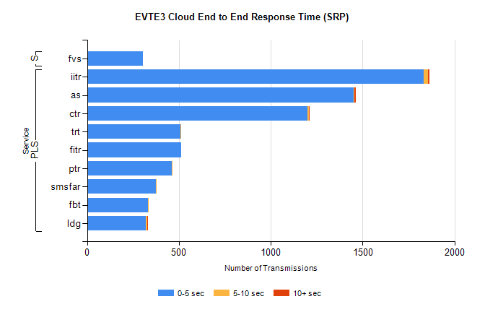
Stream | Service | 0-5 sec | 5-10 sec | >10 sec | Total | % within 5 sec timing target
PLS | iitr | 1834 | 23 | 6 | 1905 | 96.3%
PLS | as | 1451 | 6 | 7 | 1498 | 96.9%
PLS | ctr | 1199 | 10 | 1 | 1225 | 97.9%
PLS | trt | 509 | 1 | 0 | 519 | 98.1%
PLS | fitr | 511 | 0 | 0 | 517 | 98.8%
PLS | ptr | 463 | 3 | 0 | 471 | 98.3%
PLS | smsfar | 375 | 1 | 0 | 379 | 98.9%
PLS | fbt | 333 | 2 | 0 | 357 | 93.3%
PLS | ldg | 319 | 9 | 5 | 335 | 95.2%
Super | fvs | 304 | 0 | 0 | 336 | 90.5%

SBR2 External Vendor Testing Environment (EVTE3)

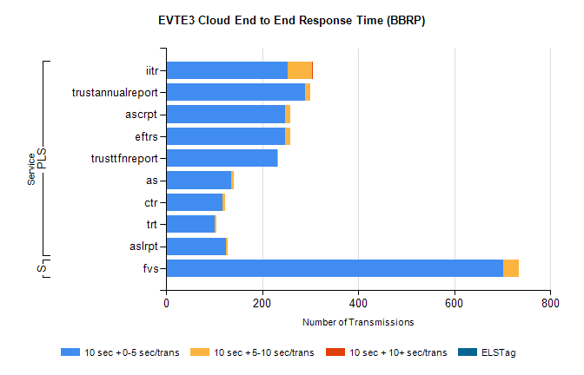
Stream | Service | 10 sec + 0-5 sec /trans | 10 sec + 5-10 sec /trans | 10 sec + >10 sec /trans | Processing Incomplete | ELStag | Total
PLS | iitr | 254 | 50 | 2 | 36 | 0 | 345
PLS | trustannualreport | 290 | 10 | 0 | 0 | 0 | 300
PLS | eftrs | 248 | 10 | 0 | 12 | 0 | 270
PLS | ascrpt | 248 | 10 | 0 | 12 | 0 | 270
PLS | trusttfnreport | 232 | 1 | 0 | 0 | 0 | 233
PLS | as | 135 | 6 | 0 | 6 | 0 | 167
PLS | ctr | 118 | 5 | 0 | 26 | 0 | 150
PLS | trt | 101 | 4 | 0 | 33 | 0 | 138
PLS | aslrpt | 124 | 5 | 0 | 6 | 0 | 135
Super | fvs | 702 | 33 | 0 | 311 | 0 | 1046

