Transmission Timings Report Week - 2
8/01/2024 - 14/01/2024

SBR2 Cloud Production2 - Single Requests (SRP)

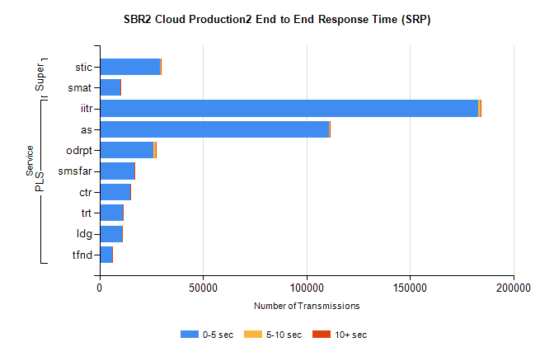
Stream | Service | 0-5 sec | 5-10 sec | >10 sec | Total | % within 5 sec timing target
PLS | iitr | 183137 | 867 | 167 | 184180 | 99.4%
PLS | as | 110979 | 294 | 235 | 111523 | 99.5%
PLS | odrpt | 26219 | 916 | 59 | 27194 | 96.4%
PLS | smsfar | 16886 | 40 | 11 | 16939 | 99.7%
PLS | ctr | 14949 | 56 | 8 | 15013 | 99.6%
PLS | trt | 11328 | 37 | 6 | 11371 | 99.6%
PLS | ldg | 10798 | 33 | 16 | 10850 | 99.5%
PLS | tfnd | 6218 | 8 | 3 | 6230 | 99.8%
Super | stic | 29289 | 172 | 36 | 29498 | 99.3%
Super | smat | 9964 | 104 | 11 | 10081 | 98.8%

SBR2 Cloud Production2 - Bulk or Batch Requests (BBRP)

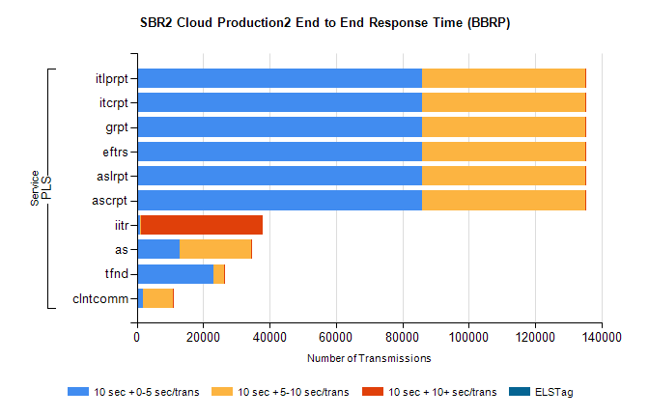
Stream | Service | 10 sec + 0-5 sec /trans | 10 sec + 5-10 sec /trans | 10 sec + >10 sec /trans | Processing Incomplete | ELStag | Total
PLS | ascrpt | 86056 | 49162 | 190 | 19 | 0 | 136924
PLS | aslrpt | 86056 | 49162 | 190 | 19 | 0 | 136924
PLS | eftrs | 86056 | 49162 | 190 | 19 | 0 | 136924
PLS | grpt | 86056 | 49162 | 190 | 19 | 0 | 136924
PLS | itcrpt | 86056 | 49162 | 190 | 19 | 0 | 136924
PLS | itlprpt | 86056 | 49162 | 190 | 19 | 0 | 136924
PLS | iitr | 981 | 167 | 36777 | 90 | 0 | 38610
PLS | as | 12989 | 21533 | 12 | 73 | 0 | 34689
PLS | tfnd | 23203 | 3210 | 13 | 2124 | 0 | 28584
PLS | clntcomm | 1818 | 9173 | 30 | 0 | 0 | 11258

SBR2 Cloud Production2 - ...

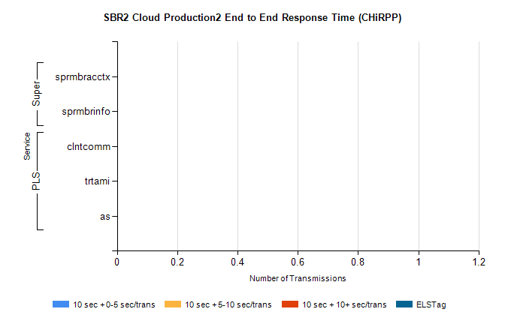
Stream | Service | 10 sec + 0-5 sec /trans | 10 sec + 5-10 sec /trans | 10 sec + >10 sec /trans | Total | % within 5 sec timing target
PLS | clntcomm | 0 | 0 | 0 | 8897 | 0.0%
PLS | trtami | 0 | 0 | 0 | 12 | 0.0%
PLS | as | 0 | 0 | 0 | 2 | 0.0%
Super | sprmbracctx | 0 | 0 | 0 | 2749 | 0.0%
Super | sprmbrinfo | 0 | 0 | 0 | 2574 | 0.0%

SBR1 Production Transactions

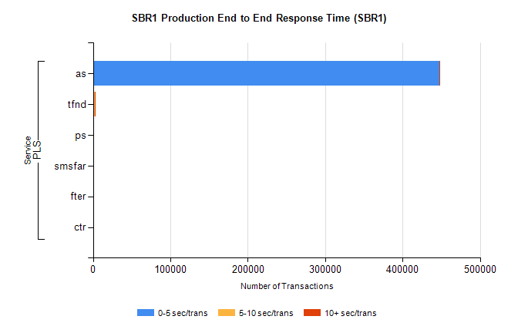
Stream | Service | 0-5 sec/trans | 5-10 sec/trans | 10+ sec/trans | Total | % within 5 sec timing target
PLS | as | 447115 | 171 | 811 | 448097 | 99.8%
PLS | tfnd | 1535 | 899 | 64 | 2498 | 61.4%
PLS | ps | 63 | 36 | 112 | 211 | 29.9%
PLS | smsfar | 5 | 25 |  | 30 | 16.7%
PLS | fter |  | 3 | 1 | 4 | 0.0%
PLS | ctr |  |  | 1 | 1 | 0.0%

