Transmission Timings Report Week - 3
15/01/2024 - 21/01/2024

SBR2 External Vendor Testing Environment (EVTE3)

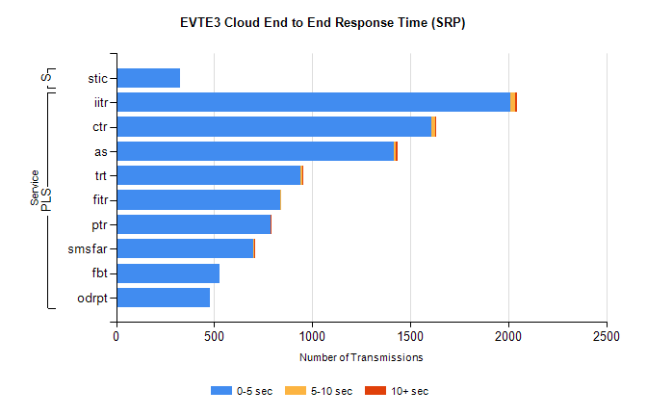
Stream | Service | 0-5 sec | 5-10 sec | >10 sec | Total | % within 5 sec timing target
PLS | iitr | 2012 | 24 | 11 | 2048 | 98.2%
PLS | ctr | 1606 | 22 | 2 | 1638 | 98.0%
PLS | as | 1414 | 13 | 8 | 1472 | 96.1%
PLS | trt | 939 | 9 | 2 | 952 | 98.6%
PLS | fitr | 838 | 1 | 0 | 839 | 99.9%
PLS | ptr | 786 | 4 | 1 | 791 | 99.4%
PLS | smsfar | 701 | 1 | 1 | 703 | 99.7%
PLS | fbt | 529 | 0 | 0 | 540 | 98.0%
PLS | odrpt | 480 | 0 | 0 | 482 | 99.6%
Super | stic | 325 | 0 | 0 | 325 | 100.0%

SBR2 External Vendor Testing Environment (EVTE3)

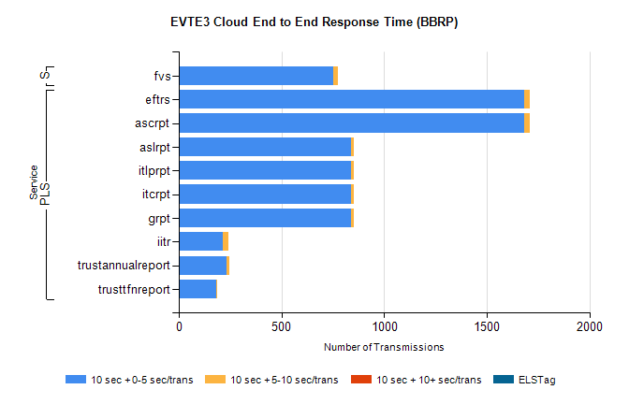
Stream | Service | 10 sec + 0-5 sec /trans | 10 sec + 5-10 sec /trans | 10 sec + >10 sec /trans | Processing Incomplete | ELStag | Total
PLS | ascrpt | 1680 | 28 | 0 | 10 | 0 | 1718
PLS | eftrs | 1680 | 28 | 0 | 10 | 0 | 1718
PLS | aslrpt | 840 | 14 | 0 | 19 | 0 | 873
PLS | grpt | 840 | 14 | 0 | 5 | 0 | 859
PLS | itcrpt | 840 | 14 | 0 | 5 | 0 | 859
PLS | itlprpt | 840 | 14 | 0 | 5 | 0 | 859
PLS | iitr | 212 | 31 | 0 | 39 | 0 | 284
PLS | trustannualreport | 234 | 12 | 0 | 0 | 0 | 246
PLS | trusttfnreport | 182 | 4 | 0 | 0 | 0 | 186
Super | fvs | 751 | 26 | 0 | 325 | 0 | 1102

