Transmission Timings Report Week - 3
15/01/2024 - 21/01/2024

SBR2 Cloud Production2 - Single Requests (SRP)

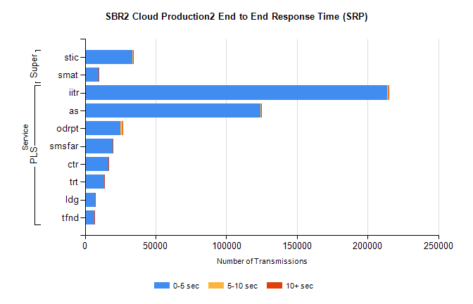
Stream | Service | 0-5 sec | 5-10 sec | >10 sec | Total | % within 5 sec timing target
PLS | iitr | 213650 | 1064 | 274 | 215002 | 99.4%
PLS | as | 124212 | 368 | 90 | 124699 | 99.6%
PLS | odrpt | 25242 | 1116 | 134 | 26493 | 95.3%
PLS | smsfar | 19413 | 44 | 30 | 19488 | 99.6%
PLS | ctr | 16445 | 51 | 19 | 16515 | 99.6%
PLS | trt | 13416 | 49 | 17 | 13484 | 99.5%
PLS | ldg | 7388 | 6 | 5 | 7405 | 99.8%
PLS | tfnd | 6694 | 28 | 3 | 6725 | 99.5%
Super | stic | 33778 | 119 | 56 | 33953 | 99.5%
Super | smat | 9666 | 110 | 24 | 9801 | 98.6%

SBR2 Cloud Production2 - Bulk or Batch Requests (BBRP)

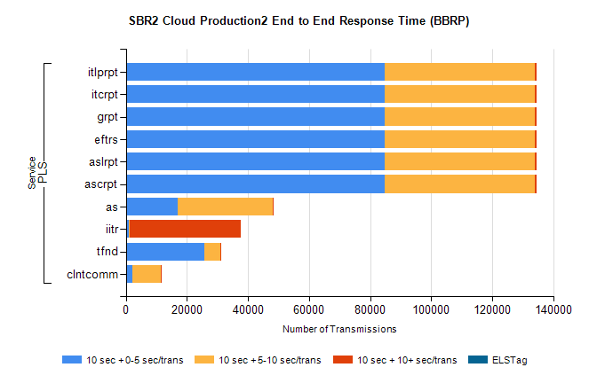
Stream | Service | 10 sec + 0-5 sec /trans | 10 sec + 5-10 sec /trans | 10 sec + >10 sec /trans | Processing Incomplete | ELStag | Total
PLS | ascrpt | 84791 | 49330 | 393 | 32 | 0 | 135814
PLS | aslrpt | 84791 | 49330 | 393 | 32 | 0 | 135814
PLS | eftrs | 84791 | 49330 | 393 | 32 | 0 | 135814
PLS | grpt | 84791 | 49330 | 393 | 32 | 0 | 135814
PLS | itcrpt | 84791 | 49330 | 393 | 32 | 0 | 135814
PLS | itlprpt | 84791 | 49330 | 393 | 32 | 0 | 135814
PLS | as | 16899 | 31176 | 92 | 79 | 0 | 48410
PLS | iitr | 1018 | 292 | 36371 | 120 | 0 | 40022
PLS | tfnd | 25704 | 5170 | 63 | 2586 | 0 | 33570
PLS | clntcomm | 2023 | 9385 | 302 | 4 | 0 | 11927

SBR2 Cloud Production2 - ...

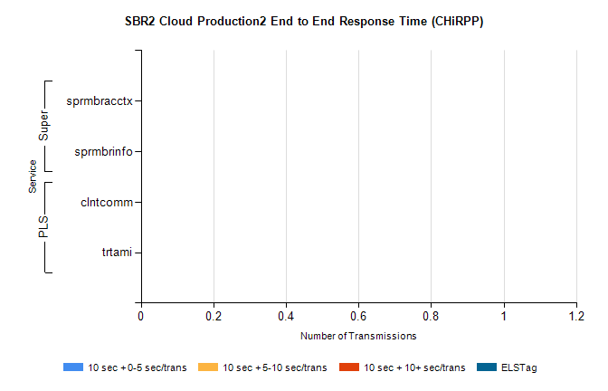
Stream | Service | 10 sec + 0-5 sec /trans | 10 sec + 5-10 sec /trans | 10 sec + >10 sec /trans | Total | % within 5 sec timing target
PLS | clntcomm | 0 | 0 | 0 | 8625 | 0.0%
PLS | trtami | 0 | 0 | 0 | 8 | 0.0%
Super | sprmbracctx | 0 | 0 | 0 | 3975 | 0.0%
Super | sprmbrinfo | 0 | 0 | 0 | 2734 | 0.0%

SBR1 Production Transactions

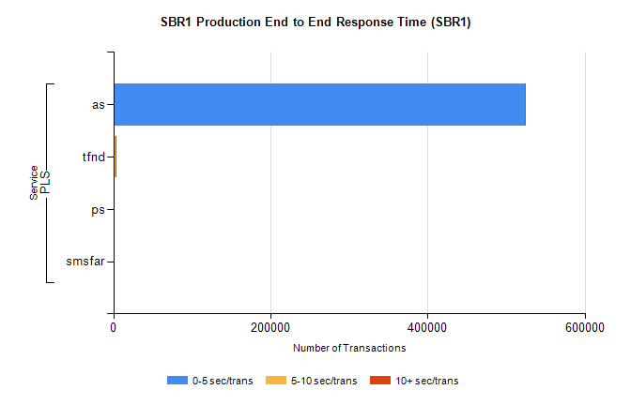
Stream | Service | 0-5 sec/trans | 5-10 sec/trans | 10+ sec/trans | Total | % within 5 sec timing target
PLS | as | 523530 | 274 | 157 | 523961 | 99.9%
PLS | tfnd | 1986 | 939 | 2 | 2927 | 67.9%
PLS | ps | 66 | 69 | 112 | 247 | 26.7%
PLS | smsfar | 7 | 7 |  | 14 | 50.0%

