Transmission Timings Report Week - 4
22/01/2024 - 28/01/2024

SBR2 External Vendor Testing Environment (EVTE3)

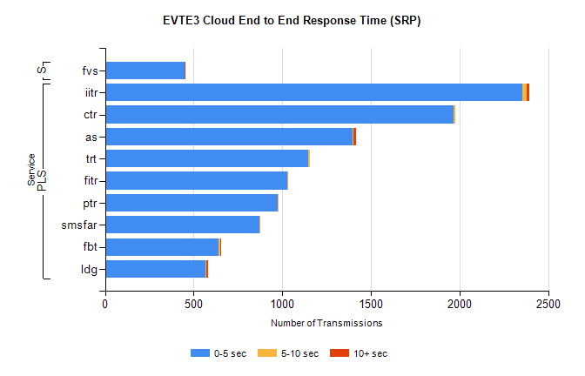
Stream | Service | 0-5 sec | 5-10 sec | >10 sec | Total | % within 5 sec timing target
PLS | iitr | 2356 | 24 | 15 | 2446 | 96.3%
PLS | ctr | 1967 | 8 | 0 | 1985 | 99.1%
PLS | as | 1396 | 7 | 12 | 1440 | 96.9%
PLS | trt | 1145 | 9 | 0 | 1162 | 98.5%
PLS | fitr | 1030 | 3 | 0 | 1033 | 99.7%
PLS | ptr | 974 | 2 | 0 | 976 | 99.8%
PLS | smsfar | 872 | 4 | 0 | 876 | 99.5%
PLS | fbt | 642 | 10 | 1 | 655 | 98.0%
PLS | ldg | 567 | 7 | 6 | 584 | 97.1%
Super | fvs | 451 | 0 | 1 | 452 | 99.8%

SBR2 External Vendor Testing Environment (EVTE3)

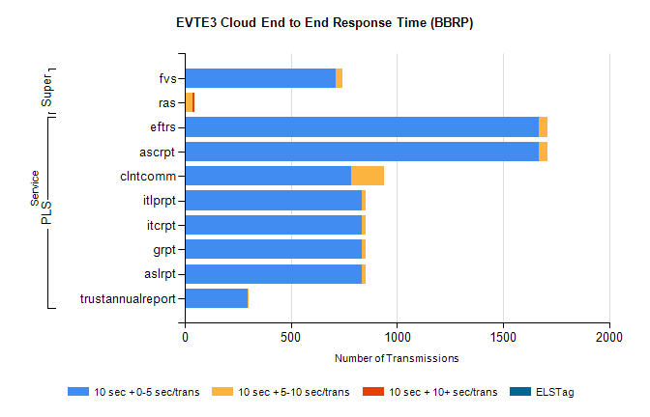
Stream | Service | 10 sec + 0-5 sec /trans | 10 sec + 5-10 sec /trans | 10 sec + >10 sec /trans | Processing Incomplete | ELStag | Total
PLS | ascrpt | 1670 | 38 | 0 | 24 | 0 | 1734
PLS | eftrs | 1670 | 38 | 0 | 24 | 0 | 1734
PLS | clntcomm | 785 | 153 | 0 | 0 | 0 | 943
PLS | aslrpt | 835 | 19 | 0 | 12 | 0 | 867
PLS | grpt | 835 | 19 | 0 | 12 | 0 | 867
PLS | itcrpt | 835 | 19 | 0 | 12 | 0 | 867
PLS | itlprpt | 835 | 19 | 0 | 12 | 0 | 867
PLS | trustannualreport | 294 | 4 | 0 | 0 | 0 | 298
Super | fvs | 713 | 29 | 0 | 305 | 0 | 1047
Super | ras | 0 | 36 | 11 | 0 | 0 | 430

