Transmission Timings Report Week - 4
22/01/2024 - 28/01/2024

SBR2 Cloud Production2 - Single Requests (SRP)

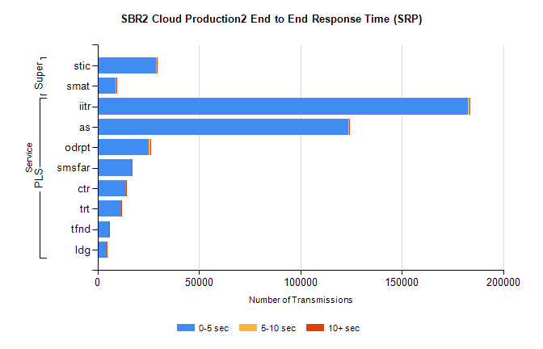
Stream | Service | 0-5 sec | 5-10 sec | >10 sec | Total | % within 5 sec timing target
PLS | iitr | 182506 | 765 | 194 | 183468 | 99.5%
PLS | as | 123822 | 308 | 70 | 124213 | 99.7%
PLS | odrpt | 25394 | 837 | 92 | 26323 | 96.5%
PLS | smsfar | 17019 | 49 | 23 | 17091 | 99.6%
PLS | ctr | 13929 | 53 | 16 | 13998 | 99.5%
PLS | trt | 11775 | 38 | 14 | 11827 | 99.6%
PLS | tfnd | 5796 | 12 | 2 | 5810 | 99.8%
PLS | ldg | 4521 | 19 | 4 | 4544 | 99.5%
Super | stic | 29013 | 138 | 41 | 29192 | 99.4%
Super | smat | 9069 | 113 | 18 | 9200 | 98.6%

SBR2 Cloud Production2 - Bulk or Batch Requests (BBRP)

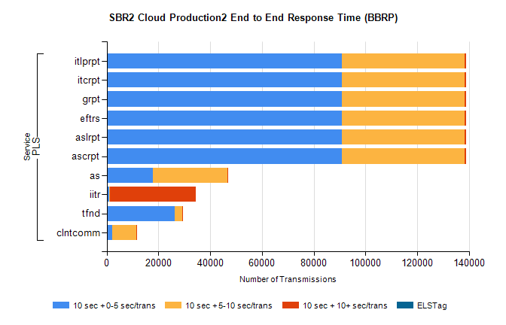
Stream | Service | 10 sec + 0-5 sec /trans | 10 sec + 5-10 sec /trans | 10 sec + >10 sec /trans | Processing Incomplete | ELStag | Total
PLS | ascrpt | 90760 | 47622 | 684 | 9 | 0 | 140584
PLS | aslrpt | 90760 | 47622 | 684 | 9 | 0 | 140584
PLS | eftrs | 90760 | 47622 | 684 | 9 | 0 | 140584
PLS | grpt | 90760 | 47622 | 684 | 9 | 0 | 140584
PLS | itcrpt | 90760 | 47622 | 684 | 9 | 0 | 140584
PLS | itlprpt | 90760 | 47622 | 684 | 9 | 0 | 140584
PLS | as | 17707 | 28847 | 60 | 104 | 0 | 46828
PLS | iitr | 893 | 464 | 33043 | 93 | 0 | 35213
PLS | tfnd | 26168 | 3034 | 20 | 2402 | 0 | 31659
PLS | clntcomm | 2014 | 9475 | 13 | 0 | 0 | 11646

SBR2 Cloud Production2 - ...

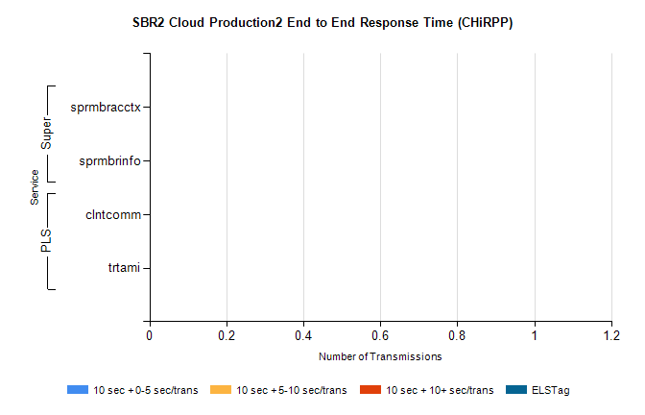
Stream | Service | 10 sec + 0-5 sec /trans | 10 sec + 5-10 sec /trans | 10 sec + >10 sec /trans | Total | % within 5 sec timing target
PLS | clntcomm | 0 | 0 | 0 | 7397 | 0.0%
PLS | trtami | 0 | 0 | 0 | 14 | 0.0%
Super | sprmbracctx | 0 | 0 | 0 | 4112 | 0.0%
Super | sprmbrinfo | 0 | 0 | 0 | 2208 | 0.0%

SBR1 Production Transactions

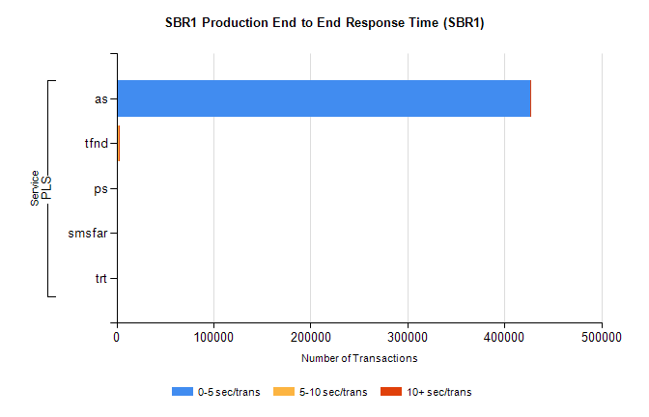
Stream | Service | 0-5 sec/trans | 5-10 sec/trans | 10+ sec/trans | Total | % within 5 sec timing target
PLS | as | 426314 | 144 | 193 | 426651 | 99.9%
PLS | tfnd | 1691 | 923 | 6 | 2620 | 64.5%
PLS | ps | 20 | 37 | 107 | 164 | 12.2%
PLS | smsfar | 15 | 29 | 1 | 45 | 33.3%
PLS | trt | 13 | 1 | 15 | 29 | 44.8%

