Transmission Timings Report Week - 50
11/12/2023 - 17/12/2023

SBR2 External Vendor Testing Environment (EVTE3)

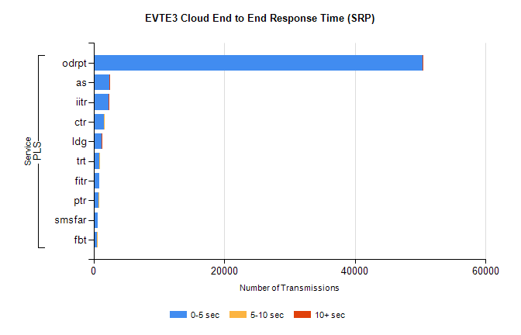
Stream | Service | 0-5 sec | 5-10 sec | >10 sec | Total | % within 5 sec timing target
PLS | odrpt | 50356 | 53 | 13 | 50430 | 99.9%
PLS | as | 2452 | 6 | 10 | 2508 | 97.8%
PLS | iitr | 2279 | 19 | 11 | 2315 | 98.4%
PLS | ctr | 1623 | 12 | 0 | 1644 | 98.7%
PLS | ldg | 1284 | 6 | 8 | 1303 | 98.5%
PLS | trt | 908 | 1 | 0 | 913 | 99.5%
PLS | fitr | 834 | 0 | 0 | 834 | 100.0%
PLS | ptr | 796 | 1 | 0 | 798 | 99.7%
PLS | smsfar | 686 | 0 | 0 | 688 | 99.7%
PLS | fbt | 518 | 3 | 0 | 534 | 97.0%

SBR2 External Vendor Testing Environment (EVTE3)

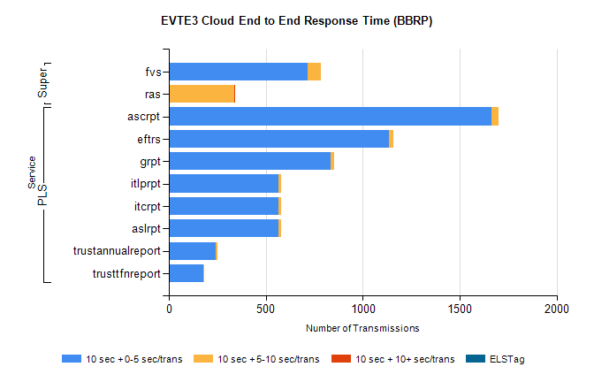
Stream | Service | 10 sec + 0-5 sec /trans | 10 sec + 5-10 sec /trans | 10 sec + >10 sec /trans | Processing Incomplete | ELStag | Total
PLS | ascrpt | 1664 | 38 | 0 | 8 | 0 | 1710
PLS | eftrs | 1134 | 22 | 0 | 8 | 0 | 1164
PLS | grpt | 832 | 19 | 0 | 4 | 0 | 855
PLS | aslrpt | 567 | 11 | 0 | 4 | 0 | 582
PLS | itcrpt | 567 | 11 | 0 | 4 | 0 | 582
PLS | itlprpt | 567 | 11 | 0 | 4 | 0 | 582
PLS | trustannualreport | 243 | 7 | 0 | 0 | 0 | 250
PLS | trusttfnreport | 176 | 5 | 0 | 0 | 0 | 182
Super | fvs | 714 | 71 | 0 | 347 | 0 | 1133
Super | ras | 1 | 337 | 1 | 6 | 0 | 459

