Transmission Timings Report Week - 50
11/12/2023 - 17/12/2023

SBR2 Cloud Production2 - Single Requests (SRP)

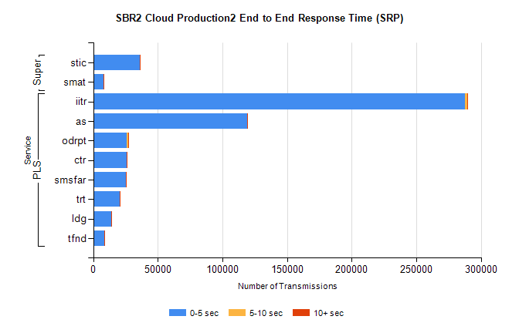
Stream | Service | 0-5 sec | 5-10 sec | >10 sec | Total | % within 5 sec timing target
PLS | iitr | 287833 | 1561 | 312 | 289724 | 99.3%
PLS | as | 118875 | 274 | 41 | 119212 | 99.7%
PLS | odrpt | 25811 | 1256 | 223 | 27290 | 94.6%
PLS | ctr | 26010 | 71 | 23 | 26105 | 99.6%
PLS | smsfar | 25102 | 71 | 24 | 25198 | 99.6%
PLS | trt | 20577 | 89 | 14 | 20682 | 99.5%
PLS | ldg | 14245 | 21 | 4 | 14272 | 99.8%
PLS | tfnd | 8617 | 23 | 4 | 8644 | 99.7%
Super | stic | 35968 | 120 | 174 | 36264 | 99.2%
Super | smat | 7944 | 79 | 19 | 8042 | 98.8%

SBR2 Cloud Production2 - Bulk or Batch Requests (BBRP)

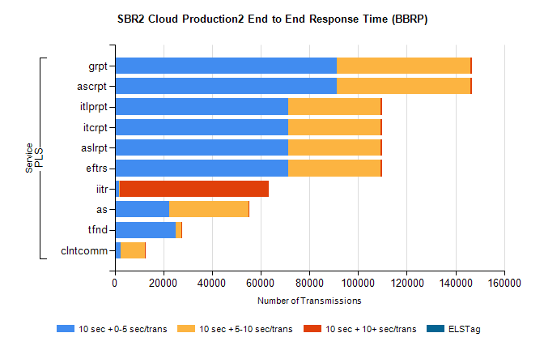
Stream | Service | 10 sec + 0-5 sec /trans | 10 sec + 5-10 sec /trans | 10 sec + >10 sec /trans | Processing Incomplete | ELStag | Total
PLS | ascrpt | 91325 | 54743 | 591 | 14 | 0 | 148555
PLS | grpt | 91325 | 54743 | 591 | 14 | 0 | 148555
PLS | eftrs | 71442 | 37801 | 464 | 5 | 0 | 110916
PLS | aslrpt | 71442 | 37801 | 464 | 5 | 0 | 110916
PLS | itcrpt | 71442 | 37801 | 464 | 5 | 0 | 110916
PLS | itlprpt | 71442 | 37801 | 464 | 5 | 0 | 110916
PLS | iitr | 1641 | 413 | 61091 | 224 | 0 | 65371
PLS | as | 22386 | 32485 | 159 | 122 | 0 | 55288
PLS | tfnd | 25022 | 2469 | 49 | 2279 | 0 | 29861
PLS | clntcomm | 2307 | 10219 | 119 | 0 | 0 | 12858

SBR2 Cloud Production2 - ...

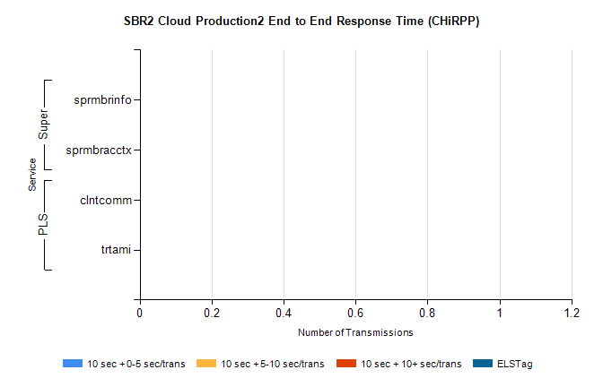
Stream | Service | 10 sec + 0-5 sec /trans | 10 sec + 5-10 sec /trans | 10 sec + >10 sec /trans | Total | % within 5 sec timing target
PLS | clntcomm | 0 | 0 | 0 | 9733 | 0.0%
PLS | trtami | 0 | 0 | 0 | 4 | 0.0%
Super | sprmbrinfo | 0 | 0 | 0 | 2887 | 0.0%
Super | sprmbracctx | 0 | 0 | 0 | 2863 | 0.0%

SBR1 Production Transactions

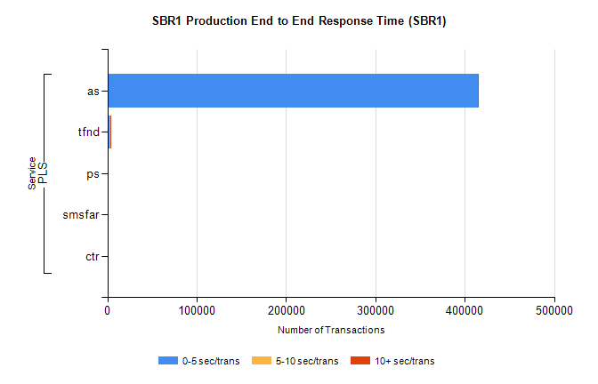
Stream | Service | 0-5 sec/trans | 5-10 sec/trans | 10+ sec/trans | Total |  | % within 5 sec timing target
PLS | as | 414502 | 135 | 121 |  | 414758 | 99.9%
PLS | tfnd | 2068 | 959 | 14 |  | 3041 | 68.0%
PLS | ps | 44 | 77 | 156 |  | 277 | 15.9%
PLS | smsfar | 13 | 35 | 2 |  | 50 | 26.0%
PLS | ctr |  |  | 2 |  | 2 | 0.0%

