Transmission Timings Report Week - 51
18/12/2023 - 24/12/2023

SBR2 External Vendor Testing Environment (EVTE3)

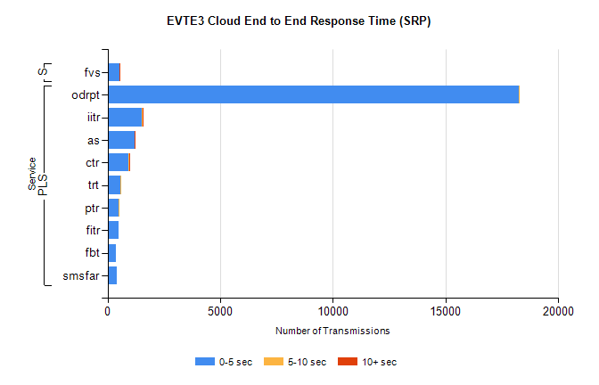
Stream | Service | 0-5 sec | 5-10 sec | >10 sec | Total | % within 5 sec timing target
PLS | odrpt | 18261 | 29 | 0 | 18292 | 99.8%
PLS | iitr | 1530 | 13 | 9 | 1552 | 98.6%
PLS | as | 1204 | 5 | 9 | 1237 | 97.3%
PLS | ctr | 943 | 11 | 3 | 961 | 98.1%
PLS | trt | 564 | 1 | 0 | 565 | 99.8%
PLS | ptr | 505 | 1 | 0 | 506 | 99.8%
PLS | fitr | 505 | 0 | 0 | 505 | 100.0%
PLS | fbt | 366 | 0 | 0 | 410 | 89.3%
PLS | smsfar | 402 | 0 | 0 | 402 | 100.0%
Super | fvs | 528 | 0 | 2 | 530 | 99.6%

SBR2 External Vendor Testing Environment (EVTE3)

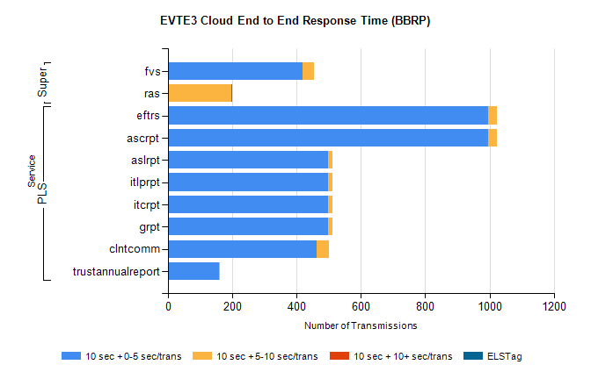
Stream | Service | 10 sec + 0-5 sec /trans | 10 sec + 5-10 sec /trans | 10 sec + >10 sec /trans | Processing Incomplete | ELStag | Total
PLS | ascrpt | 996 | 26 | 0 | 10 | 0 | 1032
PLS | eftrs | 996 | 26 | 0 | 10 | 0 | 1032
PLS | grpt | 498 | 13 | 0 | 5 | 0 | 516
PLS | itcrpt | 498 | 13 | 0 | 5 | 0 | 516
PLS | itlprpt | 498 | 13 | 0 | 5 | 0 | 516
PLS | aslrpt | 498 | 13 | 0 | 5 | 0 | 516
PLS | clntcomm | 463 | 37 | 0 | 0 | 0 | 503
PLS | trustannualreport | 158 | 3 | 0 | 0 | 0 | 161
Super | fvs | 419 | 36 | 0 | 186 | 0 | 642
Super | ras | 0 | 197 | 1 | 0 | 0 | 346

