Transmission Timings Report Week - 51
18/12/2023 - 24/12/2023

SBR2 Cloud Production2 - Single Requests (SRP)

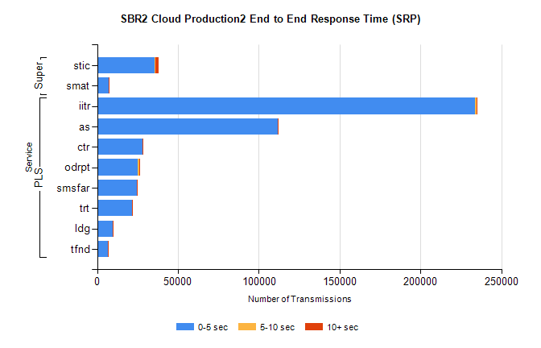
Stream | Service | 0-5 sec | 5-10 sec | >10 sec | Total | % within 5 sec timing target
PLS | iitr | 233499 | 1123 | 366 | 235002 | 99.4%
PLS | as | 111702 | 262 | 110 | 112091 | 99.7%
PLS | ctr | 28056 | 123 | 21 | 28200 | 99.5%
PLS | odrpt | 25175 | 951 | 121 | 26247 | 95.9%
PLS | smsfar | 24422 | 82 | 40 | 24544 | 99.5%
PLS | trt | 21617 | 91 | 34 | 21746 | 99.4%
PLS | ldg | 9785 | 32 | 9 | 9826 | 99.6%
PLS | tfnd | 6631 | 25 | 2 | 6658 | 99.6%
Super | stic | 35771 | 221 | 2262 | 38255 | 93.5%
Super | smat | 7015 | 87 | 52 | 7154 | 98.1%

SBR2 Cloud Production2 - Bulk or Batch Requests (BBRP)

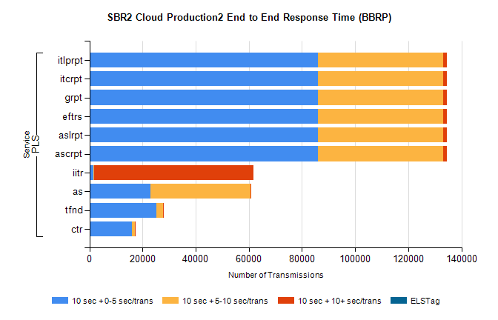
Stream | Service | 10 sec + 0-5 sec /trans | 10 sec + 5-10 sec /trans | 10 sec + >10 sec /trans | Processing Incomplete | ELStag | Total
PLS | ascrpt | 86058 | 46997 | 1378 | 9 | 0 | 135942
PLS | aslrpt | 86058 | 46997 | 1378 | 9 | 0 | 135942
PLS | eftrs | 86058 | 46997 | 1378 | 9 | 0 | 135942
PLS | grpt | 86058 | 46997 | 1378 | 9 | 0 | 135942
PLS | itcrpt | 86058 | 46997 | 1378 | 9 | 0 | 135942
PLS | itlprpt | 86058 | 46997 | 1378 | 9 | 0 | 135942
PLS | iitr | 1466 | 324 | 60014 | 168 | 0 | 63991
PLS | as | 22894 | 37767 | 47 | 158 | 0 | 61136
PLS | tfnd | 25091 | 2705 | 9 | 2410 | 0 | 30308
PLS | ctr | 16138 | 995 | 10 | 15 | 0 | 17205

SBR2 Cloud Production2 - ...

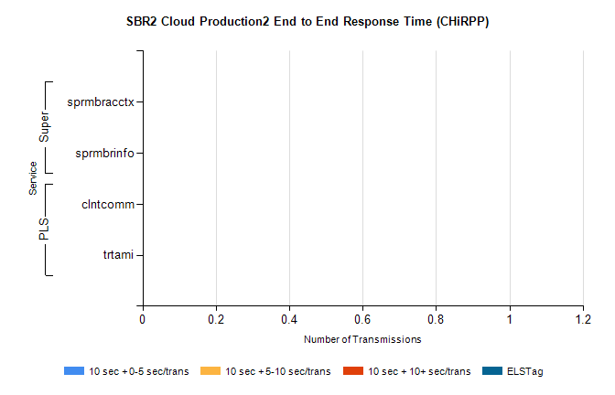
Stream | Service | 10 sec + 0-5 sec /trans | 10 sec + 5-10 sec /trans | 10 sec + >10 sec /trans | Total | % within 5 sec timing target
PLS | clntcomm | 0 | 0 | 0 | 8279 | 0.0%
PLS | trtami | 0 | 0 | 0 | 44 | 0.0%
Super | sprmbracctx | 0 | 0 | 0 | 2814 | 0.0%
Super | sprmbrinfo | 0 | 0 | 0 | 2615 | 0.0%

SBR1 Production Transactions

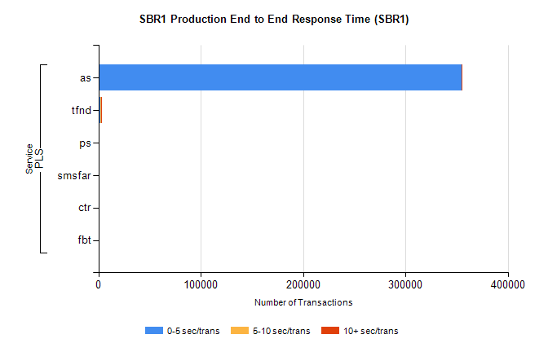
Stream | Service | 0-5 sec/trans | 5-10 sec/trans | 10+ sec/trans | Total | % within 5 sec timing target
PLS | as | 354961 | 153 | 82 | 355196 | 99.9%
PLS | tfnd | 1542 | 898 | 3 | 2443 | 63.1%
PLS | ps | 56 | 36 | 133 | 225 | 24.9%
PLS | smsfar | 14 | 20 | 1 | 35 | 40.0%
PLS | ctr |  |  | 11 | 11 | 0.0%
PLS | fbt |  | 1 |  | 1 | 0.0%

