Transmission Timings Report Week - 5
29/01/2024 - 4/02/2024

SBR2 External Vendor Testing Environment (EVTE3)

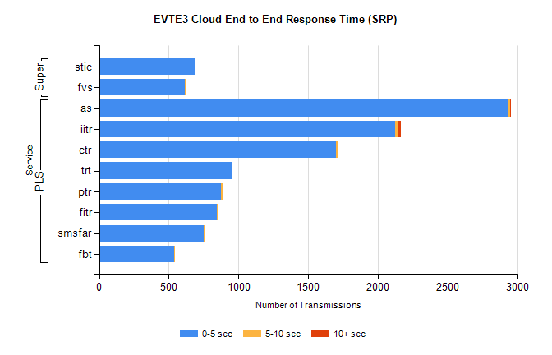
Stream | Service | 0-5 sec | 5-10 sec | >10 sec | Total | % within 5 sec timing target
PLS | as | 2939 | 7 | 6 | 2966 | 99.1%
PLS | iitr | 2126 | 17 | 22 | 2170 | 98.0%
PLS | ctr | 1699 | 13 | 1 | 1782 | 95.3%
PLS | trt | 953 | 3 | 0 | 956 | 99.7%
PLS | ptr | 877 | 7 | 0 | 885 | 99.1%
PLS | fitr | 846 | 4 | 0 | 851 | 99.4%
PLS | smsfar | 749 | 3 | 0 | 752 | 99.6%
PLS | fbt | 540 | 7 | 0 | 585 | 92.3%
Super | stic | 686 | 0 | 4 | 690 | 99.4%
Super | fvs | 618 | 1 | 0 | 619 | 99.8%

SBR2 External Vendor Testing Environment (EVTE3)

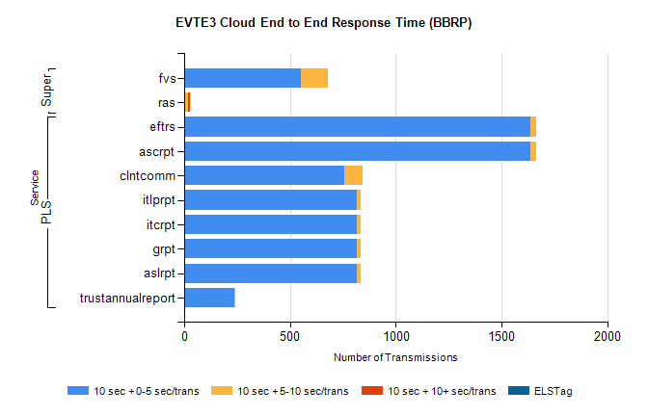
Stream | Service | 10 sec + 0-5 sec /trans | 10 sec + 5-10 sec /trans | 10 sec + >10 sec /trans | Processing Incomplete | ELStag | Total
PLS | ascrpt | 1636 | 28 | 0 | 36 | 0 | 1702
PLS | eftrs | 1636 | 28 | 0 | 36 | 0 | 1702
PLS | clntcomm | 758 | 87 | 0 | 0 | 0 | 891
PLS | aslrpt | 818 | 14 | 0 | 18 | 0 | 851
PLS | grpt | 818 | 14 | 0 | 18 | 0 | 851
PLS | itcrpt | 818 | 14 | 0 | 18 | 0 | 851
PLS | itlprpt | 818 | 14 | 0 | 18 | 0 | 851
PLS | trustannualreport | 237 | 6 | 0 | 0 | 0 | 243
Super | fvs | 551 | 128 | 0 | 256 | 0 | 937
Super | ras | 0 | 19 | 8 | 0 | 0 | 408

