Transmission Timings Report Week - 5
29/01/2024 - 4/02/2024

SBR2 Cloud Production2 - Single Requests (SRP)

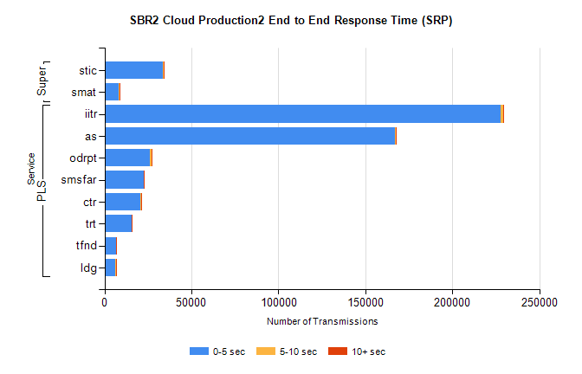
Stream | Service | 0-5 sec | 5-10 sec | >10 sec | Total | % within 5 sec timing target
PLS | iitr | 227957 | 1145 | 288 | 229512 | 99.3%
PLS | as | 167043 | 437 | 87 | 167830 | 99.5%
PLS | odrpt | 26252 | 944 | 75 | 27272 | 96.3%
PLS | smsfar | 22515 | 78 | 17 | 22622 | 99.5%
PLS | ctr | 20861 | 80 | 12 | 20960 | 99.5%
PLS | trt | 15542 | 63 | 16 | 15626 | 99.5%
PLS | tfnd | 6813 | 15 | 3 | 6837 | 99.6%
PLS | ldg | 6433 | 28 | 9 | 6475 | 99.4%
Super | stic | 33793 | 369 | 38 | 34283 | 98.6%
Super | smat | 8221 | 212 | 17 | 8454 | 97.2%

SBR2 Cloud Production2 - Bulk or Batch Requests (BBRP)

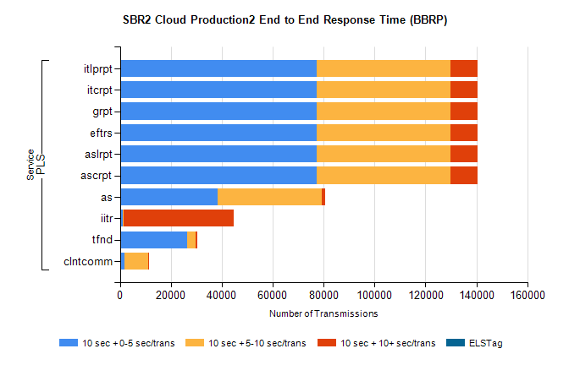
Stream | Service | 10 sec + 0-5 sec /trans | 10 sec + 5-10 sec /trans | 10 sec + >10 sec /trans | Processing Incomplete | ELStag | Total
PLS | ascrpt | 77126 | 52761 | 10645 | 62 | 0 | 144098
PLS | aslrpt | 77126 | 52761 | 10645 | 62 | 0 | 144098
PLS | eftrs | 77126 | 52761 | 10645 | 62 | 0 | 144098
PLS | grpt | 77126 | 52761 | 10645 | 62 | 0 | 144098
PLS | itcrpt | 77126 | 52761 | 10645 | 62 | 0 | 144098
PLS | itlprpt | 77126 | 52761 | 10645 | 62 | 0 | 144098
PLS | as | 38321 | 40915 | 1423 | 103 | 0 | 81372
PLS | iitr | 1102 | 437 | 42976 | 139 | 0 | 45541
PLS | tfnd | 26357 | 3492 | 385 | 2401 | 0 | 32749
PLS | clntcomm | 1731 | 9185 | 24 | 2 | 0 | 11127

SBR2 Cloud Production2 - ...

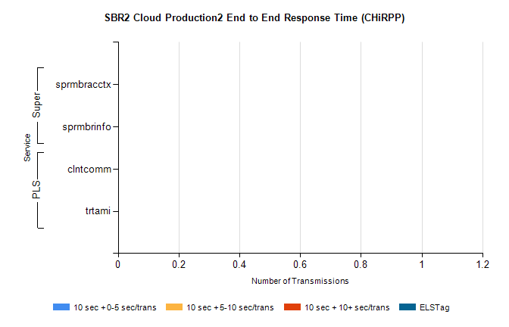
Stream | Service | 10 sec + 0-5 sec /trans | 10 sec + 5-10 sec /trans | 10 sec + >10 sec /trans | Total | % within 5 sec timing target
PLS | clntcomm | 0 | 0 | 0 | 8531 | 0.0%
PLS | trtami | 0 | 0 | 0 | 6 | 0.0%
Super | sprmbracctx | 0 | 0 | 0 | 3906 | 0.0%
Super | sprmbrinfo | 0 | 0 | 0 | 2796 | 0.0%

SBR1 Production Transactions

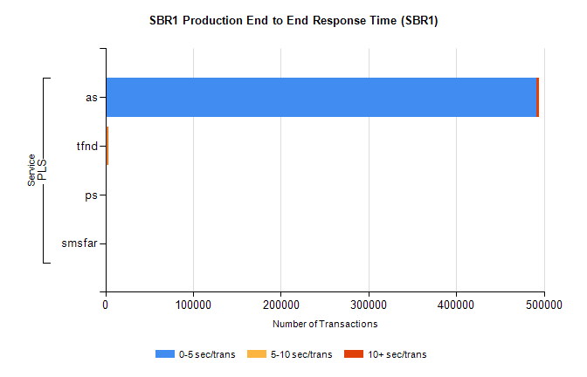
Stream | Service | 0-5 sec/trans | 5-10 sec/trans | 10+ sec/trans | Total | % within 5 sec timing target
PLS | as | 491595 | 197 | 3019 | 494811 | 99.4%
PLS | tfnd | 1720 | 894 | 96 | 2710 | 63.5%
PLS | ps | 26 | 41 | 108 | 175 | 14.9%
PLS | smsfar | 1 | 14 | 1 | 16 | 6.3%

