Transmission Timings Report Week - 6
5/02/2024 - 11/02/2024

SBR2 External Vendor Testing Environment (EVTE3)

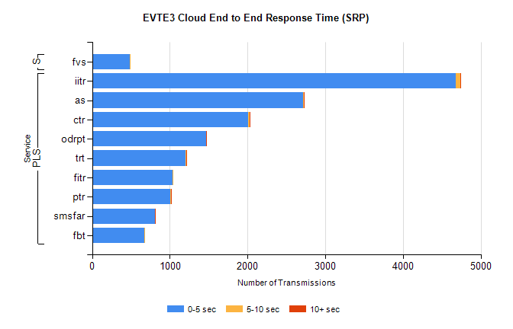
Stream | Service | 0-5 sec | 5-10 sec | >10 sec | Total | % within 5 sec timing target
PLS | iitr | 4678 | 58 | 13 | 4765 | 98.2%
PLS | as | 2711 | 9 | 9 | 2768 | 97.9%
PLS | ctr | 2010 | 17 | 1 | 2067 | 97.2%
PLS | odrpt | 1463 | 3 | 13 | 1495 | 97.9%
PLS | trt | 1203 | 13 | 6 | 1252 | 96.1%
PLS | fitr | 1037 | 6 | 0 | 1071 | 96.8%
PLS | ptr | 1003 | 9 | 3 | 1042 | 96.3%
PLS | smsfar | 805 | 7 | 3 | 815 | 98.8%
PLS | fbt | 672 | 3 | 0 | 754 | 89.1%
Super | fvs | 488 | 1 | 0 | 489 | 99.8%

SBR2 External Vendor Testing Environment (EVTE3)

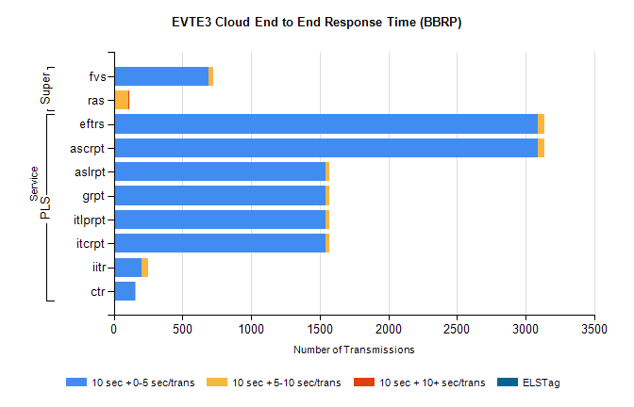
Stream | Service | 10 sec + 0-5 sec /trans | 10 sec + 5-10 sec /trans | 10 sec + >10 sec /trans | Processing Incomplete | ELStag | Total
PLS | ascrpt | 3088 | 50 | 0 | 12 | 0 | 3152
PLS | eftrs | 3088 | 50 | 0 | 12 | 0 | 3152
PLS | itcrpt | 1544 | 25 | 0 | 6 | 0 | 1576
PLS | itlprpt | 1544 | 25 | 0 | 6 | 0 | 1576
PLS | grpt | 1544 | 25 | 0 | 6 | 0 | 1576
PLS | aslrpt | 1544 | 25 | 0 | 6 | 0 | 1576
PLS | iitr | 204 | 44 | 0 | 180 | 0 | 433
PLS | ctr | 151 | 7 | 0 | 258 | 0 | 417
Super | fvs | 687 | 41 | 0 | 298 | 0 | 1026
Super | ras | 0 | 107 | 4 | 0 | 0 | 433

